Open the TI-Nspire™ document How_Does_It_Stack.tns.  Have you ever wondered why ice floats in water? Do you know why a mixture of oil and vinegar eventually separates? Have you wondered why a rock sinks in water, while polystyrene foam floats? In this activity, you’ll use a simulation to explore these questions. | 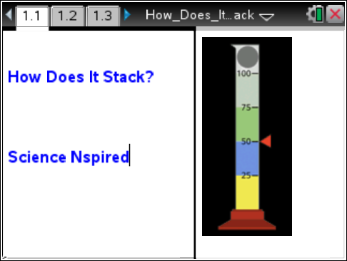
The TI-Nspire document contains a virtual density column. Your task is to calculate the density of each of the four solutions. Then, based on the results, predict the order in which the layers will settle. Finally, you will predict where a solid object will float when dropped into the column.

Move to pages 1.2 – 1.3.  - Each beaker has a different mass and volume of a solution. You may need to reveal the information, depending on the technology you are using. IMPORTANT: If you click or tap on the beaker, the liquid will be “poured” into the cylinder, forcing you to reset and start over. |  |  | 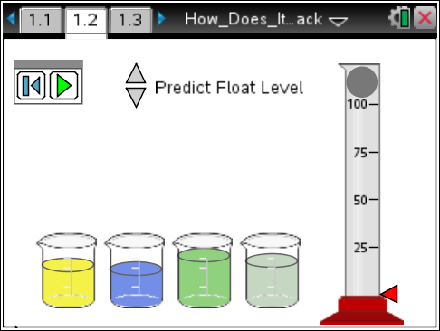
Tech Tip: To reveal the mass and volume, hover over the beakers. Be careful not to “select” them, as the liquid will be poured into the cylinder. If this happens, you will need to reset, and start over.
Tech Tip: Selecting the button will reset the simulation and ALL the masses and volumes of ALL the liquids in the beakers change. You will need to start over.
Container 1 | Container 2 | Container 3 |  | Container 4
Mass: _____________  Volume: ___________ | Mass: _____________  Volume: ___________ | Mass: _____________  Volume: ___________ |  | Mass: _____________  Volume: ___________
2. Use the calculator page 1.3 or Scratchpad to calculate the density of each solution.

What is the formula for calculating density? _______________________________
Tech Tip: Press » to use Scratchpad instead of moving between pages 1.2 and 1.3 to perform calculations.
Container 1 | Container 2 | Container 3 |  | Container 4
Density: __________  Order___ | Density: __________  Order___ | Density: __________  Order___ |  | Density: __________  Order___
3. Once you have determined the densities, return to page 1.2 and click on the beaker containing the solution that will settle to the very bottom of the cylinder. Then, continue to “pour” the liquid from each beaker into the cylinder in the order in which they will settle. If you are correct, indicate the order of how the liquids settled- 1 being at the top, 4 being at the bottom.
**If you select an incorrect order, you will receive a Goat. Reset  the page and try again. Use the multiple trials space at end to record new data. Go back to step #1.
4. Hover the cursor (or it may already be evident) over the solid ball to reveal mass and volume.

Mass: _______________________ Volume: _______________________

5. Use the calculator page 1.3 to calculate the density of the solid ball.

Density of Solid Ball: _______________________

6. Use the arrows beside “Predict Level” to move the red arrow next to the graduated cylinder to show where you predict the ball will float in the cylinder. Be careful with this prediction—if you are wrong, you will have to start over!

7. Click the play button  to watch the ball fall through the density column. If you correctly predicted the location of the ball, you will receive a Gold Star.
**If you did not predict the correct location of the ball, you will receive a Goat. Press the Reset button and try again until you receive the Gold Star. You will need to start all over again, and use the space at end for multiple trials. Go back to step #1.
Move to pages 2.1 – 2.5. Answer the following questions below or on your handheld.
Q1. When poured into the graduated cylinder, the most dense liquid will _________.
A. float on top  B. be the middle layer |  | C. be the bottom layer  D. chemically react
Q2. As the solid becomes more dense, it is most likely to ___________.
A. sink  B. float |  | C. rise to the top  D. be suspended midway in the liquids
Q3. Density is __________.
A. how heavy an object is  B. the size of an object |  | C.  D. how closely packed the matter is
Q4. The density of glycerin is 1.26 g/mL. If the mass of glycerin increases from 125 g to 250. g, the volume __________.
A. doubles  B. decreases by one half |  | C. is unchanged  D. decreases by one fourth
Q5. The density of glycerin is 1.26 g/mL. If the mass of glycerin increases from 125 g to 250. g, the density __________.
A. doubles  B. decreases by one half |  | C. is unchanged  D. decreases by one fourth

If you make a mistake, and receive “The Goat”, you will need to start over. Use the following space to record your data for multiple trials. If you need more space, use the back of your paper for more trials.
Try #2:
Container 1 | Container 2 | Container 3 |  | Container 4
Mass: _____________  Volume: ___________  Density: ___________  Order___ | Mass: _____________  Volume: ___________  Density: ___________  Order___ | Mass: _____________  Volume: ___________  Density: ___________  Order___ |  | Mass: _____________  Volume: ___________  Density: ___________  Order___
Solid Ball:  Mass: ____________  Volume:___________ |  |  | Density of the Ball: ___________
Try #3
Container 1 | Container 2 | Container 3 |  | Container 4
Mass: _____________  Volume: ___________  Density: ___________  Order___ | Mass: _____________  Volume: ___________  Density: ___________  Order___ | Mass: _____________  Volume: ___________  Density: ___________  Order___ |  | Mass: _____________  Volume: ___________  Density: ___________  Order___
Solid Ball:  Mass: ____________  Volume:___________ |  |  | Density of the Ball: ___________

