Problem 1 – Solving a Quadratic Equation by Completing the Square
Enter the following points into L1 and L2 so that the x-values are in L1 and the y-values are in L2:
(2.5, 0.25), (3.2, 2.56), (3.9, 3.89), (4.6, 4.24), (5.3, 3.61), (6, 2), (6.5, 0.25), (7.2, 2.56), (7.9, 3.89), (8.6, 4.24), (9.3, 3.61), (10, 2), (10.7, 0.25), (11.4, 2.56), (12.1, 3.89), (12.8, 4.24), (13.5, 3.61), (14.2, 2), (14.9, 0.25)
Graph a scatter plot of (L1, L2). Use the ZoomStat to view the data.
The scatter plot shows the plan for a trestle bridge. The upper part of each trestle is shaped like a parabola. In this activity, you will solve quadratic equations to answer questions about the bridge.
Let’s take a closer look at the curve described by one of the trestle sections. Enter the quadratic function y = –x² + 9x – 16, which models the curve of the trestle, in Y1.  Adjust the window settings as shown at the right.  Press s to view the graph. The x-axis represents ground level. Where does this bridge section meet ground level? |  |  |  | 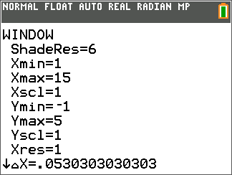
You could trace the graph to find an approximate answer. Or you could obtain an exact answer by solving a related quadratic equation, –x² + 9x – 16 = 0.
To solve the equation, first complete the square. Record your steps below. Some steps have been completed for you.
 |  | Algebra | Step
1. |  | –x² + 9x – 16 = 0 | original problem
2. |  |  | divide both sides by a = –1
3. |  |  | simplify
4.
5.
6. |  |  | simplify
7. |  |  | write the trinomial as a perfect square
8. |  |  | set one side equal to 0
At this point, stop and wait for the rest of the class to resume the activity. Continue to check your work so far.

Your equation should now be in the form (x – h)² + k = 0.
To check your algebra, you can compare the values of h and k in your equation with the coordinates of the vertex of the parabola, (h, k).
To find the coordinates of the vertex, use the maximum command found in the Calc menu (press y r).
Move the cursor and press Í to input a left bound, right bound, and a guess.  If you completed the square correctly, the coordinates of the vertex match the values of h and k in your equation. |  |  | 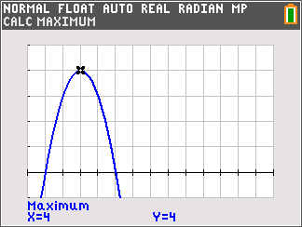
Continue to solve the equation by isolating x. Record your steps as before. Some steps have been completed for you.
Algebra |  | Step
9. | (x – 4.5) ² – 4.25 = 0 | starting equation
10.
11.
12. |  | simplify
13. |  | break into two equations
14.
15. Where does this bridge section meet ground level?

16. What is the span of this section (the distance from one ground level point to another)?

17. Rewrite the original equation, y = –x² + 9x – 16, in the form y = a(x – h) + k. What are the corresponding equations for the next two spans of the trestle?

The process you just used to solve this equation—completing the square and isolating x—can be used to solve ANY quadratic equation. Follow along with your teacher to see how this process can be written in a “shorthand” form called the quadratic formula.

Problem 2 – Using the Quadratic Formula
You can store the quadratic formula in your graphing calculator and use it to solve quadratic equations quickly.  Use ¿ to define the values of A, B, and C to match the equation 2x² + 5x + 3 = 0. |  | 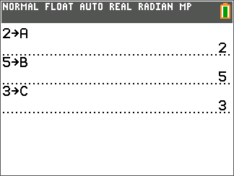
Because of the ± sign in the quadratic equation, we must store it in two pieces: Q, with a + instead of the ±, and R, with a – instead of the ±. Define Q and R. (Q is shown.) |  | 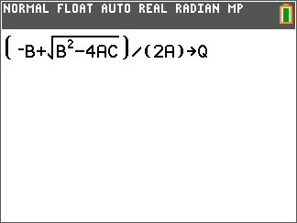
OPTIONAL:  There is another way you can solve quadratic equations with your handheld: using the Numeric Solver. The Numeric Solver tries many different values for the variable until it finds one that works. Open it by going to the Math menu and choosing it from the list. |  | 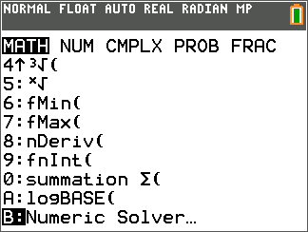
Enter the equation 2x² + 5x + 3 for E1 and 0 for E2 and press s. You can guess the solution on the second line and enter an upper and lower bound for the values where the Numeric Solver will look for the solution.  Note that the Numeric Solver is asking for the same information that a Calculate command such as maximum asks for on the graph screen. |  | 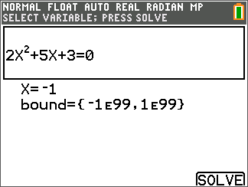
Press Í s to run the command. You will notice that the Numeric Solver returns only one solution in X, even though the equation has two solutions. This is because the Numeric Solver stops looking once it finds a value of the variable that makes the equation true. (This solution also may not be exact.) |  | 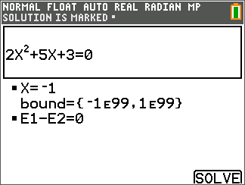
The expression E1–E2=0 means that the Numeric Solver has checked the solution by substituting it into both sides of the equations and then subtracting the right side from the left, much as you would check the answer to an equation! |  | 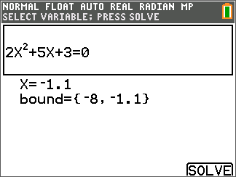
To find both solutions, you must run the Numeric Solver twice and tell it where to look for the solutions, as in the screens shown.  It is not always easy to guess where to tell the Numeric Solver to look for the solution. For example, if you had looked at < 0 and ≥ 0, you would not have found both solutions to this equation.  The quadratic formula is usually a better tool for solving quadratic equations with your calculator. |  | 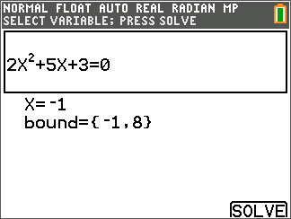
Solve each equation using the quadratic formula. You may need to simplify before applying the formula.
18. –55x + 30 = 50x² | 19. x² + 2x + 1 = 0 |  | 20. 6x² + x = 12
21. 3x² = 2x + 5 | 22. –11x² + 4x + 7 = 0 |  | 23. –4x² + 16x = –28
24. 2x² = –9x – 4 | 25. 3x² + 8x – 11 = 0 |  | 26. –2x² – 5x + 9 = 0
27. Graph the function y = x² + 4x + 4. Solve the corresponding equation x² + 4x + 4 = 0 using the different methods you’ve learned (completing the square, using the quadratic formula, etc.). Explain how you got the results, and how the results relate to the graph of the function.

28. Graph the function y = x² + 4x + 6. Solve the corresponding equation x² + 4x + 6 = 0 using the different methods you’ve learned (completing the square, using the quadratic formula, etc.). Explain how you got the results, and how the results relate to the graph of the function.

