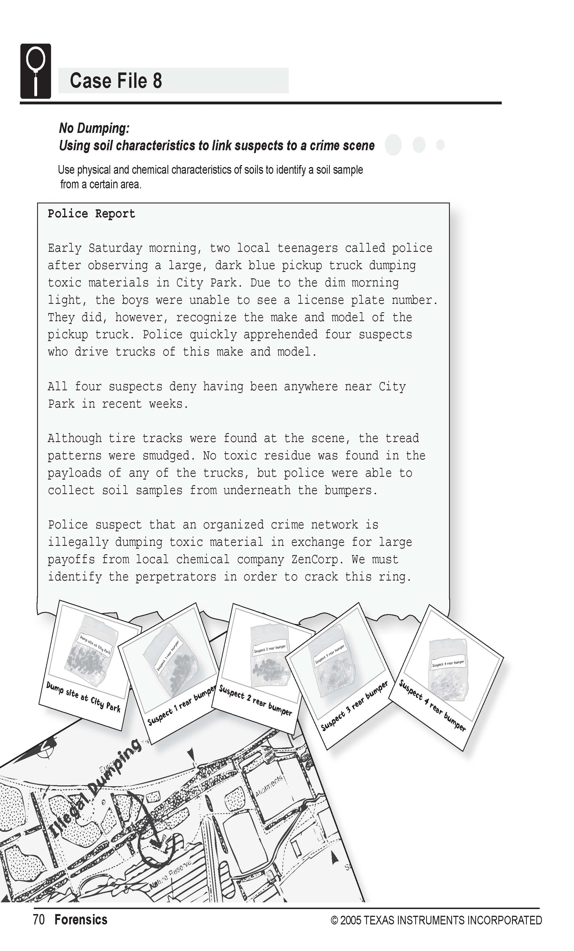
Science Objectives
- Identify characteristics of different soils to demonstrate that a suspect has been at a scene.
- Use characteristic properties to identify a soil sample.
- Measure the pH of soils.
- Measure the water absorbency of soils.
- Measure the conductivity of soils.

Activity Materials
- TI-NspireTM technology  - Case 8 No Dumping.tns file  - Vernier EasyLink™ or TI-Nspire Lab Cradle  - Vernier pH Sensor  - Vernier Conductivity Probe  - magnifying glass  - coarse filter papers (12.5 cm diameter)  - distilled water  - lint-free tissues  - wash bottle (with distilled water) | - 100 mL graduated cylinder  - five 250 mL beakers  - 5 spoons or weighing papers  - 400 mL beaker  - 50 mL beaker  - stirring rod  - large funnel  - balance  - goggles  - five 100 g soil samples
Procedure
Open the TI-Nspire document Case 8 No Dumping.tns.  In this data-gathering activity, you will identify characteristics of different soils to demonstrate that a suspect has been at a scene and use characteristic properties to identify a soil sample. |  | 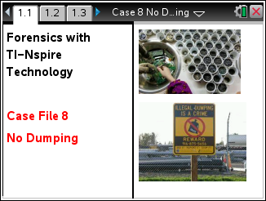
Part 1 – Preparing the Soil-and-Water Mixtures
CAUTION: Obtain and wear goggles during this experiment. Tell your teacher right away if any spills or accidents occur.
Move to pages 1.3–1.6.
1. Prepare mixtures of water and soil. For each sample, complete the following steps:
- Label a 250 mL beaker with the sample number.
- Using a balance, measure 50 g of the soil sample and place it in the labeled beaker. Note: To avoid contaminating the other samples, use a different spoon or weighing paper for each sample.
- Measure 100 mL of distilled water in the graduated cylinder. Add the water to the soil in the beaker.
- Stir the mixture thoroughly with the stirring rod. Repeat stirring once every 3 minutes for 15 minutes.
- After the final stir, let the mixture settle for 5 minutes before beginning to take readings. Note: To avoid contaminating the other samples, rinse the stirring rod with distilled water between soil samples.
Part 2 – Measuring the pH of the Samples
Move to page 1.4-1.5.  2. On page 1.5, connect the pH Sensor to TI-Nspire either using an EasyLink or the Lab Cradle. Note: For this experiment, your teacher already has the pH Sensor in a pH soaking solution in a beaker. Be careful not to tip over the beaker when you connect the sensor to the interface.  3. Use the pH Sensor to determine the pH of the solution in each sample beaker.  - Rinse the tip of the pH Sensor with distilled water from the wash bottle and place it into the liquid in the beaker containing sample 1.  - Gently swirl the sensor in the solution. Be careful not to let the tip of the sensor touch any solid material at the bottom of the beaker.  - When the pH reading stabilizes, record the pH value in the Evidence Record and/or on page 4.1 (as directed by your teacher).  - Repeat this process for each remaining soil sample.  When you are finished, rinse the pH Sensor with distilled water and return it to its storage container. Disconnect the pH Sensor. |  |  | 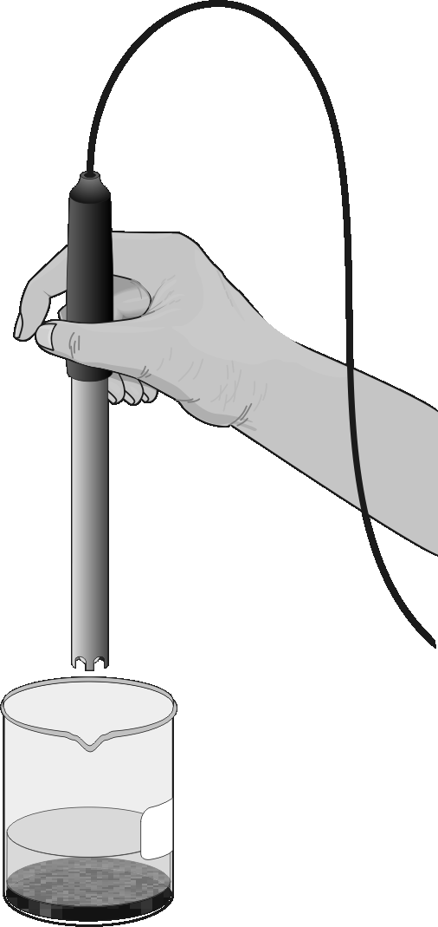
Part 3 – Testing the Conductivity of the Samples
Move to page 2.1-2.3

4. Set the switch on the Conductivity probe to the 0–20,000 μS/cm setting. On page 2.2, connect the Conductivity Probe using EasyLink or the Lab Cradle.
5. Select MENU > Experiment > Set Up Sensors > Zero to zero the Conductivity Probe.
6. Collect conductivity data for each sample.
- Place the tip of the probe into the beaker containing sample 1. The hole near the tip of the probe should be completely covered by the liquid. Gently swirl the probe in the solution.
- Once the conductivity reading has stabilized, record the value in your Evidence Record.
- Rinse the Conductivity Probe thoroughly with distilled water from the wash bottle before collecting data for the next sample. Blot the outside of the probe end dry using a tissue. It is not necessary to dry the inside of the hole near the probe end.
- Repeat this process for each of the remaining samples.
7. Empty the remaining liquid from the beakers as directed by your teacher. Rinse and dry the beakers. Disconnect all sensors. Record your data in the Evidence Record and/or on page 4.1 (as directed by your teacher).
Part 4 – The Physical Appearance of the Samples
Move to page 3.1.
8. For each sample, use the balance to measure out 50 g on a piece of filter paper labeled with the sample number.
9. Examine the samples through the magnifying glass. In the Evidence Record, make a sketch of each sample and write down some notes about its appearance.
Part 5 – Determining the Water Absorbency of the Samples
Move to page 3.2.
110. Determine how well each sample absorbs water.
- Carefully lift the sample 1 filter paper and soil that you prepared in Step 9.
- Place the filter paper and soil into a funnel.
- Have your lab partner hold the funnel over a 400 mL beaker.
- Measure 100 mL of distilled water in the graduated cylinder, and pour it through the soil. Collect any water that drains through into the beaker.
- Let the sample drip for 60 seconds.
- Pour the water from the beaker into the 100 mL graduated cylinder.
- Subtract the volume of water in the graduated cylinder from the 100 mL you poured into the soil. This is the amount of water absorbed by the soil. Write this amount in the Water Absorbency column of your Evidence Record and/or on page 4.1 (as directed by your teacher).
- For each remaining soil sample, empty the funnel, 400 mL beaker, and graduated cylinder and repeat this step.

Evidence Record
Sample | pH | Conductivity  (μS/cm) | Water Absorbancy (mL/50 g) | General  Appearance Conductivity  (μS/cm)
1
2
3
4
Crime Scene

Sketch of Physical Appearance
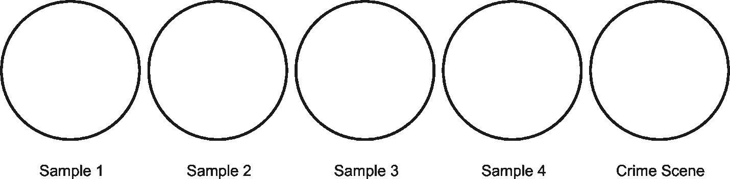

Case Analysis
Move to pages 5.1-5.12.
Answer the following questions in your .tns document or below on this worksheet, or both, as directed by your teacher.
1. What is the range of pH that you found in the five soil samples?

2. What does a high pH mean, and what does a low pH mean?

3. What can cause a soil to become acidic or basic?

4. What is the range of conductivity that you found?

5. What does a high conductivity indicate about the soil?

6. Why is it important to know the pH and the conductivity of a soil if you want to know how salty the soil is?

7. What is the range of water absorbency that you found?

8. What types of soils have a high water absorbency, and what types of soils have a low water absorbency?

9. How can an investigator use the physical appearance of a soil sample to link a suspect to a victim or crime scene?

10. What tools can a forensic scientist use to identify and match soil samples?

11. Based on your observations, were any of the suspects’ vehicles present at the crime scene? If so, which ones? Explain your answer.

