A rational function is the quotient of two polynomial functions where the polynomial function in the denominator is of degree 1 or higher. To understand the behavior of rational functions better, let’s examine the polynomial functions that make them up.  Press o and enter the polynomial function shown. Later this function will become the numerator of a rational function. | 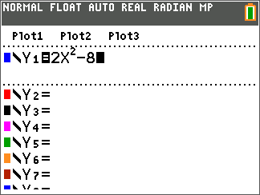
Press s. Examine the graph.

1. Where are the zeros?

2. What is the y-intercept?

You can easily check your answer for the y-intercept. Press r and type in 0 (for x = 0) Í.

Press o. In Y2 enter the factored form for y = 2x² – 8. Left arrow to the left of Y2 and press Í repeatedly to change the format of the graph to be a circle that leaves a trail.  Press s. If the circle traces over the original graph of Y1 then you know that you have the correct factored form in Y2. | 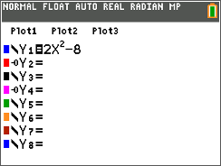
3. How does the factored form relate to the zeros of the function?

Press o. Turn off Y1 and Y2.  Enter the function y = x² – 16 into Y3. Later this will become the denominator of the rational function.  Press s. Press r and type in 0 (for x = 0) Í. | 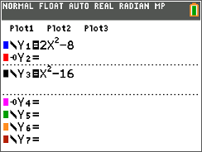
4. What indication did the equation give of what the y-intercept would be? Record the value.

The y-intercept for the denominator is y = _____________.

5. Continue to trace to find the zeros. Record.
The denominator is zero at x = ________________.

Press o. In Y4 enter the factored form for y =x² – 16. Left arrow to the left of Y4 and press Í repeatedly to change the format of the graph to be a circle that leaves a trail.  Press s. If the circle traces over the original graph of Y3 then you know that you have the correct factored form in Y4. | 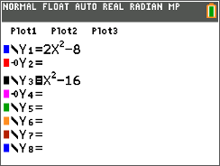
6. How does the factored form relate to the zeros of the function?

Press o. Turn the equations Y3 and Y4 off. Enter the rational function into Y5.  Press s. Press r and type in 0 (for x = 0) Í. | 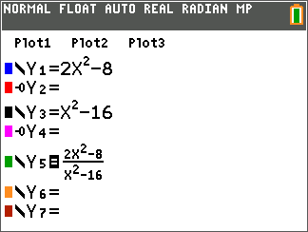
7. On cursory inspection, where do you see interesting things happening on this graph?

8. Is this a graph of a function?

Press r. Examine the behavior of the graph at some of the interesting values of x.
9. For what x-values do the zeros of this function occur?

10. The zeros of this function occur at the same locations as the zeros of the numerator. Why is this true?

11. There appear to be some vertical lines on the graph. Where do these appear?

12. While still in trace mode, type in 4 for x = 4. What is the y-value at this point? At x = –4?

The things that appear to be vertical lines are not…they are vertical asymptotes of the function. They occur because y is not defined for these values of x. Recall that 4 and –4 are the zeros of the denominator.

13. What happens when the denominator of a fraction is zero?

14. Lastly, look for the y-intercept. What is the value of y when x is 0?

15. Recall that the y-intercept of the numerator is –8 and the y-intercept of the denominator is
–16. What is the quotient of these two values?

Press o. Turn the equations Y1 and Y3 back on.  Press s. If you look closely you can see that the zeros of the numerator’s parabola intersect the zeros of the rational function and that the zeros of the denominator’s parabola appear to cross the vertical asymptotes at x = 4 and x = –4. | 