It’s a Radical, Rational Universe!  ID: 12178 | Time Required  15–20 minutes

Activity Overview
In this activity, students will explore values and optimization of rational and radical functions in real contexts by graphing and using spreadsheets. Problem 1 involves a radical function relating to acceleration due to gravity. Problem 2 involves a rational function relating to the dilution of a more concentrated solution with a less concentrated solution.

Topic: Radical and Rational Function Optimization
- Radical Functions
- Rational Functions
- Restricted domain and range in real contexts
- Optimization

Teacher Preparation and Notes
- Depending on the time available in class, the second problem could be done as a homework problem or on another day in class.
- The gravity information for the solar bodies in Problem 1 can be found on www.aerospaceweb.org.
- To download the student worksheet, go to education.ti.com/exchange and enter “12178” in the keyword search box.

Associated Materials
- RadicalRationalUniverse_Student.doc

Suggested Related Activities
To download any activity listed, go to education.ti.com/exchange and enter the number in the keyword search box.
- Radical Functions (TI-84 Plus family) — 8977
- Radical Transformations (TI-84 Plus family) — 11574
- Asymptotes & Zeros (TI-84 Plus family) — 9301
- Graphing Rational Functions (TI-Navigator) — 6651

Problem 1 – Acceleration Due to Gravity
In this problem, students first explore the time required for objects to fall from various distances on Earth. This is done by letting x replace d and 9.81 replace g in the given radical equation. Students are asked questions that may be answered on the handheld related to the graph and function values. | 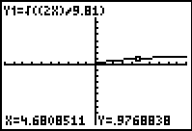
For this exploration, students should use the r command and the arrow keys to determine (x, y) coordinates on the graph.
Ask students to predict how the graph will change when x is substituted in place of g and d is replaced with the constant value 20. This is a challenge, but worthy of consideration and discussion. What values are not included in the function graph? Why?
Students should note that no negative values are included for x as this would lead to imaginary results.
If using Mathprint OS:  When entering the function in Y1 and students press  , the cursor will move under the square root bracket. To enter the fraction, students need to press   and select n/d. Then enter 2X on the top and press  to move to the bottom of the fraction. Then enter 9.81 and press . | 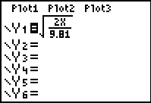
Students will then graph the revised function, where x is now gravity, 20 replaces d, and f(x) still represents time. They use the graph and related gravity information for a variety of bodies to identify locations where the time for a body to fall a distance of 20 meters would be the greatest and least. Additional related questions are included. | 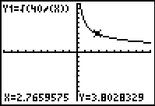
Problem 2 – Dilution of a Solution
Dilution problems provide a great opportunity for real world exploration of rational functions. In this problem, students begin with 5 liters of a 10 molar solution of hydrochloric acid and dilute it with a 2 molar solution.  Knowledge of molarity is not necessary for the understanding of the mathematical applications involved, but in case students are curious, molarity means moles of solute per liter of solution. A mole is approximately 6.022 x 10²³ molecules (or formula units) of the substance dissolved in the solution. | 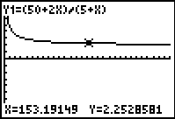
If using Mathprint OS:  When entering the function in Y1 and students press   and select n/d. Then enter 50 + 2X on the top and press  to move to the bottom of the fraction. Then enter 5 + X and press . | 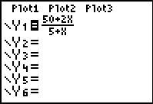
Students explore the given function to identify maximum and minimum values appropriate in the context of the problem. The problem context also rules out certain function values and restricts the domain and range. Questions included in the .tns file address these issues.
Ask students about the function value as x → ∞. Relate this real situation to limits. How does this limit of 2 make sense in the context of the problem? What is the horizontal asymptote for this function?
Student Solutions
1. negative time, distance, and gravity values don’t make sense for falling objects, so t ≥ 0, d ≥ 0, and g ≥ 0
2. approx. 6.4 seconds
3. As x → ∞, f(x) → ∞, so no maximum value exists. In reality however, there is a limit to the distance, x, from which an object can be dropped. When x is very large, the object would be outside the gravitational pull of the spatial body, in this case, Earth.
4. Pluto
5. Sun
6. 2 molar
7. about 2.0 seconds
8. 10 molar, obtained when x = 0, but this isn’t really a dilution, so students may answer just under 10 molar
9. Any negative values for concentration and volume do not make sense, so any values in Quadrants II, III, and IV don’t make sense for this problem.

