Introduction
People benefit every day from batteries when they use a flashlight, their calculator, CBR 2™, or any other battery-operated device. Have you ever put batteries into a flashlight or your calculator? How much power do you think they get from the batteries inside?
Look on the outer jacket of a battery. There is a positive terminal (+) and a negative terminal (-) at the ends of the battery. You will also see the size, e.g., AAA, AA. The voltage is also listed on the battery, e.g., 1.5 VOLTS. If you look at the position of the batteries in many flashlights, you will notice that the batteries are lined up in a column or a series. They are lined up so that the positive terminal (+) of one battery touches the negative terminal (-) of another battery.

Observe the position of the batteries in the calculator. You will notice that even though the batteries are not in a row, the battery terminals alternate and there is a piece of metal connecting the positive terminals (+) to the negative terminals (-). These batteries are connected in series or serial arrangement.
See figure.

Batteries supply electrical energy to electronic devices when a circuit is created. It might help to think of a circuit as a path linking the positive terminal to the electronic device (the load) and then back to the negative terminal. This investigation will help you explore how many total volts several batteries in a series provide to a battery-operated device.

Use five batteries of the same size and voltage. It is best if new batteries are used or a set of batteries that have been used in the same device. The batteries can be held in place using a battery holder, a ruler with a ridge down the center, or even the grout line between tiles on a table or floor. The batteries should be lined up with a positive terminal (+) touching a negative terminal (-).n this activity, you will explore absolute value inequalities, compound inequalities, disjunctions, and conjunctions graphically, numerically, and algebraically.
Objectives
In this activity, you will:
- Graph scatter plots
- Multiply as repeated addition
- Use a pattern to develop a formula
You’ll need
- TI-84 Plus CE, with Vernier EasyData® App
- Vernier EasyLink™
- Voltage sensor
- 5 same size 1.5 volt batteries (e.g., AA, AAA)
Using the Vernier Easy Link® and Vernier EasyData® App  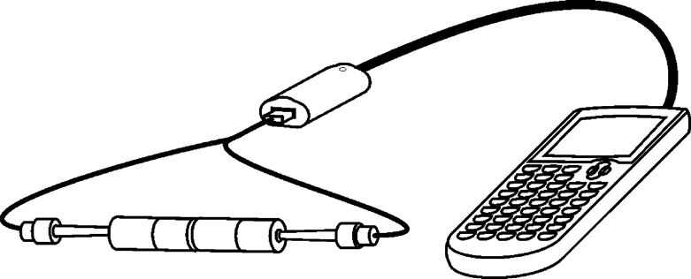  Connect the EasyLinkTM to your TI-84 Plus CE using the mini-USB port. Connect the voltage sensor to the EasyLink, and EasyData App will immediately open, The EasyData App information screen is displayed for about 3 seconds followed by the main screen. The EasyData App identifies the voltage sensor. In the EasyData App, the tabs at the bottom indicate the menus that can be accessed by pressing the actual calculator keys directly below the tab. | 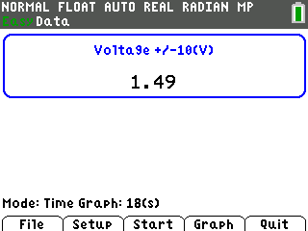  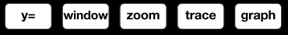

Collecting the Data
- Press o to access the File menu and select 1:New by pressing À. Or, since 1:New is highlighted, you can press Í. This resets the program and clears out old data. | 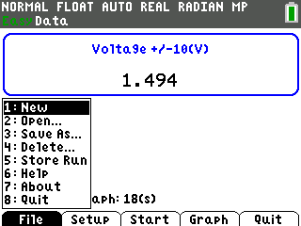
- Place one battery in a battery holder or on a ruler. Touch and hold the appropriate voltage leads to the appropriate terminal; red to (+) and black to (-). A series circuit has now been created with the calculator.
- Select Start to begin collecting data. The current voltage is displayed in the upper, right corner of the screen. Touch the red voltage lead to the (+) terminal and the black voltage lead to the (-) terminal of one battery and wait for the voltage reading to stabilize. Select Keep to record the reading.
- Repeat the above, measuring the voltage of each of the five batteries. Record these readings below. These readings should be very close to the same for each battery measured. Notice that the voltage can be seen in the upper center of the EasyData main screen.

- Record the voltage for each of the five batteries in the table below.
Battery | 1st | 2nd | 3rd | 4th | 5th
Voltage

- From the Setup menu, choose 4:Selected Events. Mode: Selected Events will be displayed on the home screen. Next, collect data as the circuit is increased by one battery at a time. | 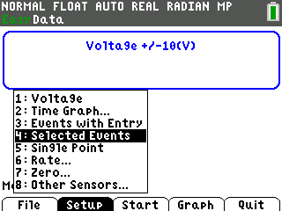
- Line up two batteries in series. Touch and hold the appropriate voltage leads to the ends of the line of batteries. Select Keep to collect the voltage of the two batteries. The Selected Events feature will keep track of which reading you are on and increase it by one each time you select Keep. | 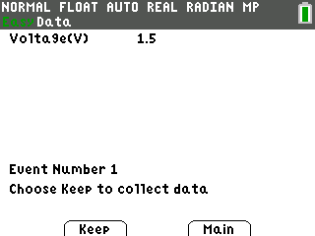
- Continue for a total of 5 trials. With each recorded value, a new data point will be displayed on the graph. You are given the option to Keep or Stop the data collection after each trial. When finished, select Stop. A graph of your data points will be displayed. Use the right and left arrow keys to view the values of the coordinates of the points.  - To confirm a description of the plots, select the Plots soft key. | 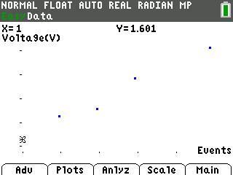
- Select Anlyz and choose 2:Linear Fit from the menu. | 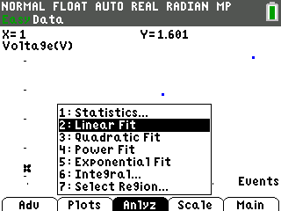
- The calculator will display an equation for the line of best fit. Select OK.  Record the values from the calculator when you used the Linear Fit feature. A=_____ B=_____ Y=_____ | 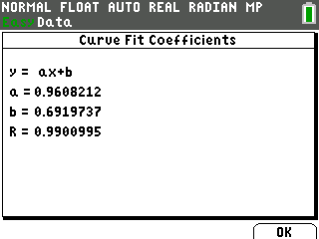
- The data points will be connected as the regression equation is drawn on the same coordinate plane. | 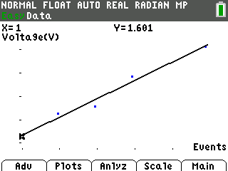
- Select the Main menu and then select Quit. A screen will display where the data from your activity is stored. Select OK to exit the App. | 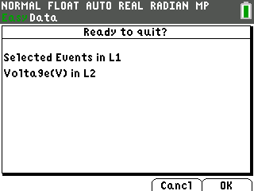
Data Analysis:
- After exiting the EasyData App, the regression equation can be found in one of several ways. When you quit the EasyData App, your data was stored in L1 and L2. The following directions will use the Manual-Fit feature of the calculator to find the regression equation. Press … Í to view the lists. | 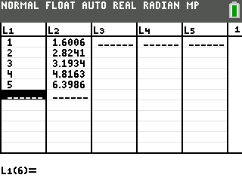
- If you press y o to access the , menu, you will see that Plot1 from this activity is still turned on. | 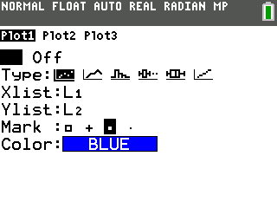

- Press s to see the plots graphed. Notice that the line of best fit is no longer in the picture. | 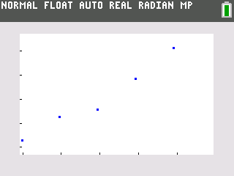
- The line is still in the o window, but its equal sign is no longer highlighted. This indicates that the equation is turned off and is not being graphed. The Manual-Fit feature will overwrite Y1. The current Y1 will need to be stored in Y2. This will allow the Manual-Fit line to be compared to the regression equation.  - Position your cursor next to the equal sign to the right of Y2. | 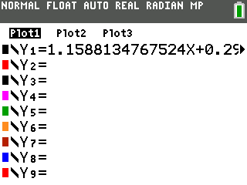
- Recall Y1 and paste it into Y2. To do this, press y ¿ to access K. Rcl (for Recall) should be at the bottom of the screen. Press ½, arrow over to Y-VARS, select 1:Function from the menu, and 1:Y1 from the next menu. | 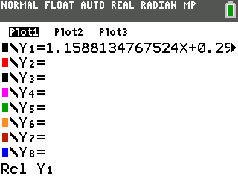
- Press Í to complete the command. This will paste Y1 into Y2. This will also highlight the equal sign beside Y2. When an equal sign is highlighted, the equation is turned on and the equation will be graphed in the graph window. | 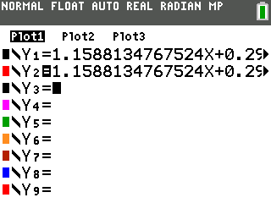
- Press s to be sure this is the regression equation. | 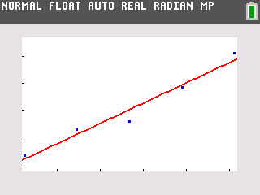
- Go to the o window and turn off the equal sign beside both equations. To do this, position the cursor on each equal sign and press Í. This is a toggle switch. If the equal signs are highlighted, after you press Í, they will be turned off. If they are not highlighted, they will be turned on. This is also where you can change the color of the line. Arrow over to the color and press Í. Use the | and ~ arrows to select the color and then move down and select OK and press Í. | 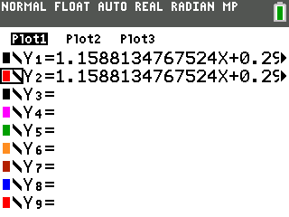
- Press s. This will move you to the graph screen. Press …, arrow over to CALC, and then scroll down until D:Manual-Fit is highlighted. | 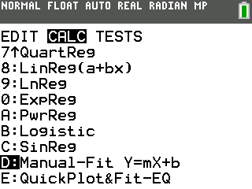
Tech Tip: Most of the menus on the calculator are “wrap around” menus.
Manual-Fit is the last entry in the CALC menu. Instead of starting at the top of the list and having to press the down arrow multiple times, press the up arrow once and you will be taken to the bottom of the list where Manual-Fit will be highlighted.
- Press Í. Fill in the template with the location you would like to store the equation. In this case choose Y1 by pressing ½ ~ then 1:Function and 1:Y1. Arrow down to Calculate and press Í. Now you are back to the graph. Use the arrow keys to move the cursor so it is as close as possible to one of the points on the left side of the screen. When there, press Í. Next, move the cursor to one of the points on the right side of the screen | 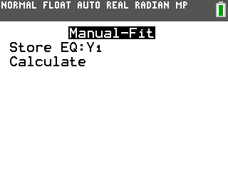
- Press Í. Fill in the template with the location you would like to store the equation. In this case choose Y1 by pressing ½ ~ then 1:Function and 1:Y1. Arrow down to Calculate and press Í. Now you are back to the graph. Use the arrow keys to move the cursor so it is as close as possible to one of the points on the left side of the screen. When there, press Í. Next, move the cursor to one of the points on the right side of the screen.
- When satisfied with the position of the cursor, press Í. The entire line will fill in and its equation will be written across the top of the screen with the slope highlighted.  Record the values when you used the Manual-Fit feature. A=_____ B=_____ Y=_____ | 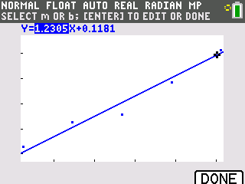
- Round the slope to the nearest tenth. Type the rounded slope value into the calculator. This new value for slope will be displayed along the bottom left side of the screen. Press Í to see the rounded slope value entered into the equation. | 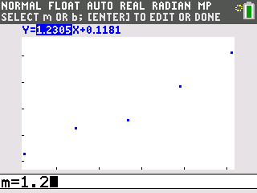
- Press the right arrow key to highlight the Y-intercept. Repeat the process above to change it. Zero is a good choice for the Y-intercept because zero batteries would register no voltage. | 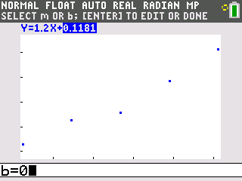
- Pressing s will take you out of the Manual-Fit program. Your line of best fit will stay in Y1 | 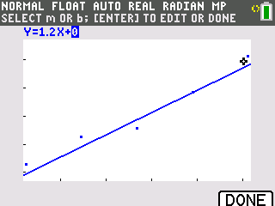
- To compare how closely the regression equation you found matches the one the calculator found, graph them both at the same time. Vary their graph style and color so that you can distinguish one line from the other. From the o window, turn on both Y1 and Y2. Leave Y1 with the default graph style and color. Use the left arrow key to highlight the slash icon in front of Y2. Repeatedly press | ~ until you see the color you like and the symbol shown in the screenshot on the right. This symbol has a ball with a small line to the left of the ball. Highlight OK and press Í… | 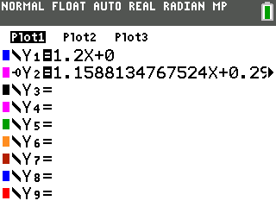  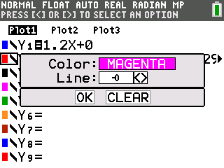
- Press s. You will see Y1 graphed normally. A different color and a small ball will mark the trail as Y2 is graphed. This is used to demonstrate how closely your graph matches the graph the calculator found | 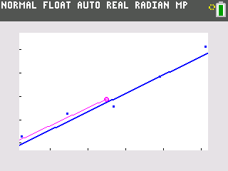
Looking at the Results
- Draw the graph of the data collected from measuring the series of one battery, then two batteries, then three, and so on. Label the axes with the appropriate units.
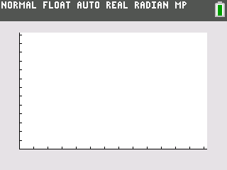
- If the points on the graph were connected, describe the general shape of the graph.

- Press the arrow keys to trace along the data points and record your data, the voltage, in the table provided.
# of Batteries  X | Voltage  Y
1
2
3
4
5

- What do you notice about the voltage measurements?

- Predict the voltage of a series of six of your batteries._______
- of 10? _____
- of 20? _____
- of n batteries? _____
- If X=number of batteries and Y= the voltage, use your data to write and equation that describes the relationship of voltage to the number of batteries.
Use your equation to fill in A=_____B=_____ where Y=Ax+B.

- For the equation of the line, Y = AX + B, A is called the _________and B is called the _________

- Are the calculator values (linear fit) of A and B (the same as your values (manual fit) for A and B? Write a comparison explaining any differences.

- Summarize your investigation. Write a description of the total voltage a battery operated device will receive if several batteries are lined up in series. Include a sketch of the batteries in series on the back of this page.

