Math Objectives  - Students will create Voronoi Diagrams and apply them to real world situations.  - Students will draw triangles and find their circumcenters using perpendicular bisectors.  - Connect the use of Voronoi Diagrams with finding the equations of lines in the form ax + by + c = 0 form, where a, b, and c are all integers.  Vocabulary  - Voronoi Diagrams • circumcenter • seeds  - Delaunay Triangulation • perpendicular bisector  About the Lesson  - This lesson involves the creation and application of Voronoi Diagrams in IB Mathematics Applications and Interpretations.  - This falls under the IB Mathematics Core Content Topic 3 Geometry and Trigonometry:  3.6 Voronoi Diagrams, sites, vertices, edges, cells  - As a result, students will:  - Perform Delaunay Triangulation given a set of coordinates or seeds.  - Find the circumcenter of each triangle created, using perpendicular bisectors.  - Use the circumcenters to separate regions or cells in the Voronoi Diagram.  - Apply Voronoi Diagrams to real world situations.  TI-Nspire™ Navigator™  - Transfer a File.  - Use Class Capture to examine patterns that emerge.  - Use Live Presenter to demonstrate.  - Use Teacher Edition computer software to review student documents.  - Use Quick Poll to assess students’ understanding.  Activity Materials  - Compatible TI Technologies:  TI-Nspire™ CX Handhelds,   TI-Nspire™ Apps for iPad®,  TI-Nspire™ Software | 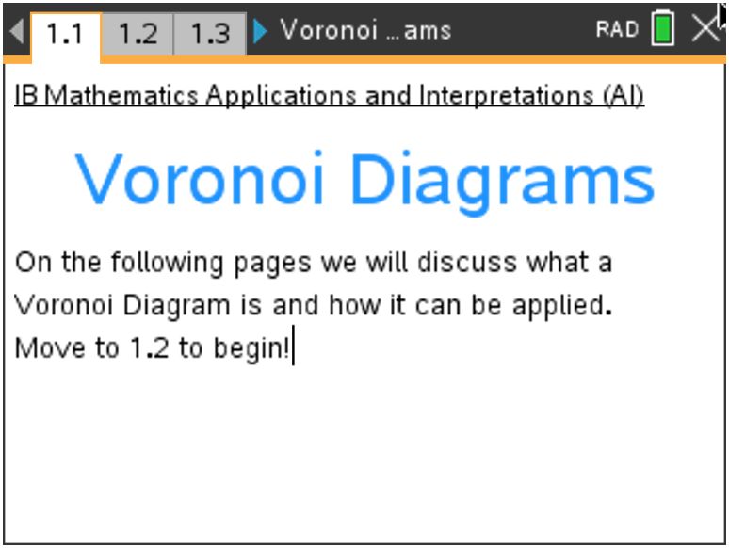  Tech Tips:  - This activity includes screen captures taken from the TI-Nspire CX handheld. It is also appropriate for use with the TI-Nspire family of products including TI-Nspire software and TI-Nspire App. Slight variations to these directions may be required if using other technologies besides the handheld.  - Watch for additional Tech Tips throughout the activity for the specific technology you are using.  - Access free tutorials at http://education.ti.com/calculators/pd/US/Online-Learning/Tutorials  Lesson Files:  Student Activity  Voronoi_Diagrams_Student-Nspire.pdf  Voronoi_Diagrams_Student-Nspire.doc  TI-Nspire document  Voronoi_Diagrams.tns  Delaunay_Triangulation.tns

Discussion Points and Possible Answers

Tech Tip: Throughout this activity, it is important to have strong knowledge and practice with the Geometry tools. Familiarize yourself before your jump in with the students.

Tech Tip: If you are using the IPad app, the visuals are stunning, but more time will have to be given to students to create the Voronoi Diagram using the Geometry Tools.

Move through pages 1.2 – 1.5 to learn about Voronoi Diagrams.
These slides give some brief background knowledge about Voronoi Diagrams. This is a good opportunity to expand on them.

Move to page 1.2
Before we can apply Voronoi Diagrams to the real world, let’s discuss what it is. It was named after the mathematician Georgy Vorinoy (1868 – 1908) and is based on the idea of the minimal distance needed to reach a landmark (hospital, school, transportation station, etc.).

Move to page 1.3
The diagram is a partition of a plane into regions, called Voronoi cells, close to each of a given set of objects. These objects are just finitely many points in the plane sometimes referred to as seeds, sites or generators. For each seed, there is a corresponding region consisting of all points of the plane closer to that seed than any other. See an example on page 1.4.

Move to page 1.4
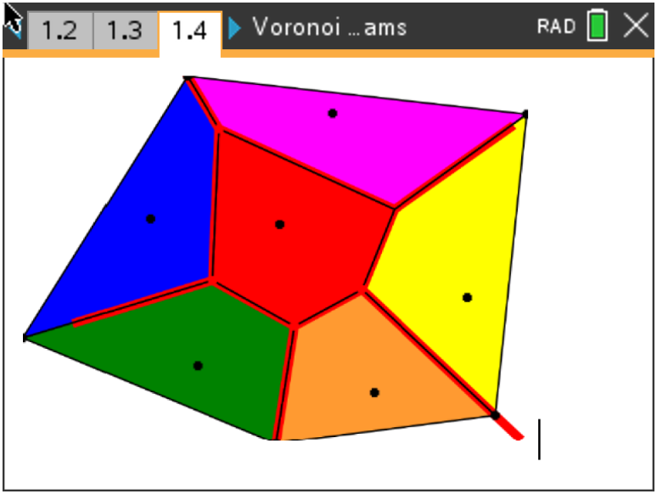

Move to page 1.5
The example created on 1.4 shows a point in each colored region, these represent the landmarks or seeds. The goal of this activity is to not only create your own Voronoi Diagram on the handheld, but it is to also understand what math is needed to make the diagram and how to apply it as you would in an IB Math AI class and on the IB Math AI exam. On page 1.6 let us discuss what it will take to creat a Vornoi Diagram.

Move to page 1.6.  1. Define a circumcenter. | 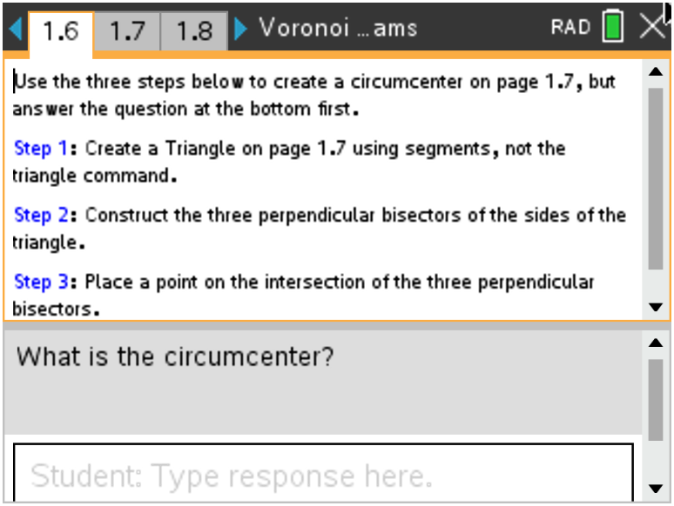
Sample Answers: The circumcenter is the center of a triangle's circumcircle, the circle that contains all the vertices of the polygon, if such a circle exists. It can be found as the intersection of the perpendicular bisectors. This is the backbone of the Voronoi Diagram.

2. Follow the directions to create a circumcenter on page 1.7. Discuss with a classmate what you have made and what possible uses there may be outside of the math classroom.

Sample Answer: There are three cities, and you want to build a factory in a location that is equidistant from all three. Draw a triangle connecting those cities on a map, and the circumcenter is the point that is equidistant from all three.

TI-Nspire Navigator Opportunity: Quick Poll (Multiple Choice or Open Response)
See Note 1 at the end of this lesson.
Teacher Tip: There is a nice opportunity to extend your explanation of how the triangles are drawn connecting the random points through a process called Delaunay Triangulation. There is a separate TNS file that is included in this activity that you could use to show your students the angle relationships created by the lines drawn from each seed, if you would like to dig deeper.

Move to page 1.8.  3. On this page, follow the directions to enhance the diagram  created on page 1.7.  Answer: Here you will practice hiding objects constructed on the Geometry page, along with possibly changing their colors. | 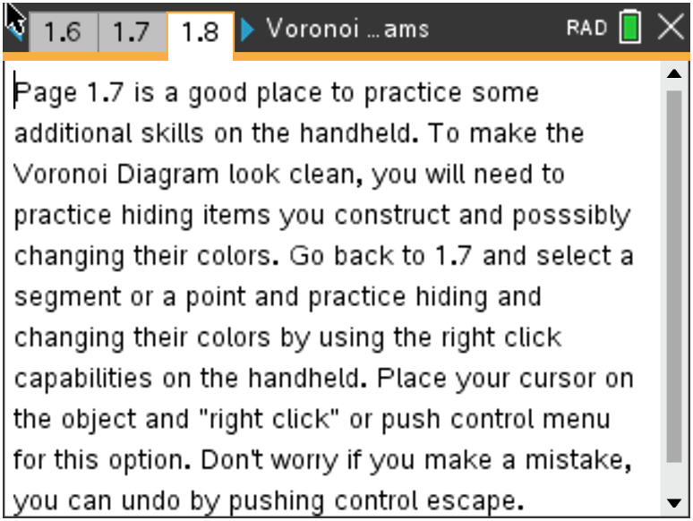
TI-Nspire Navigator Opportunity: Quick Poll (Multiple Choice or Open Response)
See Note 1 at the end of this lesson.
Practicing with Voronoi Diagrams

4. Before you continue with the activity on the handheld, let us
practice by creating your own Voronoi Diagram on the following
coordinate plane. Follow the directions below.

Step 1: Space out five (5) random points on the coordinate plane.

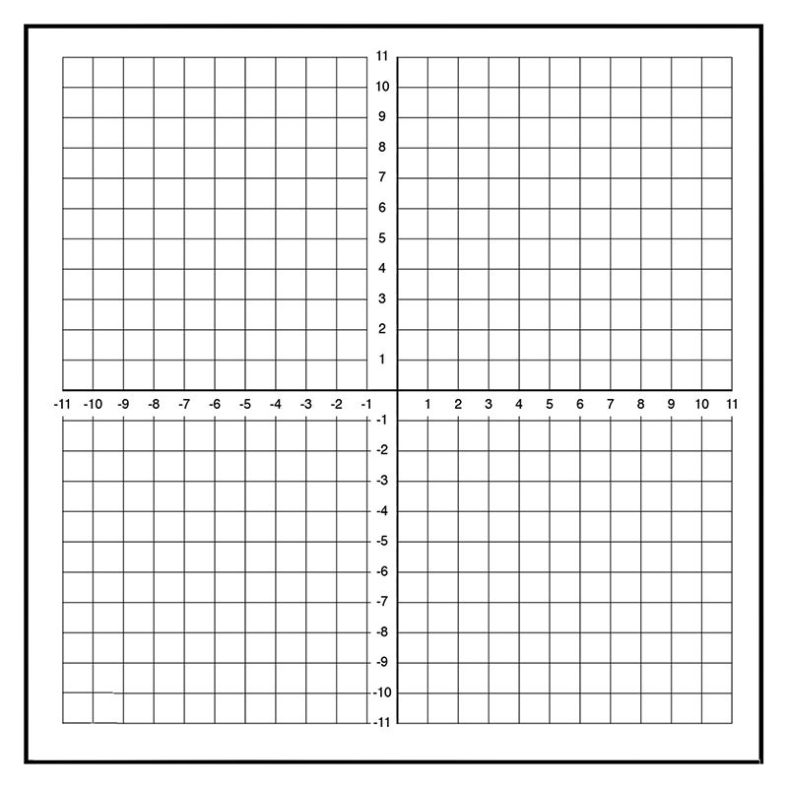
Sample points: (5, 7), (1, 1), (7, -3), (-3, -2), (-5, 5)

Step 2: Connect each of the five points creating triangles. Do not
cross any of the lines.

Step 3: With a ruler, find the midpoint of each side of each
triangle. (Red Points)

Step 4: With a ruler, draw a perpendicular bisector through each
of the midpoints. (Black segments)

Step 5: Draw a point at each of the circumcenters.
Step 6: Connect the circumcenters with segments. There
should be three line segments coming from each
circumcenter. The third line may not connect to
another circumcenter but may be drawn along one of
the perpendicular bisectors.
5. Discuss with a classmate what you have created. Give several
examples of what you think the singular point located in each
region you created represents.

Sample Answers: The points or seeds that you have created can represent school buildings, hospitals, airports, fire stations, etc., and how they are placed in certain locations around cities, towns, etc.

Move to page 1.9.

6. Now that you have created your own Voronoi Diagram, you will practice one last skill on the handheld before application. Follow the directions on page 1.9 to create a triangle using coordinates and the segment tool on page 1.10.

Answer: The goal here is for students to use coordinates on a graphs page to create a triangle, as this is where the application of Voronoi Diagrams begins to showcase.

Move to page 1.11

7. You have now created a triangle using 3 coordinates on page 1.10. Find the equation of each line that would pass through each side using the coordinates you selected. Write your equations in the form ax + by + d = 0 where a, b, d ∈ ℤ.

Answer: There will be many possible answers to this questions. Students must find the slope between any of the two points they selected and then find the equation of this line. An example would be between points (2, 1) and (4, 5). Using the slope formula m = (y₂ – y₁) / (x₂ – x₁), to get a slope of 2. Then students will plug this into either slope intercept or point slope form to find an equation, such as (y – 1) = 2(x – 2) and then converting this to standard form of 2x – y – 3 = 0.

TI-Nspire Navigator Opportunity: Quick Poll (Multiple Choice or Open Response)
See Note 1 at the end of this lesson.
Teacher Tip: Students may question why they need to write their answers in standard form. Please share with them that IB highly considers this form on the exam and it is quite common to see on a regular basis.

Move to Page 1.12.

8. This is another opportunity to enhance your handheld skills. Follow the directions on page 1.12 to learn how to create a more appealing diagram.

Answer: This is another situation where students can learn to clean up their graphs by adding color to the lines and shading within their polygon.

Extension

Move to Page 1.13.

9. Here is a chance to put all the steps together and create your own Voronoi Diagram on the handheld. Follow the instructions on page 1.13 to create your own diagram on page 1.14. Once finished, discuss with your class what the important features of the diagrams are and where you think they can be applied outside of the mathematics classroom.

Answer: In this extension, if time permits, let students make their Voronoi Diagrams look as colorful as possible. They may need some help with hiding the constructions to make it look clean.

Application

10. There are five hospitals, A, B, C, D, and E in the city. The coordinates of the hospitals are A(2, 3),
B(1, -1), C(5, 4), D(3, 1), and E(4, -2). In order for each hospital to accommodate an equal amount of the population, how should the city be divided into regions so that there is one hospital in each region and this hospital is centrally located for each region? Use the TI-Npsire CX II handheld or the graph paper on the next page to answer this problem.

Sample Answer:

11. If the city wants to add another hospital, would the location at point (6, 1) be a good choice? Why or why not?

Sample Answer: This question is meant to encourage discussion on why this point would or would not be a good choice. Students could talk about population sizes, where that population is spread in different regions, and why this region (or others) may be better.
Teacher Tip: The question might come up about how and where to extend the regions, so this may look differently on each student’s work. Remind them that this would depend on the specific city/town/etc. and there is not one correct answer.

Tech Tip: When shading the different regions, have the students shade the center region immediately after they have created that polygon before creating the outer regions. If they create all of the polygons and try to shade the center, only the outer regions are recognized.

Tech Tip: Through this activity, care needs to be given with how you create the Voronoi Diagrams on the IPad app. As was mentioned before, they look beautiful on the app, but it may be a challenge using one’s finger compared to a cursor, so accuracy might come into play. Take your time and it will pay off.

Wrap Up
Upon completion of the discussion, the teacher should ensure that students are able to understand:
- How to create a Voronoi Diagram.
- How to apply a Voronoi Diagram to the real world.
- How to interpret a Voronoi Diagram and all of its important features.

TI-Nspire Navigator
Note 1
Name of Feature: Quick Poll
A Quick Poll can be given at several points during this lesson. It can be useful to save the results and show a Class Analysis.

A sample question:
Since we have revisited the idea of a circumcenter, give a brief description of one of the following:
(a) Incenter
(b) Orthocenter
(c) Centroid

**Note: This activity has been developed independently by Texas Instruments and aligned with the IB Mathematics curriculum, but is not endorsed by IB™. IB is a registered trademark owned by the International Baccalaureate Organization.

