Open the TI-Nspire document Properties_of_Special_Quadrilaterals.tns.

In this activity, you will explore properties of some special quadrilaterals. In one part, you will use segments to build a quadrilateral. In another part, you will explore angle relationships. You will use your experiences to help make observations about the sides and angles in these special quadrilaterals.

Move to page 1.2.  Press / e to move the cursor to the bottom portion of the screen. | Press / ¢ and / ¡ to navigate through the lesson.
1. Drag point a in the bottom portion of the screen to change the value of a, and describe what happens in the top portion of the screen.

2. Drag point b in the bottom portion of the screen to change the value of b, and describe what happens in the top portion of the screen.

Press / e to move the cursor to the top portion of the screen.

3. a. Move the segments to form a quadrilateral by following the steps:

- Pairs of segments can be moved by dragging the x found at their point of intersection (common endpoint).  - The angle between the connecting segments can be changed by dragging an endpoint that looks like this: •.  - Final placement of segments can only be end-to-end.  - Move the segments and change the angle to get as close as you can to form a quadrilateral. Then press ∧ to connect.  - The goal is to have all four segments connected to one another to form a closed figure. |  | 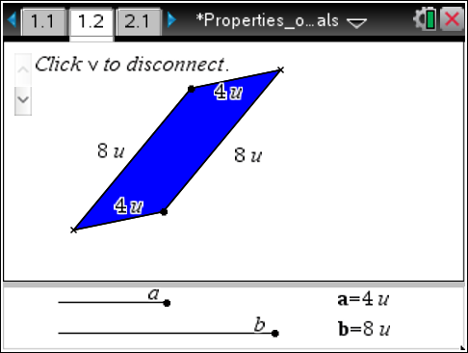
b. Sketch your results on the screen at the right.
4. a. Use the point of intersection x to drag and change the quadrilateral. Sketch your new quadrilateral.

b. Compare and contrast your quadrilaterals in questions 3 and 4.

Similarities | Differences

5. In questions 1–4, you determined the lengths of the pairs of segments and then made a quadrilateral. Press / e to move to the bottom portion of the screen. Change the values of a and b, and observe the changes in the quadrilateral. Describe what happens to the quadrilateral as the values of a and b are changed.

Move to page 2.1.

6. Change the lengths in the bottom portion of the screen so that a = b. Press / e to move to the top of the screen and move the segments to form a quadrilateral. Sketch your results. What types of quadrilaterals can be made when all four segments are equal?

Move to page 3.1.  7. A special quadrilateral has been constructed that includes angle measurements.  a. Drag a vertex other than S and record angle measurements in the chart at the right. Make a conjecture about the relationship of consecutive angles ∠P and ∠Q.
  ∠P | ∠Q
b. To display the measurements of the other two angles, press ∧ on the screen. Then drag a vertex. Make a conjecture about the measures of opposite angles ∠P and ∠R.

Move to page 4.1.

8. Find a quadrilateral that has been constructed using the intersection points of two pairs of parallel lines. Drag vertex A, B, or C. Observe the lengths of the sides.
a. What seems to be true about opposite sides of quadrilateral ABCD? To display the measurements of the other two sides, press ∧ on the screen. Make a conjecture about
opposite sides.

b. Press ∧ on the screen to display angle measurements. Explain why consecutive angles ∠BAD and ∠ADC are supplementary.

c. Explain why opposite angles ∠BAD and ∠DCB are congruent.

9. The quadrilaterals you have been exploring on all the pages of this activity are parallelograms.
a. Why do you think they are called parallelograms?

b. Renata says that in a parallelogram, the opposite sides are always parallel and congruent. Jerome says that in a parallelogram, each pair of consecutive angles is supplementary and opposite angles are congruent. Who is correct? Renata? Jerome? Both? Neither? Explain your reasoning.

