Problem 1 – Relating log functions with different bases
Execute the DIFFBASE program. Press  and choose it from the list. Press .  Choose SeeGraphs from the menu. This program displays the graphs of two logarithmic functions with different bases.  Y1(x) = log_{a}x and Y2(x) = log_{b}x  You can determine a and b by examining points on each curve. This is a picture file, not an actual graph, so you cannot use the Trace feature, but you can move the cursor along the curve yourself to approximate the coordinates of points on each curve.  - What are a and b?  - What points on the graph are the best clues to the base of the logarithmic functions? |  | 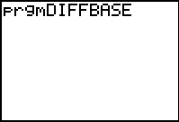  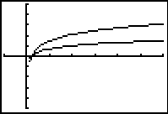
Once you think you know you a and b, run the DIFFBASE program again and choose GuessBases from the menu. Enter the values of a and b that you found.  The program graphs two logarithmic functions with bases you entered as thick lines on top of the original graph. If you choose a and b correctly, your graph will look like the one shown.  If you see more than 2 curves on your graph, try different values for a and b. |  | 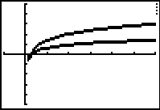
Suppose we were interested in the sum of these functions,
.
How can we write this as a single logarithmic expression?
- We cannot apply the properties of logarithms unless the bases are the same.
- We need to rewrite the functions with the same base.
- We want to find a function that is equal to Y1, but involves logarithms base b instead logarithms base a.
We could hope that there is a constant c that relates the two functions, like:  . | Then we would have  which is a logarithmic function with base b.
We cannot be sure there is such a constant, but that doesn’t have to stop us from looking for one.
Run the DIFFBASE program again and choose GraphC from the menu. The program calculates and stores the result in Y3.  Examine the graph of Y3 and then view the Y3 function table. What is c? |  | 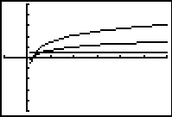
Problem 2 – A closer look at c
Is c always the same? Run the DIFFBASE program and choose CalculateC from the menu. Given a and b, the program calculates c and displays the value. Try two different values of a and b. What is c now?  Continue to choose CalculateC from the menu to experiment with different values of a and b. As you try different values, the program record the results in the Lists. (Values of a are stored in L1, b values in L2, and c values in L3.)  Be sure to try some powers of a and b such that one is a power of the other, like 2 and 8 or 9 and 3. |  | 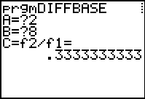
After you have tried at least 10 different values for a and b, exit the program and view the data in the lists. (Press  .) Can you guess a formula for c?  Hint: Try calculating 1/c in L4. |  | 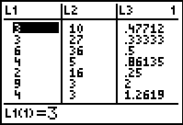
We are convinced now that there is a constant that relates to and that the constant depends on the values of a and b. We may even have an idea how to calculate the constant c given a and b.
Time to use some algebra to find out for sure.
Two functions are equal if and only if their values are equal for every x-value in their domain. Let’s pick a generic point (x, y) on the graph of Y1. For this (x, y), .
If we can write y in terms of logarithms base b, we will have our function.
- Rewrite as an exponential expression.

- We want an expression with base b logarithms, so take log_{b} of both sides.

- Simplify using the properties of logarithms.

- Solve for y.

This is the relationship! You should have found that
.
You have found a formula for changing the base of a logarithm. To change a logarithm base a to a logarithm base b, simply divide the expression by .
  - Use this formula to find if and

