All Systems Go!  ID: 10127 | Time required  45 minutes

Activity Overview
Students will learn about inverse matrices in the context of encoding/decoding secret messages and then use inverse matrices to solve systems of equations.

Topic: Linear Algebra: Vectors & Matrices
- Compute the product of any pair of matrices.
- Compute the inverse of a square non-singular matrix.
- Solve a linear system of n equations in n variables by computing the inverse of the coefficient matrix.

Teacher Preparation and Notes
  - This investigation illustrates to students that (some) matrix multiplications can be “undone” by multiplying by an inverse matrix. Such inverse matrices can also be used to solve systems of equations.
- Prior to beginning this activity, review with students how to organize information into matrices. Students should also be familiar with multiplying matrices in TI-84 graphing calculators.
- This activity does not teach students the process used to set up and/or multiply matrices; rather it explains how to find the inverse matrix of an invertible 2×2 matrix and provides several examples of the types of problems that can be solved using inverse matrices. Students should already know how to multiply matrices by hand.
- To download the student worksheet, go to education.ti.com/exchange and enter “10127” in the quick search box.

Associated Materials
- PrecalcWeek30_AllSystemsGo_worksheet_TI84.doc

Suggested Related Activities
To download any activity listed, go to education.ti.com/exchange and enter the number in the quick search box.
- How Many Solutions? (TI-84 Plus family) — 9283
- Solving Linear Systems by Graphing, Substitution, or Elimination (TI-84 Plus family with TI-Navigator) — 6425
- Reduce It! (TI-84 Plus family) — 10235

Problem 1 – A secret message
This problem introduces students to the concept of an inverse matrix by having them explore using matrices to encode and decode secret messages.
Students are given the definition of the inverse of a 2 × 2 matrix, and they are asked to find the inverse of the encoding matrix.
Multiplying the encoding matrix by the decoding matrix should result in the identity matrix, since they are inverses. Be sure that students understand that this is true regardless of the order in which the inverse matrices are multiplied. | 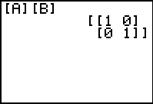
Finally, students are asked to use the decoding matrix on the encoded message to check that they are able to retrieve the original message.  They will need to create a 3 × 2 matrix, [C], with the values of the message. | 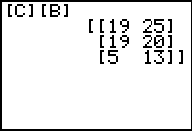
Problem 2 – Solving systems of equations
This problem helps students use inverse matrices to solve a system of equations. When students are translating the system to a matrix equation, be sure that they include all appropriate negative signs in the coefficient and/or constant matrices. You might also want to provide students with several examples of systems with “missing terms” that will translate into 0s in a coefficient matrix.
Students will multiply the inverse of the coefficient matrix by the constant matrix to obtain the solution. | 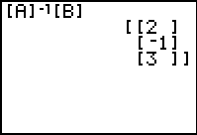
Be sure that students check their solutions. It is here that any errors in translating the system to a matrix equation will be revealed. | 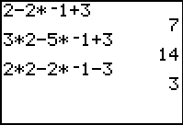
Problem 3 – Finding the equation of a parabola
This final problem asks students to find the equation of the parabola that passes through three specific points. The student worksheet provides steps that will guide students through how to use systems and matrices to solve the problem.
You may wish to perform the first substitution as an example for students. Substituting the first point
(–1, 5) into the quadratic equation y = ax² + bx + c yields 5 = a(–1)² + b(–1) + c, which simplifies to
a – b + c = 5.
The other equations follow, and result in the system and matrix equation shown to the right.
Students can confirm the solution (a = 4, b = –6, and c = –5) by substituting the coordinates and verifying the equation holds.  They can also confirm the solution by graphing the equation in Y1 and the coordinates in Plot1 to see if it indeed passes through the three points. | 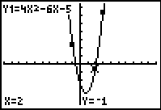

Solutions – Student Worksheet Exercises
1. The inverse of the encoding matrix is , so , which translates to I_LIKE_TI_NSPIRE.
2. Writing the system as a matrix equation gives .
Solving for the variable matrix yields a solution of x = 2, y = –3, and z = –4.
3. Writing as a system of equations: | Writing as a matrix equation:
Solving for the variable matrix, the solution is a = 2, b = –3 and c = –2,
which substituted into the equation for a parabola yields .

