Recursive Sequences  ID: 10987 | Time required  15 minutes

Activity Overview
In this activity, students will use the sequence mode of the graphing calculator to generate recursive sequences and then examine the values. They will also write recursive sequence formulas for given sequences.

Topic: Recursive Sequences
- Recursive formulas
- Initial term
- Recurrence relation

Teacher Preparation and Notes
- Teacher should practice writing sequences using the sequence mode of the graphing calculator.
- To download the student worksheet, go to education.ti.com/exchange and enter “10987” in the quick search box.

Associated Materials
- Alg2Week02_RecursiveSeq_worksheet_TI-84.doc

Suggested Related Activities
To download any activity listed, go to education.ti.com/exchange and enter the number in the quick search box.
- Arithmetic Sequences & Series — 8642
- Geometric Sequences & Series — 8674
- Spreading Doom — 10074

Introduction
The introduction to recursive sequences on the worksheet gives the students the definition, explains the parts of the formula, and shows an example.
Students are to write a verbal explanation of the example sequence and then determine the 2nd and 3rd term of the sequence by hand.
Problem 1 – Generating recursive sequences
Directions are given on the worksheet for students to change their calculator to sequence mode. SEQ should be highlighted in the Mode menu (M) during this activity. Also, make sure that they have turned off all plots.  Students will use the ! screen to enter the sequences.  nMin is the starting term (this should remain 1)  u(n) is the the recursive equation  u(nMin) the initial value  If the students are having trouble entering their recursive formula, remind them that:  Press x to enter n.  Press `7 to enter u. | 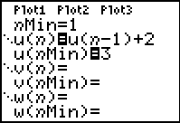  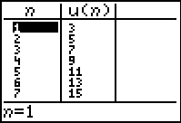
Once the students have entered their recursive sequence, they can view the generated terms in a table by pressing `%. The sequence generated from the first example appears to the right.
Students are given word descriptions for two more sequences. They are to determine the formula and the first 10 terms. The screenshots below show the correct input for the sequences.
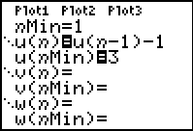 | 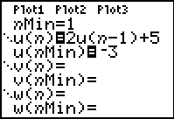
Problem 2 – Writing a recursive formula
For this problem, two sequences are given in a table. Students should determine a recursive formula for each sequence and record their responses on the worksheet.
Students can check to see if their formula is correct using the graphing calculator.
Solutions – student worksheet
Introduction
- Each term is two more than the previous term.
- 2nd term: 3 + 2 = 5; 3rd term: 5 + 2 = 7
Problem 1
- 3, 5, 7, 9, 11, 13, 15, 17, 19, 21
Formula | First 10 Terms
a₁ = 3  a_{n} = a_{n – 1} – 1 | 3, 2, 1, 0, –1, –2, –3, –4, –5, –6

Formula | First 10 Terms
a₁ = –3  a_{n} = 2*a_{n – 1} + 5 | –3, –1, 3, 11, 27, 59, 123, 251, 507, 1019

Problem 2
Sequence 1 | Sequence 2
–2, –3.5, –5, –6.5, –8, –9.5 | 0, 3, –6, 21, –60, 183
Formula | Formula
a₁ = –2  a_{n} = a_{n – 1} – 1.5 | a₁ = 0  a_{n} = –3*a_{n – 1} + 3
- Sample answer: The initial value is the first number given. Since the terms for Sequence 1 are decreasing at a constant rate, I determined that 1.5 was being subtracted from the previous term. Since the terms for Sequence 2 were not changing at a constant rate, I determined that the previous term was being multiplied by a number and then another number was added or subtracted, in this case the previous term was multiplied by –3 and then 3 was added.

