Domain & Range  ID: 11307 | Time Required  15 minutes

Activity Overview
In this activity, a variety of mathematical functions and real world applications of functions are explored to help students learn the concepts of domain and range, as well as how the context of a problem impacts domain and range. Five additional problems are provided on the corresponding student worksheet for use as further exploration or homework problems.

Topic: Functions & Their Representations
- Domain & Range
- Realistic Problem Situations

Teacher Preparation and Notes
- Students need to turn off all plots and clear all functions from the Y= screen.
- To download the student worksheet, go to http://education.ti.com/exchange and enter “11307” in the quick search box.

Associated Materials
- DomainRange_Student.doc

Suggested Related Activities
To download any activity listed, go to education.ti.com/exchange and enter the number in the quick search box.
- Domain and Range of Graphs (TI-Navigator) — 4676
- Domain and Range (TI-84 Plus) — 1564
- Algebra Nomograph (TI-Nspire technology) — 8266
- Advanced Algebra Nomograph (TI-84 Plus) — 8720

Before determining the domain and range of the problems given in the activity, students need to be able to explain what domain and range mean in their own words. Brief definitions are given on the worksheet.
Problem 1 – Sunflower Growth
The worksheet describes the growth a sunflower that can be modeled by a logistic function. Students are to graph this function. They will need to determine an appropriate viewing window (the first quadrant).  From the graph and keeping the context of the problem in mind, students are to determine the domain and range.  - domain: t ≥ 0  - range: 10.4 ≤ h(t) < 260  For several graphs in this activity, it may be helpful for students to use the table of values, obtained by pressing  . Students may also change the table set up using features available by pressing  .  Ask students how they could use the graph to help verify predictions regarding the maximum height for the sunflowers. (Students can graph a horizontal line Y₂ = 260.)  Similarly ask students how they can use the graph or a table of values to find the height of the sunflower plants at the start of the study (t = 0). They may either use the value command ( ), or they may go to the table and find the value of Y₁ when x =0.)  - These sunflowers reach a maximum height of about 260 cm. Growth is rapid early and levels off over time. The sunflowers were not planted as seeds for this analysis. | 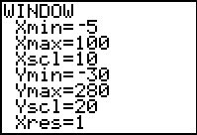  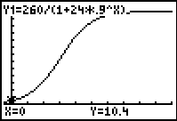  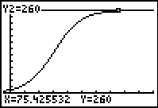  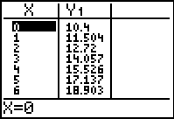

Problem 2 – Wind Turbine Power
This problem explores a cubic function involving the power output of a wind turbine based on wind speed. Students graph the function, determine the domain and range, and again interpret the graph based on values that are reasonable for the problem situation.  - You must restrict the domain and range because it doesn’t make sense to have negative wind speeds, or to have negative power. Negative power values would imply that the wind turbines would draw power out of the electrical grid.  - Domain: w ≥ 0; range: P ≥ 0 | 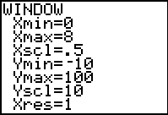  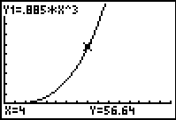
Problem 3 – Bald Eagle Population
This problem similarly involves the exponential growth of a population of bald eagles.  - Domain: t ≥ 0; Range: f(t) ≥ 5.9  Students may argue that 6 is a better choice than 5.9, since a whole number of eagles makes more sense. | 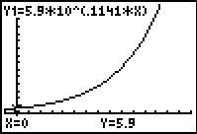
Additional Problems
Five additional problems are provided that may either be used as examples for further exploration in the classroom, or for homework. These problems include sine, logarithmic, quadratic, square root functions, and a real-world light intensity function.  For the light intensity problem on the worksheet, it would be beneficial to take time to evaluate and discuss the graph as a class. What is going on with the values of d to the left and | 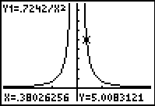
right of d = 0? What do we call the line d = 0 when this happens?
Student Worksheet Solutions – Additional Problems
1. domain: all real numbers; range: f(x) ≥ –3
2. domain: all real values, x > 5; range: all real values, f(x) > 0
3. domain: all real numbers; range: –1 ≤ f(x) ≤ 1
4. domain: x > 0; range: all real numbers
5. domain: all real numbers, d ≠ 0; range: I > 0
6. The value d = 0 makes the function undefined.
7. The graph does not have a corresponding value for I at d = 0; there’s a gap at this value.

