Introduction
As you walk, your distance from a starting point with respect to time can be plotted. Factors such as how fast you move can affect how the plot will look. What effect does walking faster or slower have on the appearance of the distance-time graph of your walk?
Objectives  - In this activity you will use a CBR2 to make a plot of your distance versus time.  - Observe the effect that the speed at which you walk has on your motion plot.  You'll Need  - TI 84 Plus CE, with Vernier EasyData™ App  - CBR 2™ motion sensor unit with mini-USB connecting cable |  | 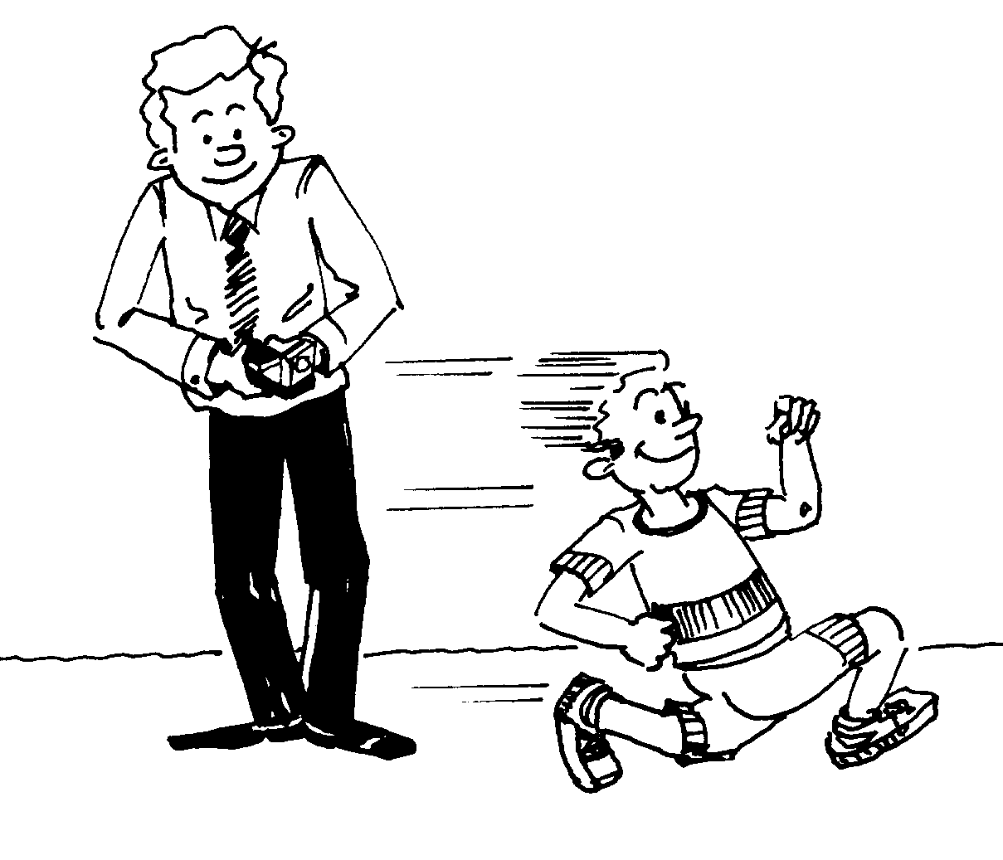
Using the CBR 2™ motion sensor and EasyData™ App  1. Connect the handheld with the CBR 2 using the USB cable. EasyData will immediately open, and the CBR 2 will begin collecting distance data every time it clicks. In the EasyData app, the tabs at the bottom indicate the menus that can be accessed by pressing the actual calculator keys directly below the tabs. To go to File to select New, press o. To change the Setup, press q. To Start, press q. To see the Graph, press r. To Quit the app, press s. |  | 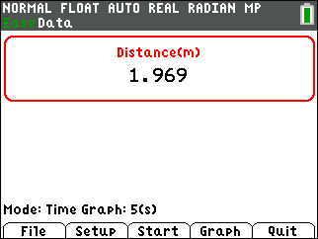  
2. To change the amount of time the CBR 2 collects data for each trial, press p to change the and select Time Graph. |  | 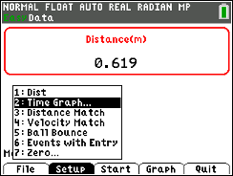
3. the settings by pressing q and enter the values shown or the ones provided by your teacher. When the changes are done, press s to the settings.  You will be walking two distance time graphs. After each graph is displayed, if you are not satisfied with your graph, press s to go back to 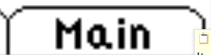. When you Start, you will get a warning message, “The selected function will overwrite the latest run.” As soon as you select , the CBR 2 will immediately start collecting data. |  | 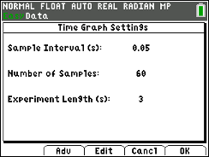
Trial 1  4. Start your walk at about 0.15 meters (6 inches) from the CBR 2. Prepare to walk directly away from the CBR 2 at a very slow but steady speed. Taking small baby steps should produce the correct results. Once data collection begins, move in this manner for approximately 3 seconds.  If you are satisfied with your graph, before making a sketch rescale your graph by pressing r to change the 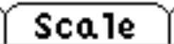 to the scaling shown or as directed by your teacher. |  | 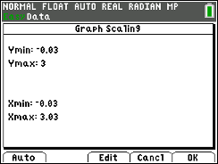
Now sketch your plot to the right. |  | 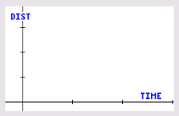
Trial 2
5. Start your second walk at about 0.15 meters (6 inches) from the CBR 2. Prepare to walk directly away from the CBR 2 at a medium pace (faster than Trial 1) but a steady speed. Once data collection begins, move in this manner for approximately 3 seconds. If you are satisfied with your graph, before making a sketch rescale your graph by pressing r to change the to the scaling shown.

Now sketch your plot to the right.

Looking at the Results
1. Which trial had the steeper line? (Be specific using words like “time” and “distance” in your response to describe both lines.)

2. In general, what effect does your speed or rate have on the distance-time graph?

3. Describe in writing what the plot would look like if you started 0.15 meter (6 inches) away from the CBR 2, walked very slowly away from the CBR 2 for about 3 seconds, and then began walking quickly for another 3 seconds.

4. On the axes on the left sketch the distance-time graph that would result from the walk in #3. Walk according to the description in #3 and record your walk in the axes on the right. Increase the number of samples from 60 to 120 so that you will collect data for 6 seconds.
Description of #3  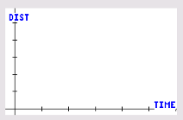 | The walk for #3
5. How well did your plot match the graph of the description? Discuss the reasons for any differences.

Going Further

1. How would your results have differed in Trials 1 and 2 if you had begun 3 meters from the CBR 2 and had been approaching rather than walking away from the CBR 2? Try another sample if you are not sure.

2. What do you think the plot would look like if you simply stood still?

3. Make a sketch of how the plot would look if you kept changing speeds from slow to fast every couple of seconds. Then try it.

