You Can’t Get There From Here  ID: 12097 | Time Required  40–45 minutes

Activity Overview
In this activity, students will explore rational functions graphically and algebraically to identify singularities and asymptotes, both vertical and horizontal.

Topic: Asymptotes
- Singularities
- Vertical Asymptotes
- Horizontal Asymptotes

Teacher Preparation and Notes
- Problems 1 and 2 should be done as in-class exploration and guided practice. Consider having students work in small groups, which may be particularly helpful for Problems 3 and 4. Problems 3 and 4 may be done as small group work or homework. Additional problems are provided on the student worksheet for further practice.
- To download the student worksheet, go to education.ti.com/exchange and enter “12097” in the keyword search box.

Associated Materials
- YouCantGetThereFromHere_Student.doc

Suggested Related Activities
To download any activity listed, go to education.ti.com/exchange and enter the number in the keyword search box.
- Rational Functions (TI-84 Plus family) — 8967
- Asymptotes & Zeros (TI-84 Plus family) — 9301

Problem 1 – The Basics
Problem 1 involves an exploration of asymptotes involving graphing, exploring a table of values, and algebraic manipulation. Students will use a variety of tools to identify the x-value(s) at which the function is undefined..  First, a graphic representation is explored. From the graph, students can get reasonable approximations of the x-value(s) at which f(x) is undefined. |  |  |  | 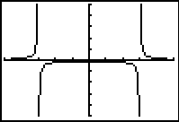
If using MathPrintTM OS:  When entering the function in Y1, students can use the fraction template. To do this, they should press  , and choose 1:n/d. They then enter the numerator, press , and enter the denominator. Note, if students press , the cursor will move to the exponent. Students should enter the value of the exponent and then press  to move out of the exponent. |  |  |  |  | 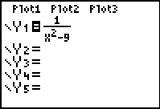
Ask students how they can be certain of the values of x for which the function is undefined. What tools are provided on the graphing screen to help with this?  Students might suggest tracing the graph to obtain valuesof ordered pairs.  Next, students view a table of values and will observe how undefined function values are represented in the table. |  |  |  | 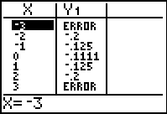
Problem 2 – Exploration
Students explore what was learned in Problem 1 to develop an understanding of the patterns involved with asymptotes and rational functions. This part provides a great opportunity for students working in pairs or small groups to develop a deeper understanding of what was learned in Part 1.
Problem 2 focuses on understanding the singularities and vertical asymptote placement and the effect of the degree of the numerator and denominator in identifying horizontal and vertical asymptotes.
To change the values of A, B, and C, students can press the up and down arrows to select the correct variable and then use the left and right arrows to change the value of that variable. Students can also change the value of a highlighted variable by typing the new value and pressing e. |  |  |  | 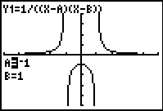
Point out to students that a horizontal asymptote may cross a function graph at the middle, but as x → ±∞, the function graph approaches the horizontal asymptote.  If students’ graphs do not look like those to the right, then have them double check their window settings. Remind them that Xres should be 1. |  |  |  | 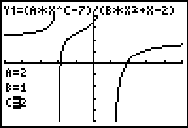
Problem 3 – Practice
Students apply what was learned in Problems 1 and 2 to finding singularities and asymptotes for the function |  |  |  | 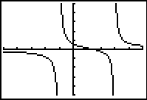
Problem 4 – The Next Level
Students again apply what has been learned, but the challenge level increases. In this situation, function is represented in two different ways, one of which helps to illustrate the vertical shift of a simpler graph.  You may wish to have students graph and compare it to the second function given. |  |  |  |  | 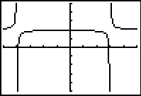
Student Solutions
1. No; for certain values of x, the function is undefined.
2. The table displays ERROR for the x-values at which the function is undefined
3. ±3
4. (x – 3)(x + 3)
5. The factors match the “skipped” x-values. (x – 3) matches the skipped value of x = 3, (x + 3) matches the “skipped” value of x = –3.
6. These values make the denominator equal to zero, causing the function to be undefined at these values of x.
7. Yes, y = 0
8. at x = a and x = b
9. Horizontal asymptotes may be present whenever the degree of the numerator is less than or equal to the degree of the denominator.
10. y = A/B, or at y = (ratio of leading coefficient of numerator to leading coefficient of denominator)
11. y = 0
12. a. Singularity: an x-value that makes the denominator of a rational function equal to zero. At that x-value, the function is undefined
b. Asymptote: an “invisible line” which the graph of a function approaches, getting closer and closer
13. 4(x – 3)(x + 1); the function is undefined at x = 3 and at x = –1.
14. Yes; y = 0
15.
16. (x – 3)(x + 4)
17. –4, 3
18. Yes, y = 2
19. The +2 at the end indicates that the function was shifted up two units. Without the +2, the horizontal asymptote would be at y = 0. The ratio of the coefficients of the leading terms of the numerator and denominator is 2/1, and the degrees of numerator and denominator are equal, so y = 2 is the horizontal asymptote.
20. | 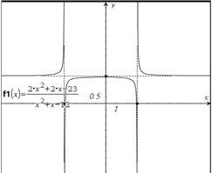 |  | 21. ±4 x = –4, x = 4 y = 0  22. –2 x = –2 y = 0  23. –4,2 x = –4, x = 2 none  24. –6,4 x = –6, x = 4 y = 2

