Part 1 – Comparing Ratios
In this problem set, you will compare ratios with different denominators. Use the <, >, and = signs under the ô menu ( ). Identify which is the better deal.
1. Boxes of Cereal:  Box 1: $3.50 for 24 ounces  Box 2: $2.40 for 16 ounces  Answer: __________ | Enter each ratio as a fraction and insert one of the comparisons between. In this example, press a ∏ e 3 . 5 0 ► 2 4 ► then ` ô and choose the <, >, or =, and then a ∏ e 2 . 4 0 ► 1 6. Press . The resulting 1 means the statement is true. A 0 result would mean the statement is false.  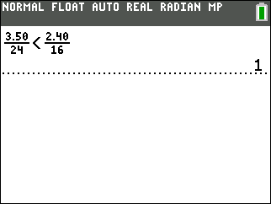
2. Containers of Juice:  Jug 1: $2.99 for 18 ounces  Jug 2: $4.29 for 64 ounces  Answer: __________ | 3. Tortillas:  Package 1: $1.99 for 15 tortillas  Package 2: $2.49 for 20 tortillas  Answer: __________
Part 2 – Writing Equivalent Ratios
In Problems 4–6, you will rewrite equivalent ratios to have comparisons with the same denominators. Write the equivalent ratio for each and then compare. Identify which is the better deal.
4. Boxes of Cereal:  Box 1: $3.50 for 24 ounces = _______  Box 2: $2.40 for 16 ounces = _______  Answer: __________ | Find an equivalent ratio using the LCM for each of the ratios. This shows confirmation that you have found an equivalent ratio.  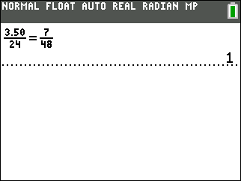
5. Ears of corn:  Option 1: $1.50 for 3 ears = _______  Option 2: $2.00 for 8 ears = _______  Answer: __________ | 6. Chips:  Bag 1: $2.90 for 18 ounces = _______  Bag 2: $4.00 for 36 ounces = _______  Answer: __________
7. When would you likely use equivalent ratios to find common denominators?

Part 3 – Writing Unit Rates
Find the unit rate for each item using division. Then identify which option is a better deal.
8. Cheese:  Bag 1: $2.89 for 15 ounces = _______  Bag 2: $3.29 for 19 ounces = _______  Answer: __________ | 9. Canned Tomatoes:  Can 1: $0.89 for 13 ounces = _______  Can 2: $1.99 for 29 ounces = _______  Answer: __________
10. Movie Passes:  Sale 1: $28 for 3 tickets = _______  Sale 2: $40 for 5 tickets = _______  Answer: __________ | 11. Socks:  Bag 1: $8.99 for 5 pair = _______  Bag 2: $17.29 for 9 pair = _______  Answer: __________
12. When would you prefer to use unit rates instead of finding like denominators to compare prices?

