Introduction
In this activity, you will measure the mass and volume of several collections of a coin type, enter the data into your TI-84 Plus CE and explore for patterns. You will discover the density value embedded in the data. |  | 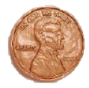
Objectives
- Make a plot of Mass vs. Volume.
- Look at the ratio of mass to volume.
- Create a mathematical model that demonstrates the relationship between mass and volume.
You’ll Need
- TI-84 Plus CE
- At least 28 coins of the domination you are assigned (0.01, 0.05, 0.10, 0.25)
Note: If you did pennies they should be all pre 1982 or post 1982.
- Massing device up to 200 grams
- Meter stick or millimeter ruler
- Optional: 100 ml graduated cylinders with H2O to measure volume by displacement

Entering the Data
- Before entering data in the lists, clear any existing data from the lists.

- Before entering data in the lists, clear any existing data from the lists. Press y L. Highlight 4:ClrAllLists, and then press Í.  This takes you to the Home screen, and you will see 4:ClrAllLists with a blinking cursor following it. Press Í, and the TI-84 Plus CE displays Done. Your lists are now cleared. | 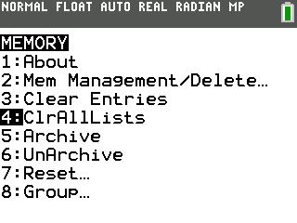
- Press …. Press Í to choose 1:Edit.Make three lists on your TI-84 Plus CE. | 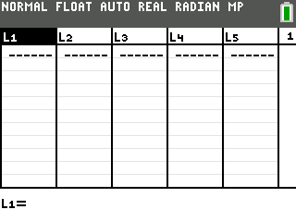
- Enter your lists COINS, VOL, and MASS. Get into alpha-lock mode by pressing y7, key in the letters for the names. Press Í and then move over to the next column and repeat the process. | 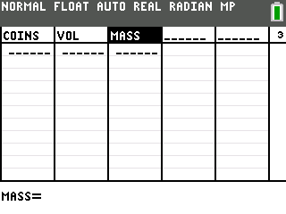
- Measure 7, 14, 21, and 28 coins at a minimum. Move into the list for COINS and enter these numbers. If you have more than 28 coins, keep adding the sets of 7 until you are finished.

- Determine the volume of your coins by measuring the diameter of one of your coins. Then make a stack of 7 coins to make a cylinder. Measure its height. Now calculate the volume using the following formula:
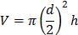
where d is the diameter in cm, h is the height in cm, and V is the volume in cubic centimeters.
Optional: Get the volume of the stacks of 7 coins by displacement. To do this, after you mass them, put 50 ml of water in a graduated cylinder and then drop the 7 coins in. Record the new water level and subtract to get the number of milliliters of water the coins occupy. This is the volume in cubic centimeters.

- To get the volume we will go to the Solver. Press » } Íto get to there. Press ‘ to remove the old equation. Note: Each line/variable will need a value on it if you have an old equation so you can’t clear out values and then move off of the variable line. Key in the formula as shown. | 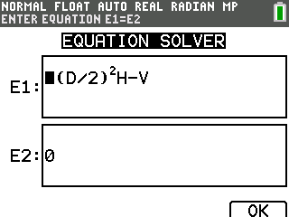
- We will enter our values for D (diameter of the coin) and H (height of your stack) and then we will solve for V. To solve for volume, you will need to put the cursor on the V= line. Key in a guess and then press ƒ Í to get the answer. Notice the bullet that indicates you have the answer. Enter this volume in your lists. You probably want to round off the answer. In this case the volume would be 4.28 cm³. Change the value for the height (H) and repeat the process. Remember that the diameter (D) stays the same. Try to guess each time. | 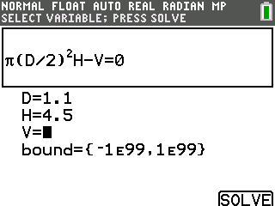
- Now place your coins on the massing device and get the mass of 7 coins. Then add 7 more coins and get the mass for 14 coins, then add 7 each time to get the mass for 21 coins and 28 coins. If you have additional sets of 7 coins, collect those masses as well. Record the mass in grams. | 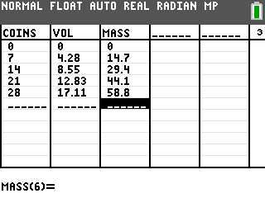
- Do you see a relationship between the numbers? A pattern? What do you think the mass of one coin is? The volume of one coin? How about 1 dollar? | 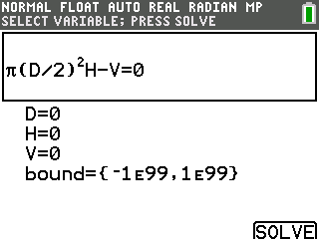  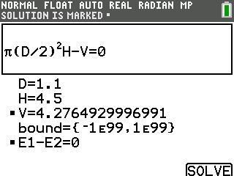
- To help determine the pattern in another way we will need to set up a plot. Press y , Í and set up the plot as shown. Recall that you can access the list names by pressing y 9. | 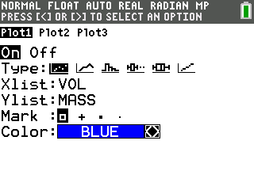
- Now check to see if you have any equations or plots on. Press o and turn off or clear your equations and see you only have Plot1 on.  - Set the Window with ZoomStat. Press q ® and explore the graph with r |~. | 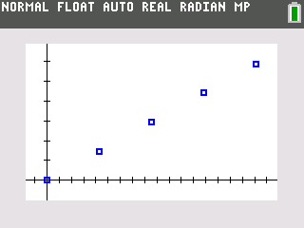
- We want to guess the equation that fits the data. Press o and start with Y1=1*X. Move to the left of the Y1 and press Í until you get it. Press s and see how close you are. If you didn’t hit it, keep trying. Recall that y 6 to insert rather than overstrike. | 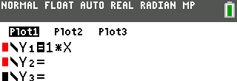  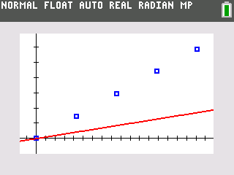
- This number, the one in front of the X, is the slope. The slope is the ratio of the change in Y and the change in X. In this situation that is the change in mass divided by the change in volume, or grams per cubic centimeters. This is the Density! | 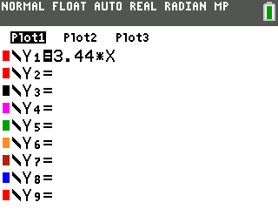
- Check on the Internet or with your teacher to get the true density for your coin. The U.S. Mint would be a good place to look. To compare your answer with the actual density we can do a percent error. To get a better value for the density of your coin we can have the computer do the calculation. Return to the List Editor and make a new list named DENSE. Use the techniques used earlier. Press … À to get to the lists. | 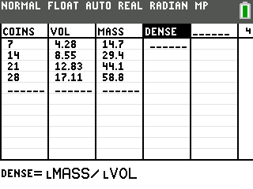
- In the header of this new list we will divide the mass by the volume. The zeros must be removed. To do this move to the place where the zero is and press { then move to the next one until you have removed all the zeros.
- Now go to the header of the DENSE list and we will enter the formula MASS/VOL. Get the list names from the list of lists –y 9. Once you have the formula in press Í.
In this case, the solution is x ≤ –4 or x ≥ 12.
- These numbers should vary so we want to get the average. Do you see that these densities are close to the value you used in the Y= area?

- To get the mean of a list go to the Home Screen and clean up. Press y 5 ‘.  - To get the command for mean press y 9 | Â. | 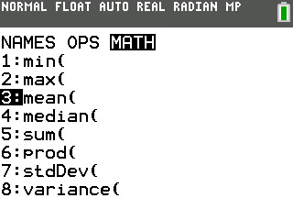
- Now we are ready to do a percent error. The formula is:  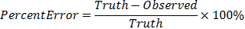  Key this in at the Home Screen using the value you picked for Y= as the Observed and the Truth will be what they report is the density of your type of coin. This should be less than 10%. In the sample it is 1.74%! | 