Open the TI-Nspire document Making_Multiples.tns.  Before you begin this lesson, look around your classroom. Have you ever wondered how so many different physical characteristics could exist among your classmates? Hair color, eye color, height, just to name a few. And what about all those different fruits and vegetables in the grocery or farmers' market? How are all of these varieties produced? |  |  | 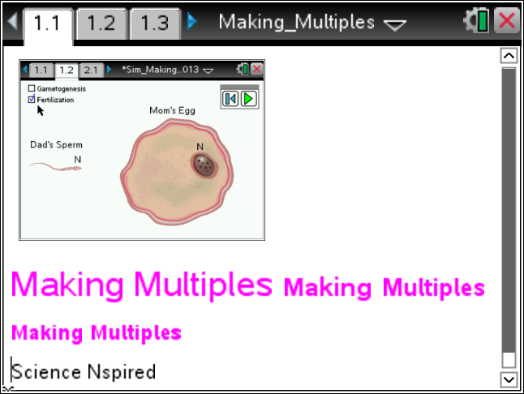
 | Move to page 1.2 - 1.3. Read the background information for this activity.
In this activity, you will explore two types of reproduction: asexual and sexual. As you run the simulations, pay attention to
1) where the process begins
2) what happens during the process
3) the end result of the process

Then, start thinking about how the offspring from one process differs from the other.

 | Move to page 1.4.
 | 1. After reading the instructions on page 1.4, close the directions box by selecting .  2. This simulation shows the process of sexual reproduction. Be sure to observe both Gametogenesis and Fertilization by selecting each title box then selecting the play button.  Note: The quantity “2n” represents the total number of chromosomes in each cell initially. Pay attention to how the number of chromosomes changes throughout the simulation. | 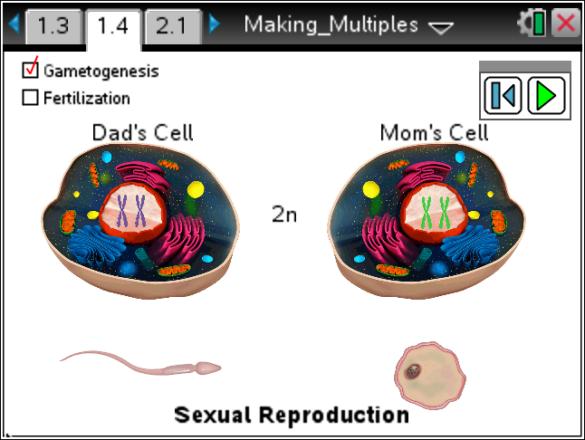
 | Tech Tip: To access the Directions again, select > Directions.
Tech Tip: To access the Directions again, select b or Document Tools () > Sexual Reproduction > Directions.
 | Move to page 2.1.
 | 1. After reading the instructions on page 2.1, close the directions box by selecting .  2. This simulation shows the process of asexual reproduction. Be sure to observe both DNA Replication and Cell Growth as well as DNA Migration and Cell Division by selecting each title box and then select the play button.  Note: Compare this process to the processes shown on 1.4. | 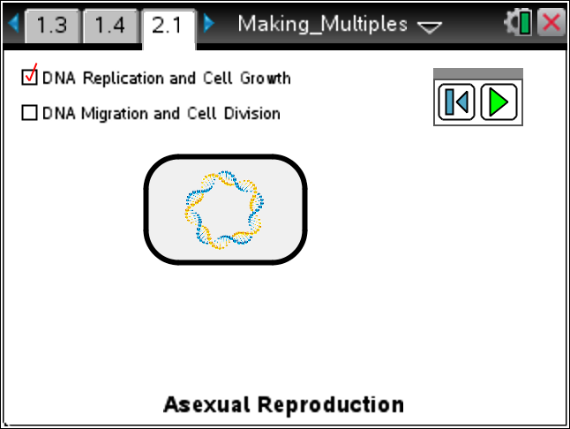
After observing both simulations on page 1.4 and 2.1, move to Page 2.2 – 2.7. Answer the questions below and/or in your .tns file.

Q1. Which type of reproduction produced an exact copy of the parent cell?

A. asexual
B. sexual

Q2. Which type of fertilization requires gametes (sperm and egg?)

A. asexual
B. sexual

Q3. In which type of reproduction does each parent contribute half of the genes acquired at random by the offspring?

- asexual
- sexual

Q4. Genes are passed down to offspring on chromosomes. The diploid (2n) number of chromosomes for human body cells is 46. What is the haploid (n) number for sperm and egg cells?

- 92
- 23

Q5. Bacteria reproduce asexually. Which advantages does this give them? Check all that apply.
- reproduce quicker
B. produce variation
C. require less energy
D. require just one parent
E. require gametes

Q6. Asexual reproduction produces clones, which are exact copies of the parent. Why could this sometimes be a disadvantage?

