Problem 1 – Tossing a coin
When you toss a coin, there are two possible outcomes. The sample space, or set of all possible outcomes, is heads or tails, {H, T}.
In this activity, we will use the calculator to simulate the tossing of a coin many times. The command randInt() that randomly generates integers.
You can choose any two integers. We will use randInt(0,1), letting 0 represent a tail and 1 represent a head.
On the Home screen, "toss a coin" 5 times by entering randint(0,1) and then pressing enter 5 times.  Note: randInt can be entering by pressing , arrow to the PRB menu and select the command.  - How many heads did you get? |  | 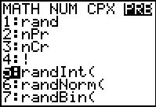
- Now, enter randInt(0,1,5). What happens? What would you need to type to toss the coin 10 times?

On the Home screen, simulate the tossing of a coin and find the number of heads by entering sum(randint(0,1,# of trials)).  Repeat this for each number of tosses listed in the second column. Press   to recall the last entry.  Record your results in the table.  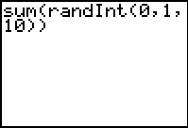
  Heads | Tosses | Percent  (=L1/L2)
   | 5
   | 10
   | 20
   | 30
   | 40
   | 50
   | 75
   | 100
   | 200
   | 300
   | 400
   | 500
   | 900
Press  . Enter the number of heads in list L1 and the number of tosses in list L2.  To calculate the percent of heads for each trial, move to the top of list L3 and enter L1/L2. |  | 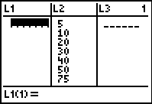
Now create a connected scatter plot of percent heads (L3) versus tosses (L2). Press   and select Plot1. Match the settings to those shown at the right.  Press  and select ZoomStat to view the plot. |  | 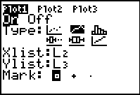
- Sketch your connected scatter plot of percent heads versus tosses. |  | 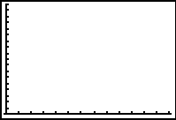
- What do you notice about the shape of the graph? Why do you think this happens?

- What can you conclude about the percent of getting heads as the number of trials increases?

Problem 2 – Rolling a die
You will now use the randInt() function to simulate the rolling of a six-sided die.
- How many possible outcomes are there? What is the sample space?

On the Home screen, simulate the rolling of a die by entering randint(1,6,# of trials)→L1. Then sort list L1 in ascending order by entering SortA(L1).  Note: Press  and select the command to sort.  Press   and arrow up twice. To determine the number of 6s in the list, subtract the row number of the first 6 from row number of the last 6 and then add 1. For example, if the first 6 is at L1(16) and the last 6 is at L1(20), it is 20 – 16 + 1 = 5.  Repeat these steps for each number of rolls listed in the second column. Press     to recall the second previous entry.  Record your results in the table.  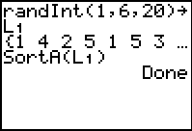
  Heads | Rolls | Percent  (=L1/L2)
   | 5
   | 10
   | 20
   | 30
   | 40
   | 50
   | 75
   | 100
   | 200
   | 300
   | 400
   | 500
   | 900
Clear list L1 (arrow to the top of L1 and press  ) and enter the data in the table into lists L1 and L2. Calculate the percent of 6s in list L3.
Then create a scatter plot of the percent of 6s versus rolls.
- Sketch your connected scatter plot.

- What can you conclude about the percent of rolling a 6 as the number of trials increases?

Extension – Rolling Two Dice
Use what you have learned in the previous problems to simulate rolling two dice and finding the sum. Record the number of sums that are 7.  - Sketch your connected scatter plot.  - What can you conclude about the percent of rolling a sum of 7 as the number of trials increases?
  Sum of 7 | Rolls | Percent  (=L1/L2)
   | 5
   | 10
   | 20
   | 30
   | 40
   | 50
   | 75
   | 100
   | 200
   | 300
   | 400
   | 500
   | 900

