Problem 1 – The Parabola
Examine the data in L₁ and L₂ to the right. Let L₁ be the x-value and L₂ be the y-values for a graph.  - How are the x and y-values related? What pattern do you see?  To enter the data press S e. In list L₁ enter –2,  –1, –0.5, 0, ½, 1, 2. Press a ! for [F1] to use the fraction template. Press the right arrow key so your cursor is on L₂ and type L₁². Press ` 1 for [L1]. Now that the data is entered press ` ! for å and set up Plot1 as shown to the right. Press # and select ZDecimal.  Enter the parent function y = x² into Y₁. Press %. This curve is called a parabola. |  |  | 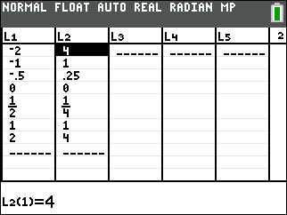  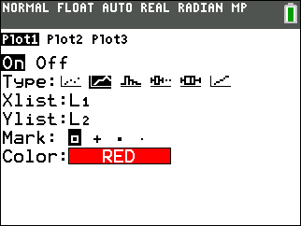
- Describe the shape of the graph of the function
We will now explore how the value of A affects the graph of the parabola y = Ax².  Press A. Choose Transfrm for the Transformation Graphing app. Press !, and a [A] to enter AX² in Y₁. |  |  | 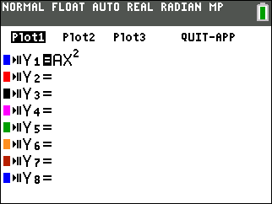
- Press %. Use the left and right arrows to explore different values of A.
  - What is the value of A that makes the equation the parent function?

  - Describe what happens to the graph when A is greater than 1.

  - What happens to the graph when A is a negative number? Explain.

  - What happens to the graph when A = 0? Explain.

  - Type in various values for A that are between 0 and 1, like ¼ and ½. Describe the shape.
- In Y₁ enter A(x – B)². Press @ : to display the Settings Screen which defines the starting values and the step size. Use A = 1, B = 0, and Step = 1. |  |  | 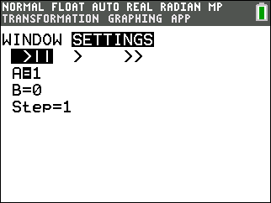
Press %. Press ; to highlight B.  Press > or < or enter a value for B to help you answer these questions.  - What happens when B is positive? When B is negative?  - Describe the changes in the graph as B increases. What happens when B decreases? |  |  | 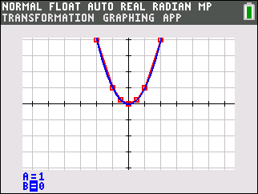
- In Y₁ enter A(x – B)² + C. Press @ : to display the Settings Screen and assign A = 1 and B = 0. Press %. Press ; to highlight C. What happens as you press > to increase the value of C? |  |  | 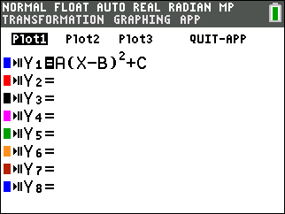
- Change B and C so that the vertex of the parabola is at (4, – 3).
  - Write your equation.
  - The formula of a parabola can be written as y = a(x – h)² + k. Why is this called vertex form? What affect does a, h, and k have on the graph? Relate the parameters a, h, and k to the parameters you explored.

To quit the Transformation Graphing App, press A ,  select Transfrm, and select Quit Transfrm Graphing. |  |  | 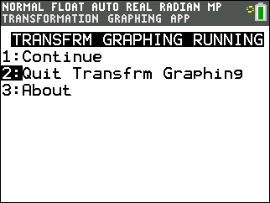
If using a TI-84 Plus C, you can use the shortcut on the Y= menu. Press ! , press : to select Plot 1, and press e to turn it off. |  |  | 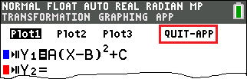
- Before graphing it, describe y = ¼ (x – 0)² – 3. Then confirm your prediction by entering it in Y₁.

From ! arrow up and press e on Plot1 to turn it off.
- Draw a line parallel to the x-axis that intersects the parabola in question 7 twice. Experiment with different equations in Y2 until you find such a line. Record the equation in the first row of the table.
Line | Left intersection | Distance from  left intersection  to y-axis |  | Right intersection | Distance from  right intersection  to y-axis
y = | ( , ) |  |  | ( , )
y = | ( , ) |  |  | ( , )
y = | ( , ) |  |  | ( , )

Use the grid to find the coordinates of the two points where the line intersects the parabola. Record them in the table.  Choose a new line parallel to the x-axis and find the coordinates of its intersection with the parabola. Repeat several times, recording the results in the table.  - Examine the table and make observations. | 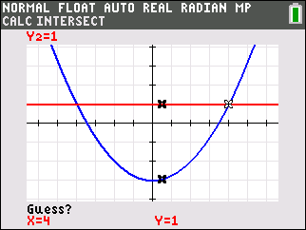
  - What do you notice about the points in the table? How do their x-coordinates compare? How do their y-coordinates compare?

  - Calculate the distance from each intersection point to the y-axis. What do you notices about the distances from each intersection point to the y-axis?

  - The relationships you see exist because the graph is symmetric and the y-axis is the axis of symmetry. What is the equation of the axis of symmetry?

- How do you think the axis of symmetry will change if h is changed from 0 to 4? Change the value of h in the equation in Y1 from 0 to 4 Graph y = (x – 4)² – 3.
As before, enter an equation in Y2 to draw a line parallel to the x-axis that passes through the parabola twice. Find the two intersection points.
Left intersection: ( ___, ___ ) Right intersection: (___. ___) Midpoint: ( ___. ___ )
The axis of symmetry runs through the midpoint of these two points. Find the coordintes of the midpoint.  To draw this vertical line press ` õ while on the graph and choose the Vertical command. This vertical line is the axis of symmetry.  - a. What is the equation for the axis of symmetry?  b. From the general equation y = a(x – h)² + k, what is the general equation of the axis of symmetry? |  | 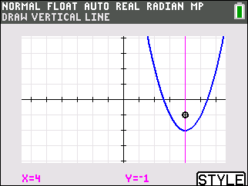

Sketch the graph of each function. Then check your graphs with your calculator. (You may need to adjust your viewing window.)
12. | 13. | 14.
- Galileo drops a cannonball out of a tower window 32 feet off the ground. The height h (in feet) of the cannonball at time t (in seconds) is given by h = – 16t² + 32. Graph the parabola in the grid below. Note that the vertical tick marks are every 8 and the horizontal tick marks are 1. From your graph, estimate how long will it take for the cannonball to hit the ground. Confirm using algebra.

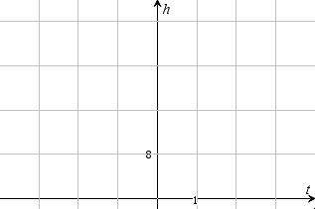

Problem 2 – Standard form
The standard form of a parabola is y = ax² + bx + c. Let’s see how the standard form relates to the vertex form.
Using algebra we can see that the b in the general equation for the parabola written in standard form is related to the h in the following way.
- For the standard form of a parabola y = ax² + bx + c, what is the x-coordinate of the vertex? Give your answer in terms of the constants from the standard form.

- The equation y = 2x² – 4 is in standard form. Graph this equation in Y₁. Press #, select ZDecimal.  - What is the value of a? Of b? Of c?  a = ____, b = ____, c = ____  - What is the x-coordinate of the vertex?  x = ____ |  |  | 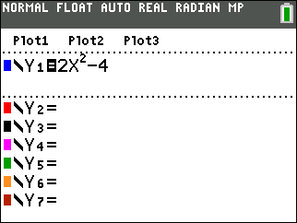
18. Use the minimum command to find the vertex of the parabola.
vertex: ( ____, ____ )
How do you think changing the coefficient of x² might affect the parabola?  Turn on the Transformation Graphing app and enter the equation for the standard form of a parabola in Y1. |  |  | 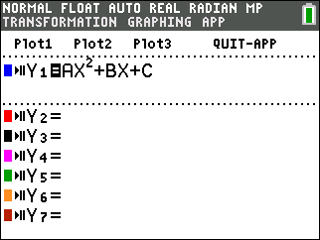
Try different values of A in the equation. Make sure to test values of A that are between –1 and 1.  You can also adjust the size of the increase and decrease when you use the right and left arrows. Press @ and arrow over to Settings. Then change the value of the step to 0.1 or another value less than 1.  19. Does the value of a change the position of the vertex? |  |  | 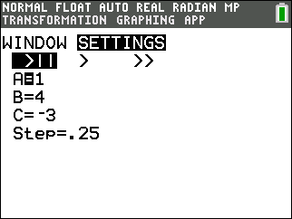
20. How does the value of a relate to the shape of the parabola?

Find the y-intercept of the parabola. Use the value command (` è) to find the value of the equation at x = 0. Change the values of a, b, and/or c and find the y-intercept. Repeat several times and record the results in the table below.
Equation | A | B |  | C | y-intercept
y = 2x² – 4 | 2 | 0 |  | –4 | –4

21. How does the equation of the parabola in standard form relate to the y-intercept of the parabola?
Sketch the graph of each function. Then check your graphs with your calculator. (Turn off Transformation Graphing first. You may need to adjust your viewing window.)
22.  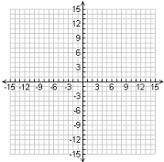 | 23. | 24.

