In this activity, you will explore:  - graphing an ellipse using a Cartesian equation  - finding the parametric equations for an ellipse  - modeling the orbit of Jupiter | 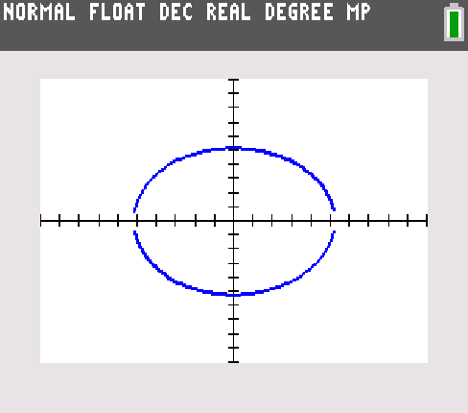
Problem 1 – A Cartesian Model
Building the Cartesian Model
Draw a picture of the orbit of Jupiter below. Use the axes as a guide. Label the aphelion and perihelion.
aphelion = 5.455 A.U. perihelion = 4.952 A.U.
Sun

x

y

- What are the coordinates of the point representing the sun?

- The sun is one focus of the ellipse. Draw the other. What are its coordinates?

- What is the value of a (the semimajor axis) for this ellipse? (Hint: what is 2a?)

- Plot one of the points where the ellipse intersects the y-axis (x = 0). Label it P. Draw line segments P to each of the foci. These line segments have length a. Explain why.

- Use the Pythagorean Theorem to solve for b, the distance from the origin to point P.
- Solve the general equation for an ellipse centered at (0, 0), , for y.

- Now that we have an equation in terms of y =, we are ready to graph the orbit of Jupiter. Actually, we will need to graph two equations. Explain why.

Evaluating the Cartesian Model
- Describe the graph of the two curves. Is it an ellipse?

- Describe the way a point on the curves moves. Does it look like Jupiter’s orbit? Explain why or why not.

- List some of the shortcomings of this model.

Problem 2 – A Parametric Model
Exploring Coordinate Equations
Use the graph of the Cartesian model to answer the following questions.
Imagine that Jupiter starts at its perihelion, at the rightmost point on the ellipse, then moves counterclockwise around its orbit.
- Complete the description of how the horizontal distance between Jupiter and the center of its orbit (represented by the origin) changes as Jupiter orbits the sun:
The distance starts out at the maximum, a = 5.2035, decreases to 0,
increases to a again,
_____________________________________________________________________,
_____________________________________________________________________,
and then this pattern repeats as Jupiter orbits the sun again.
- Describe how the vertical distance between Jupiter and the center of its orbit changes as Jupiter orbits the sun.
About t
Use the program EXPLPARA to explore the ellipse further. Enter values for a and b. View the data you collect.
- How does t change as you move counterclockwise around the ellipse, starting at the rightmost point?
Plot of x-values vs. t-values
- What is the shape of the graph?
- What are the maximum and minimum values? Where have you seen these numbers before?
- Write a function for this data. Graph it in Y3 to check.
Plot of y-values vs. t-values
- What is the shape of the graph? What function does it show?
- What are the maximum and minimum values? Where have you seen these numbers before?
- Write a function for this data. Graph it in Y3 to check.
Checking the coordinate equations
These two functions are the coordinate equations of the ellipse. They are usually written:
x(t) = a cos(t)
y(t) = b sin(t)
If you are not convinced, run the EXPLPARA program again and choose different values of a and b.
- Substitute these equations into the general equation for an ellipse centered at (0, 0), , to check.

- Write the coordinate equations for Jupiter’s orbit by substituting the values for a and b.
x(t) = _________________
y(t) = _________________
A better model of Jupiter’s orbit
Enter the coordinate equations for Jupiter’s orbit in X1(T) and Y1(T). Graph them as an animated point on the curve.

