Shark Attack  ID: 11847 | Time required  20 minutes

Activity Overview
In this activity, students will see and practice with the basic form of the equation
y = m(x – x₁) + y₁. Lists are used to assist students in separating what effect each change in the equation has on the graph. Data is introduced in two separate problems where students will calculate the slope and write their own Point-Slope form of an equation using those two data points. Then, the students will use the Trace feature to make predictions based on their own equation that models the data.

Topic: Rational Functions & Equations
- Recognizing Point-Slope form of a linear equation
- Identifying the slope and/or the ordered pair that is used in an equation
- Writing an equation in Point-Slope form when given two ordered pairs (data points).

Teacher Preparation and Notes
- Students must have experience in calculating slope from two points. Students must also recognize the notation for an ordered pair with subscripts: (x₁, y₁)
- The $ feature is useful for tracing along either data points or a function graph. When the students access this tool, however, it may first trace along the data points. The student must toggle to tracing along the line itself by pressing the up or down arrow, and then move along the graph with the right or left arrow.
- To download the student worksheet, go to education.ti.com/exchange and enter “11847” in the keyword search box.

Associated Materials
- SharkAttack_Student.doc

Suggested Related Activities
To download any activity listed, go to education.ti.com/exchange and enter the number in the keyword search box.
- Linear Equations Jeopardy (TI-84 Plus family) — 8326
- Linear Functions and Slope (TI-84 Plus family) — 9031
- Points & Slopes & Lines—Oh My! (TI-84 Plus family) — 8891

Problem 1 – Point-Slope Form of the Equation
Students will become familiar with the equation, and what m means and how the ordered pair (x₁, y₁) appears in the equation. You may need to discuss the subscripts on the ordered pair, and also the two different forms of the equation. (How did the y₁ term get to the other side?)
Discuss with students why it is important to learn another form of a linear equation, anticipating the question, “Can’t we just use y = mx +b every time?”
Students will use the Transformation Graphing application to investigate the point-slope form of an equation. You should guide them to change the values of m, x₁ and y₁ one variable at a time so they can investigate the differences in the graph. | 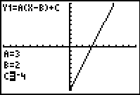
They will then answer the questions on the worksheet to assess their understanding. After completing this problem, students will need to press  and select Transfrm and then select Uninstall.
Problem 2 – Oh, Baby!
Students are given two points and need to find the equation that models the data. They can use the Home screen to calculate the slope. However, some students may be able to do this mentally.  Remind them about the phrase “average rate of change” and how it relates to slope here. | 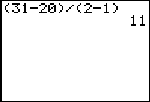
If using MathprintTM OS:  Students use the fraction template to calculate the slope. To do this, press   and select n/d. Enter the value of the numerator, press , and then enter the value of the denominator. Note that students do not need to use parentheses in either part of the fraction. | 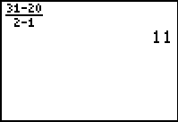
Students write their linear equation in the Point-Slope form. First, they will need to enter the data points in L1 and L2 (  and clear L1 and L2 if needed). They will then graph the scatter plot ( ) and the equation (□) they calculate on the same screen. | 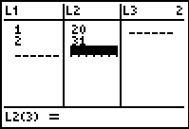
The ZoomStat command ( ) will display the graph appropriately. They are to use  to find other values along the line. The up arrow can be used to change between tracing the plot and the line.  To find an exact value while tracing, just enter the value. For age 1.5, enter   • . This is a way for students to make “predictions” based on their model without performing difficult algebraic calculations yet. It lends itself to some discussion about how this growth trend may continue or may change over the next year or few years. | 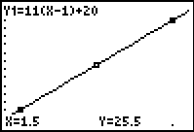
Problem 3- Shark Attack!
Again, data is given in context, along with a diagram of the fish to describe how the measurement is taken.  Students will follow the same process as in Problem 2. They are to calculate the slope and write an equation in point-slope form. Then they can graph the equation with the data points. | 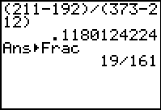
The “agree or disagree” question can lead into the discussion of direct variation and indirect variation, and perhaps even correlation. The students are led into the same type of questioning, about whether weight might relate somehow to length of a shark, and how. | 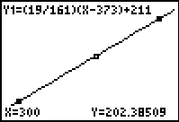
Extensions/Homework
- Take the equations from Problems 2 and 3 above and rewrite them, (on paper), in slope-intercept form. Explain the meaning of the y-intercept in the “Oh, Baby” problem. Explain the meaning of the y-intercept in the “Shark Attack” problem.
- Think of a measurement with regard to humans that would be related in a similar way,
(i.e., one number increases as the other number increases).
- Think of a relationship, (manmade or natural), that would be related in the opposite way
(i.e., one thing increases as the other decreases).

