Introduction
In this activity you will calculate the surface area of different shaped cell models, calculate the volume of different shaped cell models, understand the differences in cells, and their functions and sketch a picture demonstrating your understanding of cell function.
Take a look at your hand. Take a really close look at your hand. How many cells can you see? What do you mean you can’t see any cells? Why not? Apparently because they are too small for us to see. A typical human being has hundreds of trillions of cells in his or her body. Have you ever stopped to wonder why we have trillions of tiny cells, rather than having millions of bigger ones? This activity will help you understand why cells are usually very small.
Imagine that you have several cells in front of you. Some of the cells are spherical (round) and some are cubic (square). The sizes of the cells are given in the data table on the next page. Your job is to calculate the surface area and the volume of each cell, and then determine the ratio of the surface area to the volume of each.
In order to do this, you need to know the mathematical formulas for calculating the surface areas and the volumes of spheres and cubes. (These formulas will be provided for you later in this activity.)
Objectives
In this activity you will:
- calculate the surface area of different shaped cell models.
- calculate the volume of different shaped cell models.
- understand the differences in cells, and their functions.
- sketch a picture demonstrating your understanding of cell function.
You'll Need

- TI-84 Plus CE calculator

 | Spherical Cell Diameter  (in mm) | Cube-Shaped Cell Edge Length  (in mm)
 | 1 | 1
 | 2 | 2
 | 3 | 3
 | 4 | 4
 | 5 | 5
 | 6 | 6
 | 7 | 7
 | 8 | 8
 | 9 | 9
 | 10 | 10  Edge Length

Diameter

Entering the Data
1. Before entering data in the lists, clear any existing data from the lists.
a. Press y L.
b. Highlight 4:ClrAllLists, and then press Í.
c. This takes you to the Home screen, and you will see 4:ClrAllLists with a blinking cursor following it. Press Í, and the TI-84 Plus CE displays Done. Your lists are now cleared.
2. Press …. Press Í to choose 1:Edit.
3. Make sure you are in the first data line in L1, and enter the spherical cell diameter values from the data table above. Press either Í or † after you enter each number.
Think about how you will calculate the surface areas and volumes for the different sized cells you entered into L1.
The formula for calculating the surface area of a sphere is 4πr². The formula for calculating the volume of a sphere is 4/3πr³. You can use the lists on the TI-84 Plus CE to calculate these values for you. Before you do that, however, look at the data table again. What measurements are being shown? What measurement of the sphere do you need in order to calculate the surface area and the volume? How can you do this with the TI-84 Plus CE? Think about it, and then follow the instructions below.
4. Press } to go to the very top of L1. Be sure to highlight the heading L1, not just the first line in L1. Consider: How can you change these diameters to radii?
5. Press y d ¥ 2, and then press Í. L1 now contains the radii of each of the spherical cells.
6. From the data in L1, calculate the surface area and the volume of each cell.
a. Press ~ } to highlight L2.
b. Type in the formula for the surface area of a sphere using the data in L1. Press 4 y π y d › 2 Í.
c. What are the units of measure for the data in L2? Describe the trend in the data. ( B is above the › key.)

7. Press ~ } to highlight L3. Type in the formula for the volume of a sphere, again using the data in L1. Press 4 ¥y B y d › 3 Í.
a. What are the units of measure for the data in L3? Describe the trend in the data.

b. Compare this trend with the trend in the surface area data in L2.

8. Press ~ } to highlight L4. Type in the formula for the ratio between surface area and volume. Press y e ¥ y f Í.
Enter the data from your TI-84 Plus CE into the table below:
L1 (Radius) | L2 (Surface Area) | L3(Volume) | L4 (SA/V Ratio)

9. Now, you will make a graph comparing the volume of your cells with the surface area/volume ratio of those same cells.  a. Press y , to access the STAT PLOTS menu.  b. Press Í to select 1:Plot1. Set your TI-84 Plus CE as shown at the right.  10. Press p. Set your window as shown at the right. | 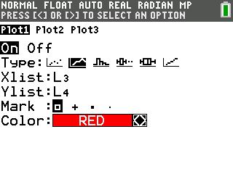  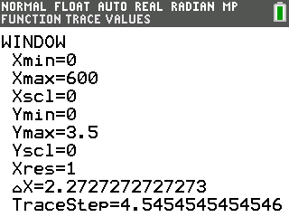
11. Press s.  Draw your graph here. Be sure to label the axes.  Graph Title: | 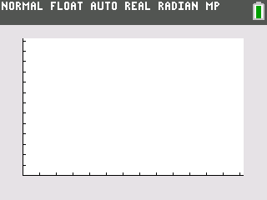
12. Press r and then press | and ~ to move the cursor from point to point on the graph. Make note of the trend you see in the data, because you will be answering questions about this graph later.
13. Clear the data from the TI-84 Plus CE lists. Press y L, choose 4:ClrAllLists, and then press Í. This clears the data from all of your lists.
14. Go back and look at the cube-shaped cells. Enter the edge length measurements in your TI-84 Plus CE.
a. Press …. Press Í to select 1:Edit.
b. In L1, enter the edge length data for the cube-shaped cells from the table.
15. Calculate the surface areas of the different sized cube-shaped cells. The surface area of a cube can be calculated by taking the area of one face of the cube (edge length x edge length, or length x width) and multiplying it by 6 (the number of sides in a cube).
a. Highlight L2. Be sure to highlight the heading L2, not just the first line in L2.
b. Press 6 ¯ y d ¡ and then press Í.
16. Calculate the volumes of the cells. The formula for determining the volume of a cube is length x width x height. In this case, you can simply take the edge length and raise it to the 3rd power.
a. Highlight L3.
b. Press y d ». Highlight 3:³ and then press Í Í.
17. Calculate the ratio of surface area to volume of the cubic cells.
a. Highlight L4.
b. Press y e ¥ y f and then press Í.
Enter your calculated data in the table here:
L1  (Edge Length) | L2 (Surface Area) | L3 (Volume)e) | L4 (SA/V Ratio)

- Describe the trend you see in the data in L4.

19. Press p. Set your TI-84 Plus CE as shown at the right.  20. Press s.  Draw your graph here. Be sure to label the axes.  Graph Title: |  | 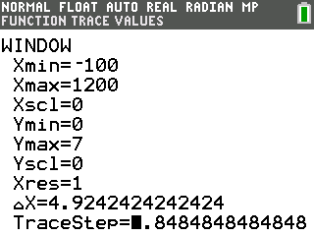
Looking at the Results
1. In the original data table provided, the cell measurements were given in units of millimeters.
- What would be the unit of measure for the calculated surface area values?

- What would be the unit of measure for the volumes?

- Why were spherical and cube-shaped cells used in this activity? What were these two shapes intended to model?

- Obviously, as the cells got larger, both the surface area and the volume increased. Describe the rates of increase of the surface area compared to the volume.

- Complete this statement: As the volume of the cell increased, the SA/V ratio _________and gets closer and closer ___________.
- The cell membrane is the regulatory passageway between the inside and the outside of the cell. A cell must take in materials such as oxygen and food, and must rid itself of waste products. According to your data, if a cell gets too large, what challenges might it face?

- What is one way that cells solve the problem of getting too large? Explain.

Going Further
- Surface area and volume are not only important factors to consider at the cellular level, but at the organism level, as well. Mammals that live in cold environments tend to have a round, thick shape with short, thick extremities. On the other hand, mammals that live in warmer environments are more likely to have thinner bodies with longer, thinner extremities. Explain why.

- In the space below, sketch a picture of an arctic fox and a desert fox, then explain why you drew them the way you did.

Arctic Fox Desert Fox

Explain.

