Your boss asks you to plan a retirement party for one of your co-workers. You are comparing the cost of a dinner party at different restaurants. Each restaurant charges a flat room fee (no matter how many guests attend) and a per plate fee.

Problem 1 – Linear Bistro
The table shows the costs of a party at Linear Bistro for different numbers of guests. Let’s investigate this data to determine the room fee and the per plate fee at Linear Bistro.  1. In your group, predict what the equation of the line would be. Show your work to find the slope of the line.
  Guests, G | Cost, C
  5 | $ 260
  10 | $ 370
  20 | $ 590
  25 | $ 700
  50 | $ 1250
Use technology to check your equation. First enter the data into L₁ and L₂ in your calculator, by pressing S Edit e | 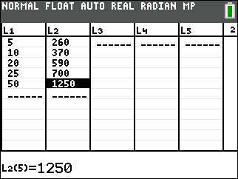
Press @, and adjust your settings as shown.  Press ` å and select Plot1 to make a scatter plot of the data from the chart.  With the TI-84 Plus C, you can press ` # to change the é settings and turn the GridLine on. | 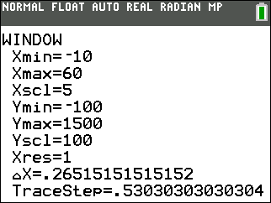
2. Look at the points. What do you notice?

3. In list L₃ calculate the change in x-values using DeltaList(L₁). Find this operation by pressing ` S for ò, select OPS, 7: ΔList(. Press ` 1 for L₁. In L₄ calculate the change in y-values using DeltaList(L₂). In L₅ calculate the ratio L₄/L₃. What do you notice? | 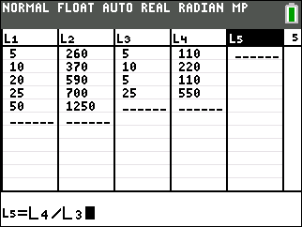
4. What are the units of the values in L5? (circle one)
A. dollars B. number of guests C. dollars per guest D. number of guests per dollar
5. What does your answer to the previous question tell you about the formula for the line?

6. a. How do the data points and the line shown to the right compare?  - What is the equation of this line? Enter the equation in Y₁.  - Use the Manual-Fit Y=mX+b command to draw a line through these data points. Press S CALC, Manual-Fit Y=mX+b and store your equation in Y₁. Use a ª to insert Y₁. Use the arrow keys to position a point on the screen, press e and repeat. Type in values for m and b, using your value for the slope in Question 3 and the scale on the y-axis to estimate the y-intercept. | 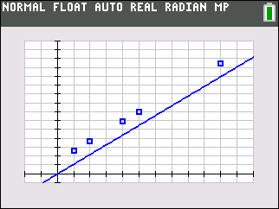  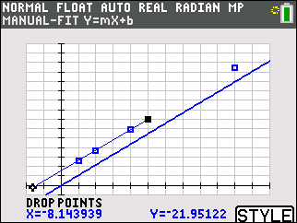
7. You have found that the formula for Linear Bistro can be written in the form y = mx + b.
a. What is the value of m?

- Substitute a point (x,y) from the table to solve for b.

- What is the formula for the linear model which gives the cost C for a dinner with G guests? Graph your equation in Y1 to check your answer.

- What is the room fee at Linear Bistro?

8. How can you find the y-intercept in a function table?

9. Determine the cost for 30 guests.

Problem 2 – Straight Eight’s Restaurant
Straight Eight’s Restaurant charges a $100 room fee and $32 per plate.
10. How much would a dinner party for 10 people cost at Straight Eight’s Restaurant?

11. Write an equation in the form y = mx + b that models the cost of a dinner party at Straight Eight’s Restaurant for x guests. Enter it in Y₂ and view its graph. (Remember to turn off your scatter plot and equation in Y₁ from Problem 1.)

View the function table and use it to check your equation. Is the y-intercept correct? Does the value at x = 10 match your answer to Question 11?

Problem 3 – First Degree Café
First Degree Café charges a whopping $800 for a party of 5 people. The cost per plate is only $10.
12. Write an equation in point-slope form, (y – y₁) = m(x – x₁), that models the cost of a dinner party at First Degree Café.

13. Write the equation in the form y = mx + b. Graph it in Y₃. (Remember to turn off your equation in Y_{2.} from Problem 2.)

14. View the function table. Explain how to use it to check your equation.

15. Your boss plans to pay for all of the expenses and asks you which of these three restaurants is the least expensive. At present, the number of guests is unknown. What should you tell your boss? Be as specific as possible.

