Distribution graphs
Sometimes, it is easier to understand the distribution of a probability by viewing its graph rather than the individual probabilities. In this activity, you will calculate probabilities and then graph their distributions.
Three Coin Flips
Simulate a scenario in which 3 coins are tossed using the Probability Sim App. Press A, choose Prob Sim, and then select Coin Toss. Press the ‘soft key’ # to set up the toss. Choose 3 coins and select OK. Select YES to agree to this set up and press @ to begin tossing. Select +50 to do many tosses at once and observe the pattern. | 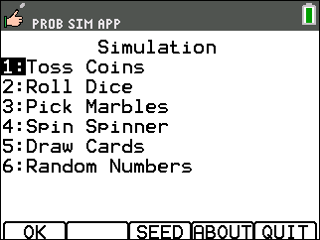

1. Suppose three coins are flipped. The possible outcomes are listed below. Calculate the probability of each possible outcome.
0 Heads | 1 Head | 2 Heads | 3 Heads
TTT | TTH | HHT | HHH
 | THT | HTH
 | HTT | THH

P(0 Heads) = ______ P(1 Head) = _______ P(2 Heads) = ________ P(3 Heads) = ________
P(less than two Heads) = ________ P(less than four Heads) = ________

To graph this distribution, enter the number of heads in L1 and the corresponding probability of obtaining that number of heads in L2. Access the lists by pressing S e. Clear a column of data by arrowing up to the top row. Then, press C. If you use a ∏ and choose n/d, you can enter the probability as a fraction. | 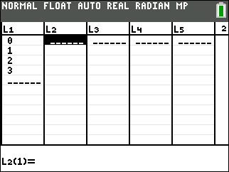
Once the data are entered, make a connected scatter plot of it by pressing ` å e. Change the settings as shown at the right. Then, press # and select ZoomStat to view the distribution. | 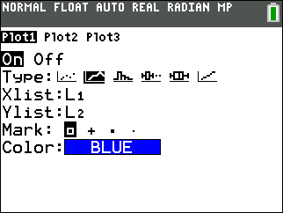
Six Coin Flips
Suppose six coins were flipped. Determine the possible outcomes for 3, 4, 5, and 6 heads. Then calculate the probabilities of each outcome listed below and graph the probability distributions.
0 Heads | 1 Head | 2 Heads | 3 Heads | 4 Heads | 5 Heads | 6 Heads
TTTTTT | HTTTTT | HHTTTT
 | THTTTT | HTHTTT
 | TTHTTT | HTTHTT
 | TTTHTT | HTTTHT
 | TTTTHT | HTTTTH
 | TTTTTH | THHTTT
 |  | THTHTT
 |  | THTTHT
 |  | THTTTH
 |  | TTHHTT
 |  | TTHTHT
 |  | TTHTTH
 |  | TTTHHT
 |  | TTTHTH
 |  | TTTTHH
2. Compute the probabilities:
P(0 Heads) = ______ P(1 Head) = ______ P(2 Heads) = ______ P(3 Heads) = ______
P(4 Heads) = ______ P(5 Heads) = ______ P(6 Heads) = ______

3. Two of the six coins are replaced by unfair coins. The unfair coins have both sides marked heads. Recalculate the possible outcomes and probabilities. How is the graph different? (Be sure to mention how the center and shape of the graph changes.)

Funny Dice - Two very unusual number cubes are rolled. They are both labeled 1, 1, 3, 3, 5, 5.
4. Find all the possible outcomes if the sums of the numbers rolled were computed.
Sum = 2 Sum = 4 Sum = 6 Sum = 8 Sum = 10

5. Find the following probabilities. Use an area model to help show the fractional probabilities:

P(2) = ______ P(4) = ______ P(6) = ______ P(8) = ______ P(10) = ______
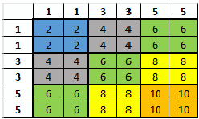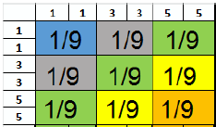

6. Display the probability distributions on the calculator. Sketch your graph below. Use the Prob Sim App to confirm.

