Problem 1 – Observe Motion
Two trains are leaving the same train station but on different tracks. Time is measured in hours and distance is measured in kilometers.
Run the program TRAINS and select option 1, OBSERVE MOTION.  This shows the trains leaving the train station (y-axis).  Train 1: top track  Train 2: bottom track | 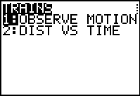
Press $ and use the arrow keys to help answer the following questions.
1. Write at least 2 complete sentences describing the motion. Compare train 1 to train 2.

2. When time = 0, what is the initial location of train 1? (include units) _________

3. What is the initial position of train 2? __________

4. Which train is traveling at a faster rate? ___________

5. What is the speed of the faster train? ___________

6. How far did the slower train go in 1 hour? __________

7. What is the rate of motion of the slower train? ___________

8. At what distance are the trains the same distance from the station? ___________

9. What time are the trains the same distance from the station? _____________

Problem 2 – Distance-Time Graph
Press ` M e. Select option 2, DIST VS TIME.  For this graph, the x-axis is time and the y-axis is distance.  Press $ and use the arrow keys to help answer the following questions. | 
10. Which train has the graph with a steeper slope? _________

11. What quantity does the slope represent? _________

12. What is the y-intercept of each graph?
a) y-intercept for train 1: ______________
b) y-intercept for train 2: ______________
13. What is the physical meaning of the y-intercept for this distance-time graph?

14. Write an equation for the graph of each train.

a) train 1: _____________________

b) train 2: _____________________

15. To algebraically solve for the time when the two trains are the same distance from the station, set the two equations equal to each other and solve for time. Substitute this time into either equation to find the distance. Show your work.

Extension: List of d = r ⋅ t Data
Clear all the lists. On the Home screen press ` +, select ClrAllLists, and press e.  Also turn off all Plots. Press ` !, select PlotsOff, and press e.  Press M and press e on G-T to display the graph and table side-by-side. | 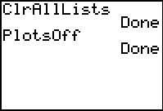
Set Plot1 to be a scatter plot by pressing `!e and match the screen to the right.  Press Window and change the settings to [–1, 6] for x and [–5, 50] for y. | 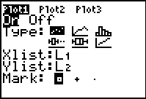
Now enter the following distance-time data into lists L1 and L2 by pressing S and selecting Edit…  L1: 0, 1, 2, 3, 4  L2: 0, 5, 10, 15, 20  Note: these distance are for a speed of 5 mi/hr. | 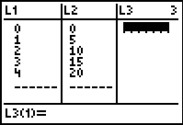
Observe the table of values and their scatter plot by pressing %.
16. When the rate is 5 mi/hr, what is the distance when the time is 5 hours? In other words, what should the next value be in L2?

Test this by entering 5 in L1 and your “guess” in L2. See if you are correct by pressing %.
To observe the changes other rates have on the resulting graph, in the List Editor move the cursor so that it is on top of L2 and enter L1∗3,.  Then view the graph to observe the resulting changes.  Enter as well as other values for the rate. | 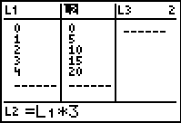
17. When r increases: Describe the slope. What happens to the distance?

When r decreases: Describe the slope. What happens to the distance?

