Problem 1 – Finding Zeros Graphically
A polynomial of the form f(x) = a_{n}xⁿ +...+ a₁x + a₀ is called an nth degree polynomial.
The values of x when 0 = a_{n}xⁿ +...+ a₁x + a₀ are called the zeros roots of the polynomial.
Goal: Graphically, find the zeros of the function f(x) = x³ – 3x² – x + 3.
Graph this polynomial by pressing □, entering the equation. Then press  and select ZStandard. |  |  | 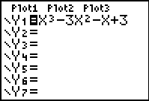
Calculate the zero appearing to pass through the point (–1, 0) by pressing   and selecting zero.  Now, use the arrow keys to move the cursor to  - the left of the zero and press ,  - the right of the zero and press ,  - the guess of the zeros location and press . |  |  | 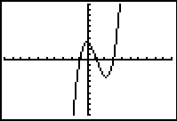
Repeat this procedure for the other zeros appearing on the graph as well as the other functions in the table below.
Function | Zeros

1. Make a conjecture about the number of real zeros of a polynomial in relation to the degree of the polynomial.

2. A fourth degree polynomial has four zeros:
Always | Sometimes |  |  | Never
3. A polynomial can have more zeros than the highest degree of the function.
True |  | False
4. What is the greatest number of zeros possible for the function ?

5. Determine the number of real zeros for ?

6. What are the real zeros of ?

Problem 2 – Rational Root Theorem
If f(x) = a_{n}xⁿ +...+ a₁x + a₀ has integer coefficients, then every rational zero of f(x) has the following form: , where p is a factor of the constant term a₀ and q is a factor of the leading coefficient a_{n}.
Goal: Use the Rational Root Theorem to find the zeros of the polynomial .
To use your graphing calculator for this, following the steps outlined below.  Enter this polynomial into the graphing calculator by pressing □ and entering the function | 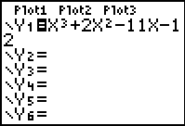
Set the table function to ask you for each x-value by pressing   and matching the screen to the right. | 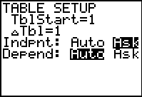
Now, press   and enter each of the ±(p/q) values into the table. The rational roots will result in y-values of 0. | 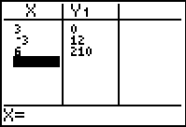
For each polynomial given, use the Rational Root Theorem to list the possible rational zeros. When you have the possible zeros, use the calculator to determine which values are actual zeros of the function.
Function | Possible Zeros | Actual Zeros

