Part 1 – Men’s 100-Meter Dash  In this activity, you’ll find the line of best fit for two sets of data.  1. Create a scatterplot of the Men’s Olympic 100-Meter Dash data for the given years on the graph below the table. If you let the year 1900 = 0, then what would be an appropriate window for the plot? Make sure to identify the scale and label the axes.  Enter the lists into your TI-84 or get the lists from your teacher. Confirm your plot by pressing ` å and select Plot1. Set the plot up to be a scatterplot (à) with L1 for the Xlist and L2 for the Ylist. Press ¼@ and choose your Xmin/Xmax for Year and Ymin/Ymax for Time. Try Xscl of 20 and Yscl of 0.2 for the tick mark spacing.  2. What is the general trend in the data? |  | 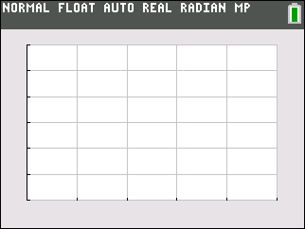
  Year | Time (s)
  1900 | 10.8
  1912 | 10.6
  1932 | 10.3
  1960 | 10.2
  1964 | 10.0
  1968 | 9.95
  1988 | 9.92
  1996 | 9.84
Draw a manual line of best fit. Press S, choose CALC. Press up arrow to select Manual-Fit. In the Store EQ: press aª and select Y1. Highlight Calculate and press e . Now that you are on the graph screen, press e to drop the first point of the line. Move the cursor to draw the line and press e to drop the second point. You can use ◄ and ► to change between the slope of the line and the y-intercept and you can change the value of m or b by typing in the number and pressing e.
3. What is the meaning of the slope and y-intercept? Include units. Write the line of best fit you determined.

4. Sketch the line on your graph in Question 1.
5. Using the line of best fit, what would you predict the time might be in 4 more years? What might the time be in 12 more years?

6. Do you think the line can predict the time indefinitely? Why or why not?

Part 2 – Women’s 100 meter Dash  7. Create a scatterplot of the Women’s 100-Meter Dash data for the given years provided by your teacher. Choose L3 for the Xlist and L4 for the Ylist. What are the domain and range of the data?  Plot the data to the right. Make sure to define a scale and label the axes. | 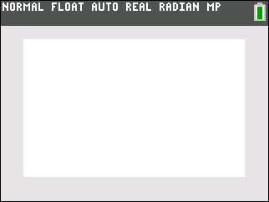
8. What is the general trend in the data?

9. How does this compare to the Men’s data?

10. Draw a manual line of best fit for this second set of data. Store this equation in Y3. Write the line of best fit you determine.

11. Sketch the line on your graph in Question 7.
12. Using the line of best fit, what would you predict the time might be:
In 4 more years?
In 8 more years?
13. Do you think the Women’s time will ever be less than the Men’s time? Explain why or why not.

Part 3 – Manual Fit vs. LinReg
Let’s compare the best fit line you found to the best fit line the calculator will find.
14. Use the LinReg(ax+b) command to find a line of best fit for the Men’s data. From a clear home screen, press S and choose LinReg from the CALC menu. A wizard will open. Configure as shown. To access L1 and L2 press ` Ω and ` æ. Use the arrows to select Store RegEQ and press aª to select Y2. Highlight Calculate and press e.
What does the calculator calculate as the line of best fit?

15. How does the calculated line of best fit compare to the manual-fit equation you found for the men in Question 3?

16. Calculate the LinReg for the Women’s data. Store in Y4. Record this equation.

17. How does this compare to the manual-fit equation you found for the women in Question 10?

18. What do you think causes the differences in your manual-fit line and the line the calculator finds?

