Problem 1 – Introduction to Parametric Equations
Parametric equations are useful in modeling motion because in addition to horizontal and vertical distances, they include a third variable, time. Using these equations, the location of a projectile can be determined at a specific time during its travel.
Basic parametric equations to model projectile motion are as follows...
where h is the starting distance from the ground, g is the acceleration due to gravity (32 ft/sec² or 9.8 m/sec²), and v is the initial velocity.
A problem to try...
A batter at spring training camp hits a baseball with an initial velocity of 90 ft/s at an angle of 35° from the horizontal. Assume that the batter hits the ball at 2.5 feet above home plate.
1. What value for gravity is used for this problem? Explain your reasoning.

2. Write parametric equations to model the motion of the ball.
x(t) =
y(t) =

To graph the parametric equations on the graphing calculator, press  and select DEGREE and PARAMETRIC as seen to the right.  Now, press □ and enter the two parametric equations from Question 2, in X1(T) and Y1(T).  Set an appropriate window and press  to view the result. | 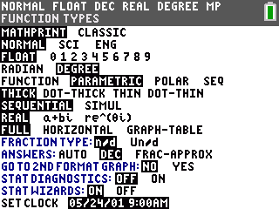
Press  and use the arrow keys to determine the following.
3. What is the maximum height reached by the ball?

4. What is the horizontal distance traveled by the ball?

5. How much time elapsed between the ball being hit and landing on the ground?

Problem 2 – Parametric to Quadratic
A golfer hits a ball with an initial velocity of 41 m/s at an angle of 36° from the horizontal. The resulting parametric equations are:
Enter the given parametric equations into the calculator and view the resulting graph as outlined earlier.
In parametric mode, you are unable to use the Calculate menu to find the maximum height or the zeros. To find these values, you must convert this to a polynomial equation.
Press  and record 10 data points (x, y) from different parts of the graph.  Press   and enter the x-values into list L1 and the y-values into list L2. | 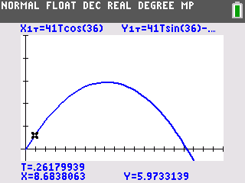
Now, perform the quadratic regression on the data points by pressing , arrow to the CALC menu, and select QuadReg. Match the syntax at the right, press   to find Y1.  Press  to view the quadratic equation.  To view the graph of this polynomial, press  and select FUNCTION and then press . | 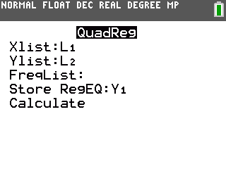
Now that you have the graph of a polynomial, all the Calculate menu commands are available (maximum and zero). Use these two commands to answer the following questions.
6. What is your quadratic regression equation? Round all decimals to 4 places.

7. How far will the ball travel horizontally before landing?

8. How long will it take for the ball to hit the ground?

9. What is the maximum height reached by the golf ball?

10. Will the ball clear a 4 meter high fence that is in the path of the ball 150 meters from the golfer? Draw a sketch of the graph to illustrate this situation and explain how you arrived at your answer.

