In this activity, you will calculate the distance from the northernmost point to the southernmost point in New Jersey. The black horizontal line shows the scale of 50 miles.  - Before you use your TI graphing calculator, quickly estimate the vertical distance from the southern to the northern tip of New Jersey on the map. How did you come up with your estimate? | 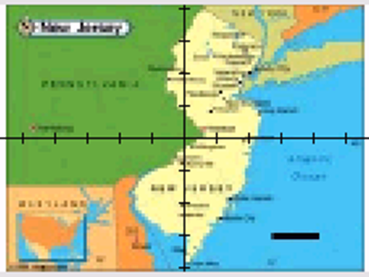
Tech Tip: The following instructions to load background images are for the color TI-84 Plus C family of graphing calculators. For the TI-84 skip step 2 and use Pic2 instead of Pic1.
Step 1:  Press ` ´ 7 Reset, 2: Defaults, 2: Reset to set the calculator to its default settings. This will set the M to all the left-most settings as well as the ` é screen.  On the ! screen, clear any functions, and turn off any StatPlots.  Step 2:  To load the image as a background, press ` é and arrow up to background. Use the spinner’s left and right arrows until the desired image is in place.  Step 3:  Press # then 4: ZDecimal. The graph screen will be displayed. Move the arrow keys to show the coordinates as you move the cursor around the screen. | 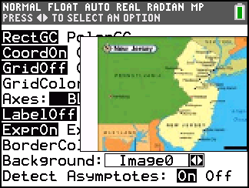  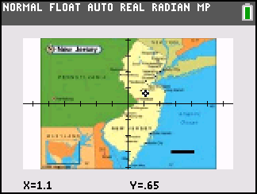
Step 4:  Once the picture has been transferred to you, load Pic1 from the Draw options. Press ` õ, then press the right arrow twice so that STO is highlighted. Choose 2:RecallPic, and then select Pic1 if using the color TI-84 Plus C (select Pic2 for a non-color larger pixel picture for the TI-84 Plus).  Step 5:  Recall that the length of the black bar at the bottom right of the map represents 50 miles. Let’s determine how long that line is on our coordinate axes. To do this we’re going to use the DRAW Line command to construct another bar.  To accomplish this, press ` õ 2:Line(. Move the free trace cursor to just below the bar. The color can be changed by pressing % for the STYLE soft key. | 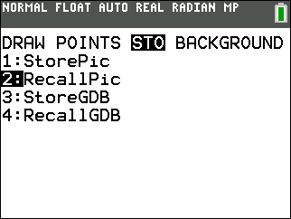  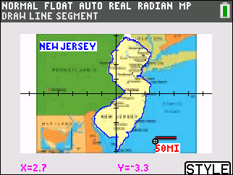
- Press e to mark the endpoint of the segment. What are the coordinates of the point?

( , )
Right arrow over to the end of the segment. Press e to finish the segment.
- What are the coordinates of the endpoint?

( , )
Select C to exit the Draw feature. If you are not happy with the length of your segment try again, but be sure to record to the coordinates.
- Calculate the distance between these two coordinates you recorded above.
- Use the ratio of these known distances to calculate the distance from the northernmost point to the southernmost point in this NJ map. You can use what you have learned about the Draw Line command. Show your work, and explain how you arrived at your estimate.

