A scientist has a piece of radioactive urannite shaped like a regular octahedron. Weighing it, she finds its volume is 1,512 mm³. What is the approximate edge length of the piece?
Problem 1 – Edge length of a square
First let’s solve a simpler problem involving the area of squares. Once you find a way to solve this simpler problem, you can use it to solve the scientist’s problem. | area = 45 cm²
What is the side length of a square with an area of 45 cm²? Use the formula for the area A of a square with side length s, A = s². Solve this formula for s. Record your answer as a function.
- s(A) =
If you solved for s correctly, your formula contains a ± sign. However, in this real-world application, all the numbers represent length and area measurements are positive, so we can omit the ± sign. Rewrite s(A) without it.
- s(A) =
To make sure this function makes sense, let’s take a look at its graph. Graph your function by entering it in Y1. Use x for A.  Change the viewing window to the settings shown at the right. | 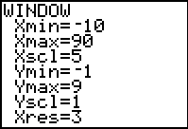
- Look at the shape of the graph. What happens to s as A increases? Does this make sense in this situation?

Radical expressions can also be written with fractional exponents. For example, $\sqrt{x}$ can also be written as $x^{\frac{1}{2}}$ or x^{0.5}. Rewrite your equation with fractional exponents and enter it in Y2. Use the graph to confirm that it is equivalent to Y1. | 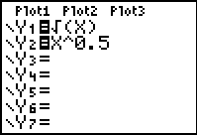
Let’s check this function more closely by creating some sample squares and comparing their measurements with points on the curve.  Launch Cabri Jr. and open the file EDGE1. | 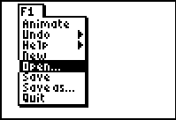
The file contains an adjustable square. To change its size, move the cursor over the bottom right vertex and press  to “grab” the point. The cursor will turn into a hand, as shown. Use the left and right arrow keys to change the size of the square.  Press  to “let go” of the point. | 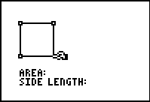
Use the Area tool to measure the area of the square. Place the area value next to the word AREA.  Use the D. & Length tool to measure the side length of the square by selecting two adjacent vertices. Place the length measurement next the word SIDE LENGTH. | 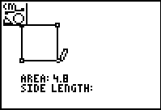
- Record your area and length measurements here:
A = ___________ cm² s = ___________ cm
Exit Cabri Jr. by pressing  . Return to your graph and press . Type in your area measurement to move to the point on the graph with an x-value equal to the area.  - What is the y-value at this point? | 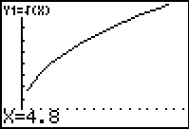
Reopen the Cabri Jr. app and adjust the size of the square. The area and side length measurements will update. Gather a few more pairs of measurements and compare them with the graph. | 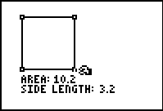
Exit Cabri Jr. Evaluate your formula for A = 45. What is the edge length of the square?
- s(45) =

Problem 2 – Edge length of a cube
Next let’s apply the method you just used to a slightly harder problem involving the volume of cubes.  What is the edge length of a cube with a volume of 356 cm³? | volume = 356 cm³
Use the formula for the volume V of a cube with side length s, V = s³. Solve this formula for s. Record your answer as a function.
- s(V) =
To make sure this equation makes sense, let’s take a look at its graph. Graph your function by entering it in Y1. Use x for V.
- Look at the shape of the graph. What happens to s as V increases? Does this make sense in this situation?

Rewrite this equation with fractional exponents and enter it in Y2. Use the graph to confirm that the two ways to writing the expression are equivalent. | 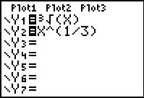
Let’s check this function more closely by creating some sample cubes and comparing their measurements with points on the curve. Launch Cabri Jr. and open the file EDGE2. | 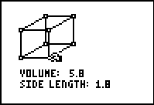
The file contains an adjustable square. To change its size, grab the bottom right vertex of the face closest to you. The volume and side length of the cube are measured for you. Gather a few pairs of measurements and compare them with the graph of your function using the Trace feature.
Exit Cabri Jr.  - Evaluate your formula for V = 356. What is the edge length of the cube? | 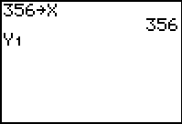
Problem 3 – Edge length of an octahedron
Now we are ready to apply this method to the original problem.
A scientist has a piece of radioactive uraninite shaped like a regular octahedron. Weighing it, she finds its volume is 1512 mm³. What is the approximate edge length of the piece?

Use the formula for the volume V of a regular octahedron with side length s : $V=\frac{\sqrt{2}}{3}s^{3}$. Solve this formula for s. Rewrite the radical expressions with fractional exponents and simplify, then rationalize the denominator.
- s =

We have already validated this method of solving for s in two simpler situations, so we do not need to test it further. However, to check your algebra, substitute $V=\frac{\sqrt{2}}{3}s^{3}$ for V in your formula and simplify the right side. If this yields s = s, your formula is correct.
- Evaluate your formula for V = 1,512. What is the edge length of the octahedron?

