Enter the data from the table above into lists.  Press  . Enter the x column in L1 and the y column in L2 as shown.
  x | y
  1 | 24
  2 | 12
  3 | 8
  4 | 6
  5 | 4.8
  6 | 4
Press   and select Plot1.  Press  to turn the plot On. Select scatter as the type of plot, L1 for the Xlist, and L2 for the Ylist.  Press . Set the window to the following:  Xmin = 0, Xmax = 10, Xscl = 2  Ymin = 0, Ymax = 25, Yscl = 5 | 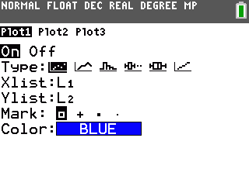
Press .
- How would you describe the relationship between x and y by examining this data?

Press   to return to the lists.
- What relationships can you see by examining the numbers in the lists?

- What is the product of each pair of numbers?

Arrow to the top of L3. Enter a formula to multiply the entries in L1 by the entries in L2. Press   for L1 and press   for L2. | 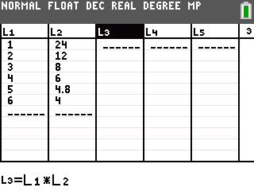
Press  to execute the formula. The product in each case is 24.  So, or . This relationship, when x and y have a constant product, is called “inverse variation.”  - What type of situation might this be a formula for? | 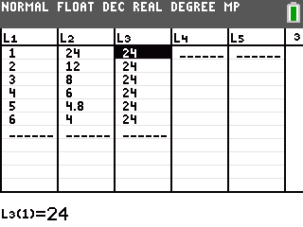
Solve the equation for y. Press □. Enter the equation into Y1.
- What is your equation?

Press .
- What other information can you find from the graph of the equation that you could not gather from the plot?

- Does this graph appear to be a function? Explain.

Press   to examine the function table.
- What is happening when x = 0? Why?

Arrow up to the negative x-values in the table.
- What do you notice about the y-values?

- Why does this occur?

- What do you think the graph of your equation looks like to the left of the y-axis?

Press . Set the window as shown to examine the graph when x is negative.  Press .  - What appears to be happening when x = 0? | 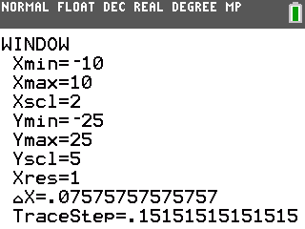
- Why does the graph of the equation not appear in Quadrants II or IV?

- Do you think an inverse variation can ever be found in Quadrants II or IV? Why?

- Does this graph appear to be a function now? Explain.

