Problem 1 – Linear Piecewise Function
Graph the piecewise function where a is a constant.
Step 1: Press o and enter the two equations you see at the right into your device. The inequality symbols can be found by pressing y». Note that we have begun with an a-value of 5.  Note: To set the domain for piecewise functions, each piece must be entered into its own equation line and be divided by its restricted domain. |  | 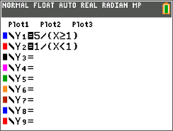
Step 2: Set the viewing window to standard by pressing q and selecting ZStandard. |  | 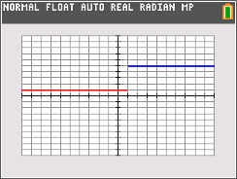
Step 3: Press r and use the left/right arrow keys to move along the domain of each piece. Press the up/down arrows to move between the pieces. |  | 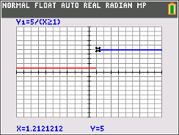
1. Graphically, what do the following one-sided limits appear to be?
a.

b.

Step 4: Try other values for a in our piecewise function to determine what a-value makes exist. Remember, Y1 is the function that has the a-value we are changing. In the screen to the right, a has been changed to 2. After changing the a-value, press s to see the resulting changes in the graph. Try different values for a. Graph it to see if f(x) appears continuous. |  | 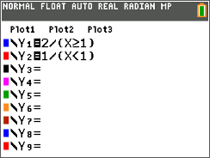
Step 5: Check your answer numerically to determine if your  a-value is correct. Set up the table by pressing y p and changing the settings to those on the right. |  | 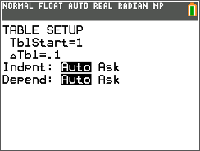
Step 6: Now, press y s to view your table. Use the up and down arrows to move through the table. The table will show ERROR for any x-value that is not in the domain of the Y2 or Y2. |  | 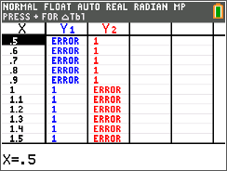
2. After checking graphically and numerically, what value of a resulted in f(x) being continuous?
Problem 2 – Linear and Quadratic Piecewise Function
Repeat the steps from earlier for the function starting with an a-value of 5.
3. Graphically and numerically, what do the following one-sided limits appear to be?
a.

b.

4. a. After checking graphically and numerically, what value of a resulted in g(x) being
continuous?

b. Show calculations of the left hand limit and the right hand limit to verify that your value for a makes the limit exist.

Problem 3 – Trigonometric Piecewise Function
Repeat the steps from earlier for the function starting with an a-value of 5.

5. Graphically and numerically, what do the following one-sided limits appear to be?
6. a. After checking graphically, and numerically, what value of a resulted in h(x) being continuous?

b. Show calculations of the left-hand limit and the right-hand limit to verify that your value for a makes the limit exist.

