The t distribution is used when n is small (less than 30) and the population standard deviation is unknown. For a sample size of n, the number of degrees of freedom is n – 1.
Problem 1 – Characteristics of the t Distribution
Press  and set the values as shown at the right.  Graph the standard normal distribution: Y1 = normalpdf(X, 0, 1).  Then graph the t distribution for n = 4: Y2 = tpdf(X, 3).  Note: The normalpdf and tpdf commands are in the Distribution menu ( ).  The format is (x, degrees of freedom). To help distinguish this graph from the first, make it bold by moving the cursor to the left of Y2 and pressing  so that a bolder line appears. | 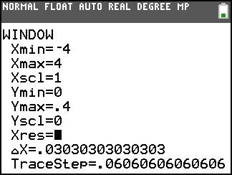  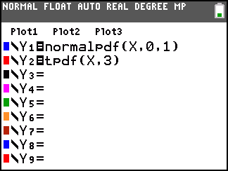
1. How does the t distribution for n = 4 (d.f. = 3) compare to the normal distribution?

Press □ and change Y2 to a t distribution where n = 9 (degrees of freedom = 8). Press . Repeat for n = 16 and n = 26.
2. What happens as n gets larger? Why?

Problem 2 – Comparing Areas
Press □ and clear the entries. On the Home screen enter ShadeNorm(–3, 3, 0, 1) and press  to find and display the area under the standard normal curve that is within three standard deviations of the mean.  ShadeNorm is accessed by pressing   and then moving to the DRAW menu. The format is (lower bound, upper bound, mean, standard deviation).  3. What is the value of this area? | 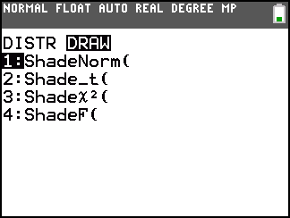
Press    to clear the drawing. On the Home screen enter Shade_t(–3, 3, 3) and press  to find and display the area between these same points under the t distribution.
Note: Shade_t is in the DRAW menu. The format is (lower bound, upper bound, d. f.).
4. What is this area?

5. In the same way, find the area under the t distribution for 8, 15, and 25 d. f.

6. What happens to the area and why?

Problem 3 – Critical Values for a t Distribution
To find a critical value for a t distribution, use the invT command located in the DISTR menu. Similar to invNorm, invT will give the t-value associated with a given area to the left of that value. The format for invT is (area to the left, degrees of freedom). The format for invNorm is (area to the left, mean, standard deviation).  7. Verify that for n = 3 at the 95% level. Then complete the chart by finding each value at the 95% level. | 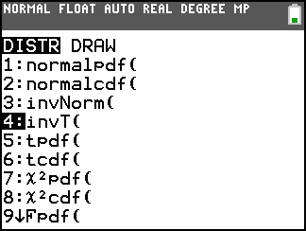
, n = 3 | , n = 8 | , n = 15 | , n = 25
4.303

8. If any, what patterns do you see?

9. Predict how the following will compare among each other.
50% CI, , n = 4 and n = 28
80% CI, , n = 4 and n = 28
100% CI, , n = 4 and n = 28
10. Find the six critical values listed above by using the invT command.

Problem 4 – Constructing a Confidence Interval
For a t distribution, the margin of error for estimating the population mean is given by .
The weights of 10 randomly selected newborn kittens, in grams, are shown below. Enter these values into L1 by pressing  and choosing Edit.
98, 107, 101, 102, 94, 103, 105, 97, 99, 102
Press , arrow to the CALC menu, choose 1-Var Stats, and enter L1.  11. What is the mean and standard deviation of the weights? | 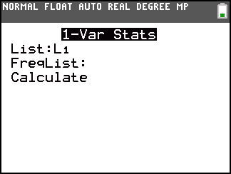
Graph the weights to verify that the distribution is roughly normal. Press   and select Plot1. Match the settings as shown at the right.  Press  and choose ZoomStat to get an appropriate viewing window. | 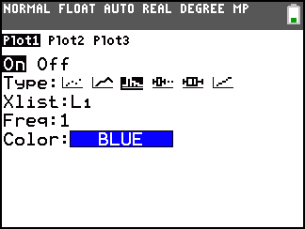
12. Calculate a 90% confidence interval and a 95% confidence interval for the mean weight of all newborn kittens.
90%: critical value: __________, margin of error: _________, confidence interval: _________

95%: critical value: __________, margin of error: _________, confidence interval: _________
Ten more newborn kittens are randomly selected and weighed. Their weights, in grams, are
97, 104, 92, 96, 100, 105, 103, 95, 92, 109
13. Add these weights to list L1. What is the new mean and standard deviation?

14. Calculate a new 90% confidence interval and a 95% confidence interval for the mean weight of all newborn kittens. (n = 20)
90%: critical value: _________, margin of error: ________, confidence interval: _______

95%: critical value: _________, margin of error: ________, confidence interval: _______
Check your confidence intervals by pressing , moving to the TESTS menu, and selecting TInterval. You have the option of choosing data from a list (choose Data) or by entering the sample mean, standard deviation, and sample size (choose Stats).

