Problem 1 – Solving a quadratic equation
The equation 2x² + 3 = 5x is solved step by step on the right. Your task is to solve the equation in each step graphically on the using your calculator. Simply enter the expression on the left-hand side of the equation into the Y1 and the expression on the right-hand side into Y2. Adjust the viewing window or use the zoom commands as necessary to see where the two graphs intersect.  Repeat the same process for each step of the equation and record the solution(s)—the point(s) of intersection—on the appropriate lines below.
  Solve: 2x² + 3 = 5x
  Step 1: 2x² + 3 = 5x
  Step 2: 2x² – 5x + 3 = 0
  Step 3: (2x – 3)(x – 1) = 0
  Step 4: $x=\frac{3}{2}$ and x = 1
As an example, the first step is shown here. | 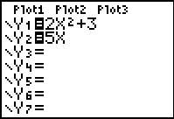 |  | 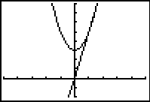
Use the intersect command (found in the Calc menu) to find the exact solutions. Choose each curve, then guess where the intersection point is located. (Remember that there are two solutions!) |  |  | 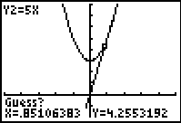
Step 1: x = ______________  Step 2: x = ______________ |  | Step 3: x = ______________  Step 4: x = ______________
- Do the solution(s) to each step that you found graphically equal the solution(s) found algebraically in Step 4?
Re-enter the functions graphed for Step 1 as Y1 and Y2, that is, define Y1 = x² + 3 and Y2 = 5x. View the function table by pressing ` ê . Verify the solutions you found above with the function table. To “zoom in” on the table, press ` ç and make the table step (∆Tbl) less than 1. |  |  | 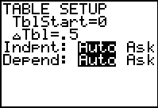
Verify the solution further by substituting the values back into the equation for x, then comparing the values of Y1 and Y2. The first solution is shown.  - Do both of the solutions satisfy the original equation? |  |  | 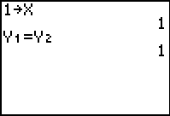
Problem 2 – Solving a radical equation
The step-by-step solution to the equation is shown on the right. Solve this equation graphically in the same manner as in Problem 1: graphing both sides of the equation in each step, and record the solutions below. When you are finished, reset functions Y1 and Y2 as they were in Step 1, and check your solution(s) in the function table and algebraically.
  Solve:$\sqrt{x+\text{11}}+1=x$
  Step 1: $\sqrt{x+\text{11}}+1=x$
  Step 2: $\sqrt{x+\text{11}}=x−1$
  Step 3: $x+\text{11}={\left(x−1\right)}^{2}$
  Step 4: x + 11 = x² – 2x + 1
  Step 5: 0 = x² – 3x – 10
  Step 6: 0 = (x – 5)(x + 2)
  Step 7: x = 5 and x = –2
Step 1: x = ____________
Step 2: x = ____________ |  |  | Step 5: x = ____________
Step 3: x = ____________ |  |  | Step 6: x = ____________
Step 4: x = ____________ |  |  | Step 7: x = ____________
- Do all of your solutions make the original equation true?

- In which step do you find the extraneous solution? Why do you think it appeared in that particular step?

Extension
The steps to solving the equation are shown on the left. Once again, use graphs and the function table to solve the equation in each step and verify your solutions.  - Which, if any, of the solution(s) are true solutions?
  Solve:
  Step 1:
  Step 2: (3x)(x – 3) = (2x – 3)(x – 3)
  Step 3: 3x² – 9x = 2x² – 9x + 9
  Step 4: x² = 9
  Step 5: x = –3 and x = 3
- In which step does the extraneous solution (or solutions) appear?
Explain why you think this occurs.

