Math Objectives
- Students will analyze data determined by a simulation involving tossing dice.
- Students will find and analyze exponential growth and decay functions.
- Students will model with mathematics.
- Students will try to make a connection with how to understand these topics in IB Mathematics courses and on their final assessments.

Vocabulary
- exponential decay function • half-life • simulation
- exponential growth function • doubling time

About the Lesson
- This lesson is aligning with the curriculum of IB Mathematics Applications and Interpretations (AI) SL/HL and IB Mathematics Approaches and Analysis (AA) SL/HL
- This falls under the IB Mathematics Content Topic 2 Functions:
AI 2.5b Exponential growth and decay models
AA 2.9a Exponential functions and their graphs
AA 2.9b $f\left(x\right)= a^{x}, a>0, f\left(x\right)= e^{x}$
- This lesson involves using a simulation to generate data that can be modeled by exponential growth and decay functions.
- As a result, students will:
- Apply this information to real world situations by fitting a function to data using simulation, regression and theoretical analysis, and analyzing properties of growth and decay functions (i.e. doubling and half-life).
TI-Nspire™ Navigator™
- Transfer a File.
- Use Class Capture to examine patterns that emerge.
- Use Live Presenter to demonstrate.
- Use Teacher Edition computer software to review student documents.
- Use Quick Poll to assess students’ understanding.

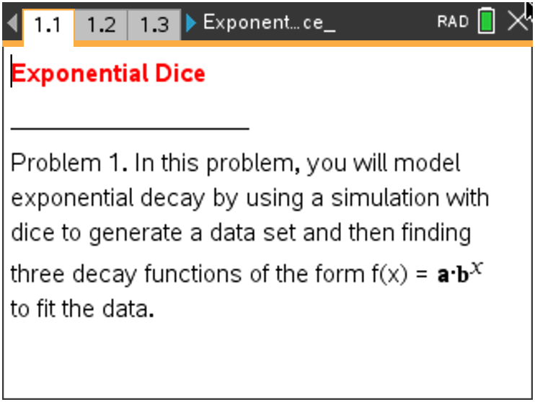

Tech Tips:
- This activity includes screen captures taken from the TI-Nspire CX II handheld. It is also appropriate for use with the TI-Nspire family of products including TI-Nspire software and TI-Nspire App. Slight variations to these directions may be required if using other technologies besides the handheld.
- Watch for additional Tech Tips throughout the activity for the specific technology you are using.
Access free tutorials at http://education.ti.com/calculators/pd/US/Online-Learning/Tutorials

Lesson Files:
Student Activity
Exponential_Dice_Student.pdf
Exponential_Dice_Student.doc
Exponential_Dice.tns

Discussion Points and Possible Answers

In Problem 1, a simulation involving dice will generate a data set that can be modeled by a function in the form $f\left(x\right)=a∙b^{x}$. You will input a value of a and then determine three possible values of b .
In the simulation, we toss a large number of dice, remove all the dice with certain face value(s) such as
6’s, 3’s and 4’s, etc., and then repeat these two steps until only a few dice are left. You will need to enter two values in this simulation:
- a = initial number of dice (around 200 is reasonable)
- f = number of face values to remove for the next toss ( f = 1 if you are removing one face such as the 6’s only; f = 2 if you are removing two faces such as the 2’s and 3’s, etc.)

Teacher Tip: To help students understand what is happening during the simulation, demonstrate the process by conducting several trials of the simulation using a set of
30 – 50 dice. Even better, have each group of 2 – 4 students perform such a
demonstration.

Imagine that a stomach bug is spreading through your school and you are trying to keep track of the number of students who have not yet become ill. You can suppose that:
- Each die represents a person.
- Each toss represents a week.
- If a 6 comes up, a student becomes ill, so remove that die from the population.

Move to page 1.2.

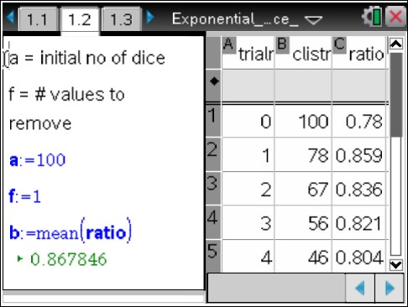
1. Reset the simulation by changing the value of a to a = 0. Then change the values of a and f to a = 200 and f = 1 to simulate starting with 200 dice (students) and removing all the
6’s at each trial. The right half of the page is a spreadsheet
where the first two columns contain the trial number and the number of dice remaining (number of students who have not yet become ill) after that trial.
- For the first function $1\left(x\right)=a∙b^{x}$ , explain why a is initial the number of dice.

Sample Answers: The initial value is $f\left(0\right)=a∙b^{0}=a.$

In the third column, ratio, the ratios between consecutive entries in Column B, $\frac{b2}{b1}, \frac{b3}{b2}, \frac{b4}{b3}, …$etc.,
have been calculated.
- Explain what each ratio represents.

Sample Answers: Each ratio is less than 1 and represents the fraction

$\frac{number of dice in trial(k+1)}{number of dice in trial(k)}$ for $k=1, 2, 3, …$

The value of b for the first function is the average value of these ratios. It is calculated and stored as b.
- Explain why this value of b is a reasonable choice for the base of an exponential decay function to model this data.

Sample Answers: The average of the fractions of dice remaining from one trial to the next is a good estimate for the fixed rate of change that is the base for a decay model.

- Record your first function here: f1(x) = _______________________.

Sample Answers: $f1\left(x\right)=a∙b^{x}$ where a = 200 [entered] and b = mean(ratio) [calculated.] Students can enter $f1\left(x\right)=a∙b^{x}$ or the numerical values of a and b since 200 is stored in a and mean(ratio) is stored in b.

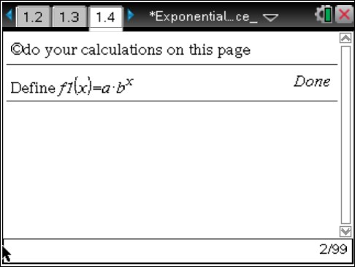
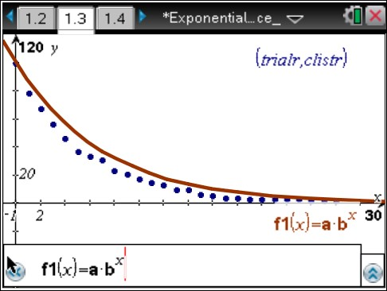
Move to page 1.4.

Enter your function on this page by typing
define $f1\left(x\right)=a∙b^{x}$. You can type either the variables a and b or type their numerical values.

Move back to page 1.3.

On Page 1.3, you will see a scatterplot of your data (trialr, clistr). If the graph of f1(x) is not displayed on the scatterplot, open the entry line, move back up to f1(x), and press ·.

- Explain how well the graph of your function fits the data.

Sample Answers: The graph of f1(x)is always above (below) the data points, so it does not fit the data very well. OR The graph of f1(x)has some data points slightly above the graph and other data points slightly below the graph, so it fits the data very well.

- According to this model, approximate the percent of the dice that are being removed during each trial.

Sample Answers: $\left(1-b\right)∙100$; if $b=0.85$ for example, then approximately 15% of the number of dice at one trial are removed for the next trial.

Move to page 1.4.

On Page 1.4, you will find the regression equation to fit the data by selecting MENU > Statistics > Stat
Calculations > Exponential Regression. Select “trialr” as the x-list and “clistr” as the y-list, and store this equation as f 2 .

- a. Record your regression function here: f 2(x) = _______________________.

Sample Answers: The regression function has the form $f2\left(x\right)=c∙d^{x}$ where c is around 200 and d is around 0.83.

Move back to page 1.3.

Go back to Page 1.3 to view the graph of the regression function on the scatterplot. If the graph of
f 2(x) is not displayed, open the entry line, move up to f 2(x), and press ·.
  - Discuss how the graph of the exponential regression function compares to that of your first function.

Sample Answers: The graph of f 2(x) is always higher (lower) than that of f 1(x); The graphs intersect and f 2(x) is higher for larger values of x while f 1(x) is higher for smaller values of x; etc.

Theoretically, you would expect that $\frac{1}{6}$ of the current number of dice would be removed at every trial.
- a. For this situation, state the theoretical value for b.

Sample Answers: $b= \left(1- \frac{1}{6}\right)= \frac{5}{6}$

  - Record your third function here: f 3(x) = _______________________ using this theoretical value of b and the initial value a you selected for the first function.
Sample Answers: $f3\left(x\right)=200∙{\left(\frac{5}{6}\right)}^{x}$

Move to page 1.4.

Enter the theoretical function onto this page by typing define f 3(x) = and adding the function from part 3b after the equals sign.

Move back to page 1.3.

If the graph of f 3(x) is not displayed on the scatterplot, open the entry line, move up to f 3(x), and press ·.

Move to page 1.4.

- Compute and interpret the following quantities;
  - f 1(6) – f 3(6) and f 2(6) – f 3(6)

  - f 1(9) – f 3(9) and f 2(9) – f 3(9)

  - f 1(12) – f 3(12) and f 2(12) – f 3(12)

Note: It is possible to get an error message if fewer than 12 trials were needed in the simulation. Check the spreadsheet on Page 1.2. If 18 or more trials were needed, you might want to compute these quantities when x = 15 or some larger value.

Sample Answers: Answers will vary. Type for example, f 1(6) – f 3(6), and press · to calculate the difference. The quantities f 1(k) – f 3(k) and f 2(k) – f 3(k) are the deviations between the values of the exponential functions based on the data and the theoretical function for any value of k. They will generally get smaller as the value of k increases.

Teacher Tip: You could ask the students to look carefully at the three graphs and decide which one, if any, best represents the data.

TI-Nspire Navigator Opportunity: Quick Poll See Note 1 at the end of this lesson.

- The half-life of a quantity whose value decreases with time is the length of time it takes for the quantity to decay to half of its initial value. Knowing the value of the half-life of various radioactive elements is sometimes used to determine the age of fossils and other natural objects.

  - Find the half-life of this decay model using the exponential regression function, f 2(x).
Hint: You can use the “nsolve” command on this Calculator page.

Sample Answers: Answers will vary but can be found using $"nsolve\left(f2\left(x\right)=100,x\right)"$.
Typical values are between 3 and 6.

  - Find the half-life of this decay model using the theoretical exponential decay function,
f 3(x).

Sample Answers: Using $"nsolve\left(f3\left(x\right)=100, x\right)", x ≈ 3.80$.

Teacher Tip: You could mention that the theoretical value of the half-life is
the solution to $\frac{1}{2}= b^{x}$ or $x= \frac{-\log{2}}{\log{b}}$.

- Suppose you ran another simulation where you removed all the 3’s and 4’s at each trial starting with 220 dice.

a. Find the theoretical decay function, g(x) for this situation.

Sample Answers: $g\left(x\right)=220∙{\left(\frac{2}{3}\right)}^{x}$
b. Find the half-life of a decreasing quantity modeled by the function g(x).

Sample Answers: $x ≈1.71$

Teacher Tip: Students could perform another simulation and use exponential regression to verify this theoretical model. It would be best to delete the graphs of f1, f2, and f3 by moving to Page 1.3, clicking on each graph, and deleting them.

Move to page 2.1.
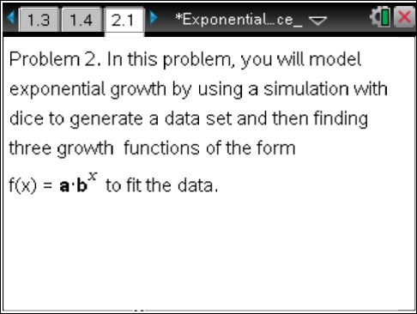
Many things such as populations of people and animals grow at an exponential rate, In Problem 2, a simulation involving dice will generate a data set that can be modeled by a function in the form
$f\left(x\right)=a∙b^{x}$. You will input a value of a and then determine three
possible values of b .
In the simulation, we toss a small number of dice, add a die for each die with certain face value(s) such as 6’s, 3’s and 4’s, etc. and then repeat these two steps until there are around 200 dice. You will need to enter two values in this simulation:
- a = initial number of dice (3 – 5 is reasonable)
- f = number of faces to save for the next toss (f = 2 if you add a die for each of two
faces such as the 3’s and 4’s ; f = 3 if you add a die for each of three faces such as the 3’s, 4’s, and 5’s, etc.)

Teacher Tip: To help students understand what is happening during the simulation, demonstrate the process by conducting several trials of the simulation using a set of
30 – 50 dice. Even better, have each group of 2 – 4 students perform such a
demonstration.

Imagine that you are keeping track of the deer population in a nearby animal park. You can suppose that
- Each die represents a deer
- Each toss represents a year.
- If a 3 or 4 comes up, a deer is born, so add a die to the population.

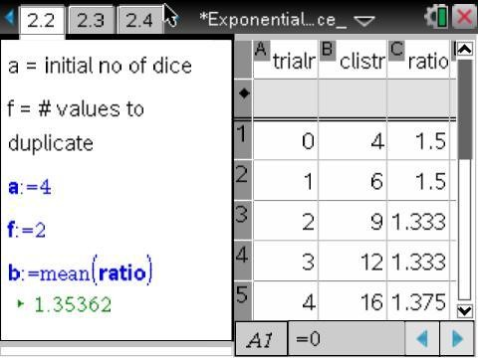
Move to page 2.2.

Reset the simulation by changing the value of a to a = 0. Then change the values of a and f to a = 4 and f = 2 to simulate starting with 4 dice and adding a die for each of the 3’s and 4’s that occur.

The right half of the page is a spreadsheet where the first two columns contain the trial number and the number of dice accumulated after that trial. In the third column, ratio, the ratios between
consecutive entries in Column B, $\frac{b2}{b1}, \frac{b3}{b2}, \frac{b4}{b3}, …$ etc.,
have been calculated.

- a. Explain what each ratio represents.

Sample Answers: Each ratio is greater than 1 and represents the fraction

$\frac{number of dice in trial(k+1)}{number of dice in trial(k)}$ for $k=1, 2, 3, …$

The first value of b is the average value of these ratios. It is calculated and stored as b.
  - Explain why this value of b is a reasonable choice for the base of an exponential growth function to model this data.

Sample Answers: The average of the fractions of dice added from one trial to the next is a good estimate for the fixed rate of change that is the base for a growth model.

  - Record your first function here: f 1(x) = _______________________ .

Sample Answers: $f1\left(x\right)=a∙b^{x}$ where a = 4 [entered] and b = mean(ratio) [calculated]. Students can enter $f1\left(x\right)=a∙b^{x}$ or the numerical values of a and b since 4 is stored in a and mean(ratio) is stored in b.

Move to page 2.4.

Enter your function onto this page by typing define $1\left(x\right)=a∙b^{x}$ . You can type either the variables a and b or type their numerical values.

Move back to page 2.3.

On Page 2.3, you will see a scatterplot of your data (trialr, clistr). If the graph of f 1(x) is not displayed on the scatterplot, open the entry line, move up to f 1(x), and press ·.
  - Describe how well the graph of your function fits the data.

Sample Answers: The graph of f 1(x) is always above (below) the data points, so it does not fit the date very well. OR The graph of f 1(x) has some data points slightly above the graph and other data points slightly below the graph, so it fits the data very well.

  - According to this model, approximate the percent of the dice that are being added during each trial.

Sample Answers: $\left(b-1\right)∙100$; $b=1.35$for example, then approximately 35% of the number of
dice at one trial are added for the next trial.

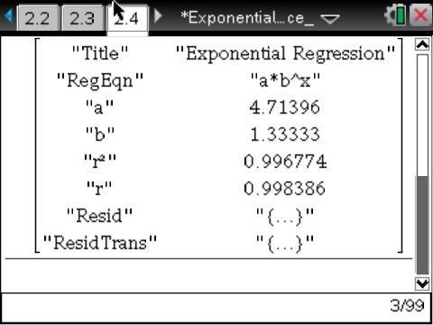
Move to page 2.4.

On Page 2.4, find the regression equation to fit the data by selecting MENU > Statistics > Stat Calculations > Exponential
Regression. Select “trialr” as the x-list and “clistr” as the y-list, and store this equation as f 2 .

- a. Record your regression function here: $f2\left(x\right)=$ _______________________.

Sample Answers: The regression function has the form $f2\left(x\right)=c∙d^{x}$ where c is around 4 and d is around 1.33.

Move back to page 2.3.

Go back to Page 2.3 to view the graph of the regression function on the scatterplot. If the graph of
f 2(x) is not displayed, open the entry line, move up to f 2(x), and press ·.
  - Discuss how the graph of the exponential regression function compares to that of your first function.
Theoretically, you would expect that $\frac{1}{3}$ of the current number of dice would be added at every trial.

Sample Answers: The graph of f 2(x) is always higher (lower) than that of f 1(x); The graphs intersect and f 2(x)is higher for larger values of x while f 1(x)is higher for smaller values of x; etc..

- a. For this situation, state the theoretical value for b.

Sample Answers: $b= \left(1+ \frac{1}{3}\right)= \frac{4}{3}$

  - Record your third function here: f 3(x) = _______________________ using this theoretical value of b and the initial value a you selected for the first function in 7c.

Sample Answers: $f3\left(x\right)=4∙{\left(\frac{4}{3}\right)}^{x}$

Move to page 2.4.

Enter the theoretical function on this page by typing define f 3(x) = and adding the function from part
9b after the equals sign

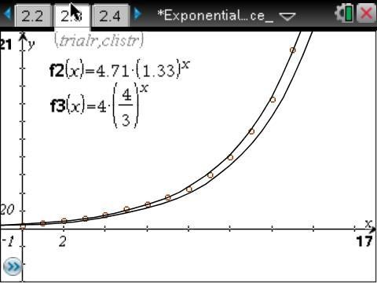
Move back to page 2.3.

If the graph of f 3(x) is not displayed on the scatterplot, open the entry line, move up to f 3(x), and press ·.

Move to page 2.4.

- Compute and interpret the quantities:
  - f 1(6) – f 3(6) and f 2(6) – f 3(6)

  - f 1(9) – f 3(9) and f 2(9) – f 3(9)

  - f 1(12) – f 3(12) and f 2(12) – f 3(12)

Sample Answers: Answers will vary. Type for example, f 1(6) – f 3(6), and press · to calculate the difference. The quantities f 1(k) – f 3(k) and f 2(k) – f 3(k) are the deviations between the values of the exponential functions based on the data and the theoretical function for any value of k. They will generally get smaller as the value of k increases.

Note: It is possible to get an error message if fewer than 12 trials were needed in the simulation. Check the spreadsheet on Page 2.2. If 18 or more trials were needed, you might want to compute these quantities when x = 15 or some larger value.

Teacher Tip: You could ask the students to look carefully at the three graphs and decide which one, if any, best represents the data.

TI-Nspire Navigator Opportunity: Quick Poll See Note 2 at the end of this lesson.

- The doubling time of a quantity whose value increases over time is the length of time it takes for the quantity to double in size. It is applied to population growth, inflation, compound interest, the volume of tumors, and many other things that tend to grow over time.
  - Find the doubling time of this growth model using the exponential regression function, f 2(x).

Hint: You can use the “nsolve” command on this Calculator page.

Sample Answers: Answers will vary, but can be found using $"nsolve\left(f2\left(x\right)=8,x\right)"$. Typical
values are between 2 and 4.

  - Find the doubling time of this growth model using the theoretical exponential growth function,
f 3(x).

Sample Answers: Using $"nsolve\left(f3\left(x\right)=8, x\right)"; x≈ 3.80.$

Teacher Tip: You could mention that the theoretical value of the half-life is
the solution to $2= b^{x} or x= \frac{\log{2}}{\log{b}}$.

- Suppose you added a die for each of the 3’s, 5’s, and 6’s at each trial starting with 3 dice.

  - Find the theoretical growth function, g(x) for this situation.

Sample Answers: $g\left(x\right)=3∙{\left(\frac{3}{2}\right)}^{x}.$

  - Find the doubling time of an increasing quantity modeled by the function g(x) .

Sample Answers: $x≈1.71$.

Teacher Tip: Students could perform another simulation and exponential regression to verify this theoretical model. It would be best to delete the graphs of f1, f2, and f3 by moving to Page 2.3, clicking on each graph, and then deleting them.

Additional Question:

Explain why the half-life in #6 is the same as the doubling time in #12.

Further IB Extension
A mysterious virus has been spreading over the last several weeks since flu season began. Dr. Murphy and her team of researchers have been watching the spread closely and has modeled the data with the following function:
$$P=750+325{\left(1.375\right)}^{t} , t ≥0$$

Where $t$ is the number of days since the start of flu season and $P$ is the number of patients who have contracted this mysterious virus.

(a) i. Find the number of patients who contracted the virus at the start of flu season.

Answer: Substituting $t=0$ (M1)
$P=750+325{\left(1.375\right)}^{0}$
$P=1075$ patients A1

ii. Find the number of patients who contracted the virus after 6 days. [4 marks]

Answer: Substituting $t=6$ (M1)
$P=750+325{\left(1.375\right)}^{6}$
$P≈2946$ patients A1

(b) Find how many days it will take to reach 20,000 patients who have contracted the virus.
[3 marks]
Answer: Method 1
Setting the function equal to 20,000 (M1)
$20,000=750+325{\left(1.375\right)}^{t}$
$19250=325{\left(1.375\right)}^{t}$
$\frac{19250}{325}= {1.375}^{t}$
Converting to log form (M1)
${t= log}_{1.375}{\frac{19250}{325}} ≈12.8164…$
$t ≈13 days$ A1
Method 2
Evidence of graphing the functions:
$f\left(x\right)=20,000$ and $f\left(x\right)=750+325{\left(1.375\right)}^{x}$ (M1)
Finding the point of intersection between the functions:
$\left(12.8164…, 20000\right)$ (M1)
$t ≈13 days$ A1

Wrap Up
Upon completion of the lesson, the teacher should ensure that students are able to understand:
- The purpose of a simulation.
- How to find an exponential growth or decay function in various ways and interpret its features.
- How to find the half-life of an exponential decay function and the doubling time of an exponential growth function.

TI-Nspire Navigator
Note 1
Question: 4, Name of Feature: Quick Poll
Use a Quick Poll, and ask the students to indicate their choice. Then discuss their selections and why they chose them to assess students understanding of how well the graph of a function fits a set of data.

Note 2
Question: 10, Name of Feature: Quick Poll
Use a Quick Poll, and ask the students to indicate their choice. Then discuss their selections and why they chose them to assess students understanding of how well the graph of a function fits a set of data.

**Note: This activity has been developed independently by Texas Instruments and aligned with the IB Mathematics curriculum, but is not endorsed by IB™. IB is a registered trademark owned by the International Baccalaureate Organization.

