Sequence Investigation  ID: 11061 | Time required  15 minutes

Activity Overview
In this activity, students will use the calculator to create an arithmetic sequence. Through this they will learn some of the vocabulary of sequences. Then students will then explore the effect of each variable in the formula of the nth term of an arithmetic sequence. Students will learn how to graph a sequence.

Topic: Sequence, Series & Functions
- Sequence terminology
- Graphing sequences

Teacher Preparation and Notes
- This activity can serve as a nice introductory activity to sequences. It is written for arithmetic, but everything is adaptable for geometric series.
- To download the student worksheet, go to education.ti.com/exchange and enter “11061” in the quick search box.

Associated Materials
- Alg2Week03_GraphSeq_worksheet_TI-84

Suggested Related Activities
- Geometric Sequence & Series ⎯ 8674
- Working with Sequence and Series ⎯ 9808
- Arithmetic Sequences & Series ⎯ 8642
- Spreading Doom ⎯ 10074
- Sequence & Series Introductory Quiz ⎯ 10486

Problem 1 – Create a sequence
Students use the graphing calculator to create an arithmetic sequence. They are introduced to the vocabulary of “term of a sequence.”  If the student presses an operation, like +, immediately after a result is shown, then an iterative process will begin. For example, it will say Ans + –3, and when e is pressed, it calculates the previous answer plus –3. Pressing e again will add –3 to the answer again.  If done correctly, the sequences created by all students should be arithmetic sequences with 5 terms and a common difference of –3. The only difference is the starting value. | 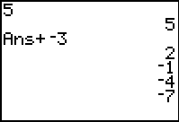
Problem 2 – Graphically and numerically explore nth term formula
Students explore the variables in the formula of the nth term of an arithmetic sequence by pressing ! and changing the values of the different variables of the sequence.  Students are told that n is the number of terms, but they should determine the following:  a₁ is the first term  d is the common difference  Then they need to determine the effect each variable has on the graph. Students may respond graphically: a₁ makes the graph go up or down, d changes the slope and n puts more data points on the graph.  If a student’s sequence is out of the range for the graph, have them change the window settings by pressing @ and adjusting the Ymin and Ymax values. | 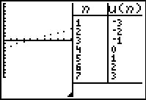  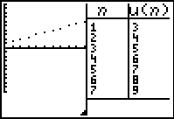
Problem 3 – Summing it up
For this sequence, the students will have a formula where a₁ is their favorite number and d is –3.  A sample ! screen appears to the right where a₁ = 5. The formula would be a_{n} = 5 + (n – 1) ∗ –3. | 