About the Lesson  - This lesson is aligning with the curriculum of IB Mathematics Approaches and Analysis HL  - This falls under the IB Mathematics Content Topic 5 Calculus:  5.19a Maclaurin (Taylor) series to obtain expansions for e^{x},  sin x, cos x, arctan x, ln(1 + x), (1 + x)^{p}  As a result, students will:  - Define a Taylor polynomial approximation to a function f of degree n about a point x = a  - Graph convergence of Taylor polynomials  - Use Taylor polynomials to approximate function values  Vocabulary  - Taylor polynomial  - factorial  - derivatives  Teacher Preparation and Notes  - Taylor polynomial approximations are introduced as generalizations of tangent line approximations. The graphing handheld is used as a tool to graph Taylor polynomial approximations of functions. Taylor polynomials are also used to approximate specific function values.  - Students should be familiar with tangent line approximations and higher order derivatives  - Given a function f, students should be able to find the Taylor polynomial approximation of degree n about a point x = a, approximate specific function values using a Taylor polynomial, and approximate the graph of a function using a Taylor polynomial.  Activity Materials  - Compatible TI Technologies:  TI-84 Plus*, TI-84 Plus Silver Edition*, TI-84 Plus C Silver Edition, TI-84 Plus CE |  | 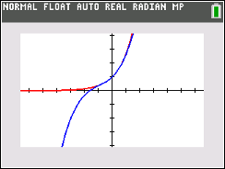  Tech Tips:  - This activity includes screen captures taken from the TI-84 Plus CE. It is also appropriate for use with the rest of the TI-84 Plus family. Slight variations to these directions given within may be required if using other calculator models.  - Access free tutorials at http://education.ti.com/  calculators/pd/US/Online-Learning/Tutorials  - Any required calculator files can be distributed to students via handheld-to-handheld transfer.  Lesson Files:  - Taylor Polynomials_Student-84.pdf  - Taylor Polynomials_Student-84.doc
Consider the functions below:

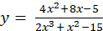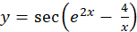
The first function, the polynomial function, is probably the easier to integrate. Although a polynomial can have many terms, its basic structure is a sum of products of numbers (coefficients) and nonnegative integer powers of x, the independent variable. You can evaluate any polynomial at a specific value x by using only the plus, times, and negative buttons on any four-function calculator because whole-number powers of x are only shorthand for repeated multiplication.

Polynomials are so easy to manipulate, in fact, that they are sought after as approximations to more complicated functions. You may have encountered one such kind of approximation in statistics with polynomial regression. A special case of a polynomial regression is the “line of best fit,” y = ax + b, to a scatter plot of data points.

In this activity, you will examine another kind of polynomial approximation that is a generalization of the tangent line approximation. These polynomials are called Taylor polynomials.

Explorations
If , the derivative of a function, is known at a point (a, f(a)) on its graph, then the point-slope form for the equation of the tangent line can be used with as the slope. written with y isolated is .

The tangent line approximation is sometimes called the best linear local approximation to a function f at the point x = a because it is the only line that has the same y-value and the same derivative value as f at the point x = a. In other words, the tangent line matches the function’s value and its first-order derivative’s
value at x = a.

The tangent line approximation is the first-degree Taylor polynomial approximation to the function f about the point x = a. To obtain higher-degree Taylor polynomial approximations, higher-order derivative values need to be matched. For example, to find the best quadratic (second-degree) approximation to the function at at x = 0, a quadratic function must be found such that y, , and match those derivative values of the function at x = 0. The calculations that need to match to solve for the coefficients a, b, and c are arranged across the rows in the table below.
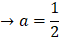

The quadratic approximation is 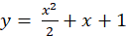.

It is customary to write the terms of a Taylor polynomial in increasing powers, so the
second-degree Taylor polynomial approximation to about x = 0 is

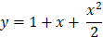

In general, the degree n Taylor polynomial approximation for a function f about the point x = 0 is given by

where represents the nth derivative of f and is “n factorial.”

Taylor polynomial approximations for about x = 0 are particularly easy to find because all higher-order derivatives of f are exactly the same, namely for all n, and so for all n. Thus, the sixth-degree Taylor polynomial for about x = 0 would be

The above example would lead a person to believe that these higher-degree Taylor polynomial approximations are simply better local approximations than a tangent line approximation; that is, that the approximation should only be used for a very small interval about the point. In many cases, but not all cases, higher-degree Taylor polynomials may provide very good approximations of the function over much larger intervals. To illustrate this, you can try graphing a function and several of its Taylor polynomials.

Graph and its first through sixth degree Taylor polynomials about x = 0. Use the viewing window below.

Input the first-degree Taylor polynomial in Y₁ in the Y = editor, the second-degree Taylor polynomial in Y₂, and so on up to the sixth degree Taylor polynomial in Y₆. In Y₇, input the original function . The screens shows these entries | 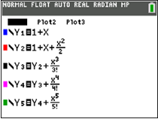  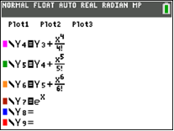
Notice that with each increase in degree of a Taylor polynomial, you can simply add an additional term to the previous Taylor polynomial. The graph of (Y₇) is shown here. | 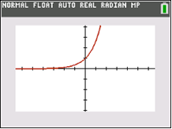
The graphs show the first six Taylor polynomials graphed in the same window with .

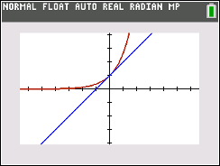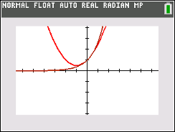

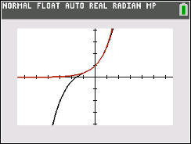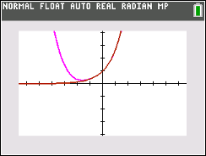

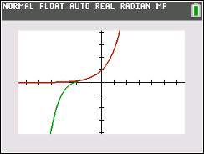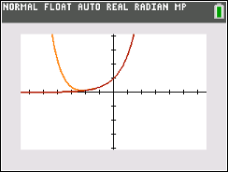

Notice how the graph of the polynomial visually approximates the graph of over a wider and wider interval around x = 0. If you trace to the x = 1 crosshair and compare the values of the two functions, you will see how close the numerical approximations are.

Y₇(1) = 2.718281828 (e rounded to 9 decimal places)
Y₆(1) = 2.718055556 (e accurate to the nearest thousandth)

The degree n Taylor polynomial approximation for a function f about the point x = a
is expanded in powers of (x – a) and has the form

The first two terms give exactly the tangent line approximation. Powers of (x – a) might not seem necessary at first glance, but consider a function that is not defined at x = 0 and you can see the need for expanding around some other point.

The function f(x) = ln(x) is not defined for x = 0, but a Taylor polynomial about x = 1 could be found instead. The necessary derivative information is shown below.

. .
. .
. .

. .

The nth-degree Taylor polynomial for f(x) = ln(x) about x = 1 is

For each of the functions on the following pages:

a. Find the indicated Taylor polynomial approximations.

b. Graph each Taylor polynomial approximation using the same viewing window, from the previous
example, along with the original function. Sketch a graph in the screens provided that shows how each
Taylor polynomial compares with the original function.

c. Evaluate the original function and each Taylor polynomial approximation at x = 3.

Problem 1 –

Find and graph about x = 0.

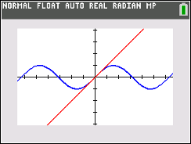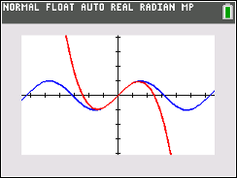

= 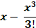

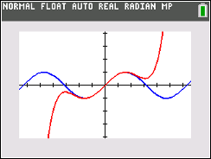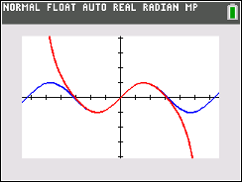

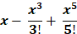 = 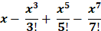

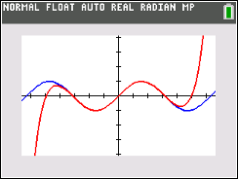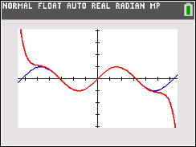

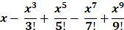 = 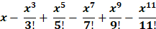

____0.1411200081____________

____3______________________ _____-1.5__________________

____0.525__________________ _____0.0910714286__________

____0.1453125______________ ____0.1408745942__________

Problem 2 –

Find and graph about x = 0.

Note: uses only the function output at x = 0 and will be a constant function. In other words, its
graph will be a horizontal line.

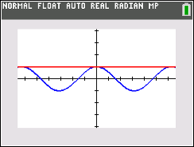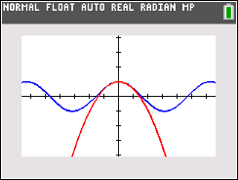
1 = 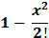

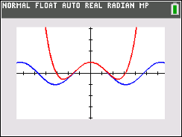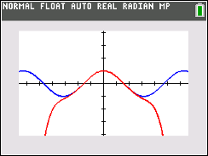

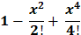 = 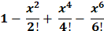

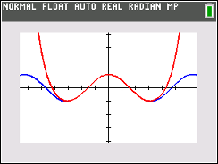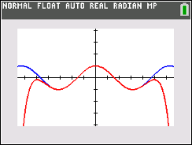

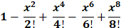 = 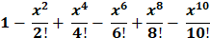

___-0.9899924966____________

____1______________________ ____-3.5___________________

____-0.125__________________ ____-1.1375________________

____-0.9747767857___________ ___-0.991049107___________

Problem 3 –

Find and graph about x = 0.

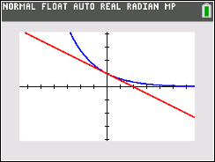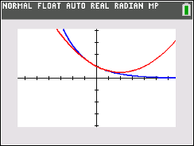

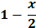 = 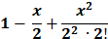

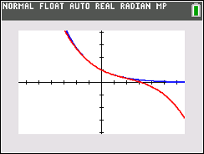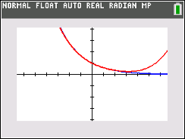

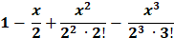 = 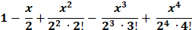

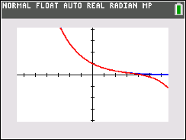
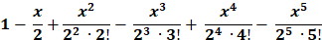
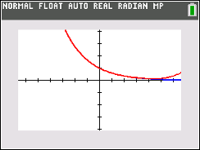

= 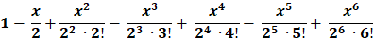

____0.2231301601____________

___-0.5____________________ ____0.625__________________

____0.0625_________________ ____0.2734375_____________

____0.21015625_____________ ____0.2259765625__________
Teacher Note: The Taylor polynomials for could also be obtained by substituting -x/2 in place of x discussed in the activity.

Problem 4 –

Find and graph about x = 0.

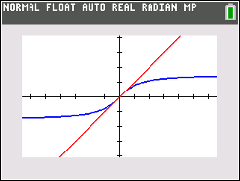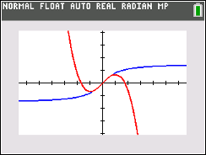

= 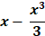

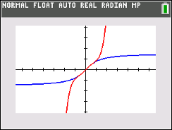
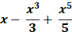

____1.249045772____________ ____3______________________

___-6_____________________ ____42.6___________________

Teacher’s Note: The Taylor series for arctan(x) is very slow in converging.

Problem 5 –

Find and graph about x = 1.

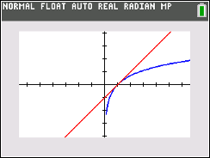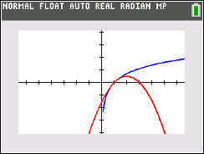

x – 1 = 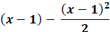

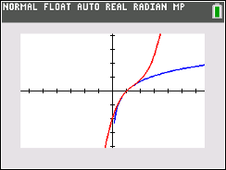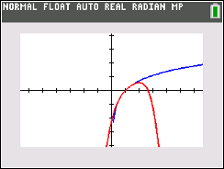

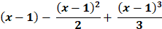 = 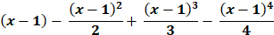

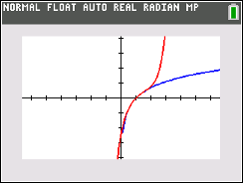

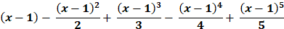

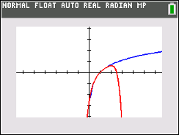

=

___1.098612289______________

___2_______________________ ____0_____________________

___2.666666667_____________ ____-1.33333333333_________

___5.066666667_____________ ____-5.6___________________

Teacher Tip: The value x = 3 lies just outside the interval of convergence for these Taylor polynomials for f(x) = ln(x) (the interval of convergence is 0 < x ≤ 2). You could compare the numerical results obtained for approximating another value of x that lies within this interval of convergence (such as
x = 3/2).

Problem 6 –

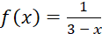

Find and graph about x = 2.

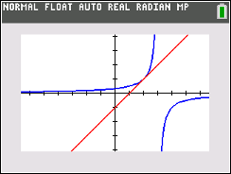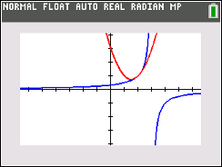

1 + (x – 2) = 1 + (x – 2) + (x – 2)²

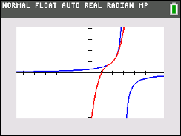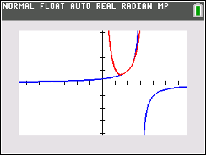

1 + (x – 2) + (x – 2)² + (x – 2)³ = 1 + (x – 2) + (x – 2)² + (x – 2)³ + (x – 2)⁴

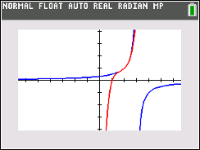

1 + (x – 2) + (x – 2)² + (x – 2)³ + (x – 2)⁴ + (x – 2)⁵

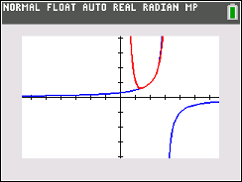

= 1 + (x – 2) + (x – 2)² + (x – 2)³ + (x – 2)⁴ + (x – 2)⁵ + (x – 2)⁷

___undefined________________

____2______________________ _____3____________________

____4______________________ _____5____________________

____6______________________ _____7____________________

Teacher Tip: The value x = 3 lies just outside the interval of convergence for these Taylor polynomials for f(x) = 1/(x – 3) (the interval of convergence is 1 < x < 3). You could compare the numerical results obtained for approximating another value of x that lies within this interval of convergence (such as x = 3/2). Indeed, it does not make sense to use these Taylor polynomials to approximate the value of a function not even defined at x = 3. Also, the Taylor polynomial for f(x) = 1/(x – 3) represent a sequence of geometric sums and can be used to make connections with geometric series. The interval of convergence for these Taylor polynomials corresponds exactly to the values of x for which the corresponding geometric series converges.
**Note: This activity has been developed independently by Texas Instruments and aligned with the IB Mathematics curriculum, but is not endorsed by IB™. IB is a registered trademark owned by the International Baccalaureate Organization.

