Problem 1 – Simulating Independent Events
- Describe two different events that are independent.

- Describe two different events that are not independent.

The probability of obtaining a tail with a coin toss is ½. If a coin is tossed twice, what is the probability that both are tails? Heads? Or one of each? You will investigate this problem using a simulation.
- What do you think will be the probability of tossing no tails? One tail? Two tails?

Let 0 represent a head and 1 represent a tail. Use lists L1, L2, and L3 to store your data.
Step 1: Simulate 100 trials of the first coin toss.  Press  . At the top of L1, select randInt command and set lower as 0, upper as 1, and n as 100.  Step 2: Simulate 100 trials of the second coin toss. Enter the same formula at the top of L2. | 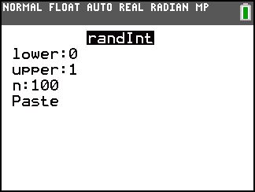
Step 3: Calculate the number of tails for each trial. At the top of L3, enter L1 + L2.  - Survey the results. What is the number of tails that occurs most often? Least often? | 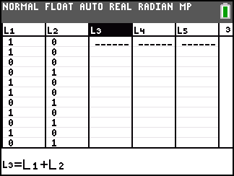
Step 4: Graph the results of the two tosses. Make a histogram of the values in L3 by opening the Statplot menu ( ) and choosing Plot1. Adjusting the settings as shown in the screen shot. | 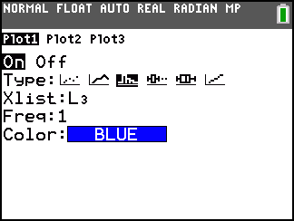
Step 5: Press  and change the settings to those shown at the right.  Press  to view the plot and then . This shows the height (n) of each bar of the histogram at the bottom of the screen. Use the left and right arrow keys to move between the bars.  Calculate each of the experimental probabilities for your data and enter it in the table below. | 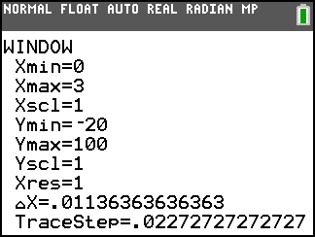
Step 6: Combine your data as a group and calculate the experimental probabilities. Then, calculate the class experimental probabilities. Enter all probabilities in the table.
 | No Tails | One Tail | Two Tails
Individual Results
Group Results
Class Results

Conclusions:
- Did your results match your predictions? Why or why not?

- Why do you think the probability of getting one tail is higher than getting no tails or two tails?

- What is the sample space, set of all possible outcomes, for tossing a coin twice?

- Using the sample space, calculate the three theoretical probabilities for tossing a coin twice.
No tails: ________________
One tail: ________________
Two tails: _______________
- As you combined your results with the class, how did the experimental probabilities compare to the theoretical probabilities?

- Knowing that the probability of flipping one coin once and it landing on tails is ½, how can the theoretical probabilities above be computed (added, subtracted, multiplied, divided) without finding the sample space?

- Explain why the computation for the probability of one tail is different from the others.

Complete the following sentence.
- If two events A and B are independent, then P(A and B) = _______________________.

Problem 2 – One Independent and One Dependent
A basket contains 3 green balls, 3 white balls, and 1 red ball.
- What is the probability of choosing a red ball with one draw?

- Suppose 1 red ball is removed from the basket. If a red ball has been chosen and not replaced, what is the probability of choosing a white ball on the second draw?

The probability of choosing a white ball after a red ball was already drawn is an example of conditional probability. In this example, the events are not independent because knowing that the first one took place affects the probability of the second event.
- The probability of choosing the red ball on the first draw and a white ball on the second draw is . How is the probability of each of these events used to compute the probability?

- What is the probability of choosing a red ball and a white ball in two draws (the order does not matter)? Hint: Think of this as two events, (1) choosing red then white and (2) choosing white then red.

Problem 3 – Conditional Probability
When P(A) > 0, the conditional probability of B given A is

The data in the chart represents the number (in thousands) of students enrolled in college in 2003. The total number of students represented by the chart is 16,638,000.  Enter the data show in the table in L1 and L2. Use the formula L1 + L2 I in the formula bar of L3.  Then use the data to answer the following questions:  - What is the probability that a student chosen at random is a male?
  Age | Male (L1) | Female (L2)
  15 – 17 | 61 | 89
  18 – 21 | 3119 | 3926
  22 – 24 | 1578 | 1742
  25 – 29 | 982 | 1181
  30 – 34 | 607 | 723
  35+ | 970 | 1660
- What is the probability that a student chosen at random is of age 15 – 17?

- What is the probability that a student chosen at random is male and is of age 15 – 17?

- Are the events male and 15 – 17 independent events? Prove or disprove using the rules of probability.

- Given that the student is male, what is the probability that the student is 15 – 17? Confirm your answer using the rule above.

Homework
1. A family decides that they would like to have 3 children.
a. What is the probability that a child is a girl?
b. Using the List Editor, simulate the birth of 3 children. Describe your simulation.
c. What is the experimental probability of having 2 boys and 1 girl?
d. What is the sample space for 3 children?
e. What is the theoretical probability of having 2 boys and 1 girl?
f. What is the theoretical probability of having all girls or all boys?
2. A roulette wheel has 38 slots, numbered 00 and 0 to 36. The slots 0 and 00 are green, 18 of the other are red, and 18 are black. The dealer spins the wheel and at the same time rolls a small ball along the wheel in the opposite direction. The wheel is balanced so that the ball is equally likely to land in any slot as the wheel comes to a stop.
a. What is the probability that the ball will land in any one spot?
b. What is the probability that the ball will land in a red spot?
c. If the wheel is spun twice, what is the probability that the ball will land in a red spot both times?
d. What is the probability that the ball will land in a spot with a 0 or 00?
e. If the wheel is spun three times, what is the probability that it will NOT land on a 0 or 00?
3. Blue eyes are a recessive gene for humans. This means that for a child to have blue eyes, they must inherit the blue eye gene from both parents. Assume that the probability of inheriting the blue-eyed gene is ½. If both parents carry one gene for blue eyes and one gene for brown eyes, what is the probability that they will have a blue-eyed child? If they have two children, what is the probability that both children will be blue-eyed? What is the probability that neither child will be blue-eyed?
4. A standard deck of cards has 4 suits – hearts, diamonds, clubs, and spades. There are 13 cards in each suit – A, 2, 3, 4, 5, 6, 7, 8, 9, 10, J, Q, K.
a. What is the probability that a heart will be chosen?
b. What is the probability that an Ace will be chosen?
c. What is the probability that an Ace of hearts will be chosen?
d. What is the probability that the second card drawn will be a heart given that the first card drawn was a heart?
e. What is the probability that the first two cards drawn will be hearts?
f. What is the probability that a hand of five cards will all be hearts?
g. What is the probability that a hand will contain 4 of a kind?

