|  |  |
| --- | --- |
| **Open the TI-Nspire™ document Tranformations_Dilating_Functions.tns.**  This activity investigates the effect that changing parameters has on the graph of the function. Specifically, you will investigate vertical reflections (through the *x*-axis) and dilations (vertical stretch and shrink). Different types of functions will be explored. |  |

|  |
| --- |
| **Move to page 1.2.** |
| 1. Grab and drag the open point on the parabola. Notice that as the point is moved vertically, the value of *a* changes in the equation and hints appear on the left side of the screen.  a. Using the hints on the left side of the screen, move the open point until there is a reflection, but no stretch or shrink. What is the value of *a?* Describe how the graph changes.  b. Move the open point so that the hint shows a vertical shrink. What must be true about any value of *a*that makes the graph shrink vertically? Describe how the shape of the graph changes.  c. Move the open point so that the hint shows a vertical stretch. What must be true about any value of *a* that makes the graph stretch vertically? Describe how the shape of the graph changes.  d. What must be true of the value of *a* for there to be both a vertical stretch and a vertical reflection? |
| **Move to page 1.3.** |
| 2.On the bottom left portion of the screen, there is a “thumbprint” of the parabola. The thumbprint shows five ordered pairs on the parabola and the difference between each *y*-coordinate.  a. When you vertically stretch or shrink (compress) the graph by moving the open point, what changes in the ordered pairs? What remains the same?  b. Use the thumbprint on page 1.3 to fill in the table below. When the value of *a* = 2, the function can be described as being vertically stretched by a factor of 2. Looking at the table, explain why that description makes sense.   |  |  |  | | --- | --- | --- | | *x* |  |  | | 0 |  |  | | 1 |  |  | | 2 |  |  | | 3 |  |  | | 4 |  |  | |

|  |
| --- |
| **Move to page 2.1.** |
| 3. Observe the ordered pairs of the thumbprint view on the left as you move the open point to change the value of *a* in the absolute value graph. Given the equation , what would the value of *a* be if the graph contains the point ? |
| **Move to page 3.1.** |
| 4. Observe the ordered pairs as you move the open point on the square root graph.  a. What is the *y*-value of the function , when *x* = 2? Why do you think that the ordered pair when *x* = 4 is labeled instead of the ordered pair when *x* = 2?  b. Another point on the function graph is the point (9, 3) when*a* = 1. What ordered pair would be on the graph if the function was vertically stretched by a factor of 3? |
| 5. Given that the point (7, 12) is a point on the graph of *y = f(x)*, what ordered pair would be on the graph of ?  6. Describe the transformation(s) that occur to the function  if the new function is . |

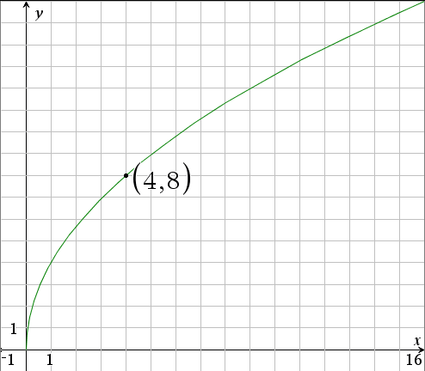7. Given the graph to the right, find the value of *k* for the square root function *f*(*x*) = *k* .

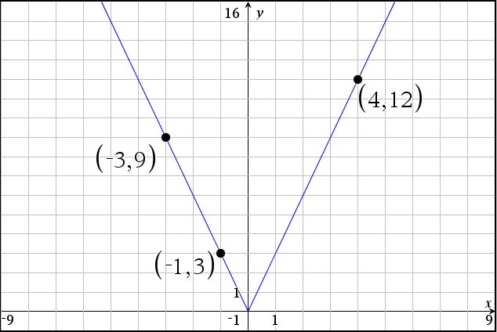

8. What is the equation of the graph to the right?