Part 1 – Empty or Full Seat
Airlines routinely overbook flights to ensure that as many seats as possible are full for each flight. They overbook because they expect a certain percent of people to not show up for their assigned seat.
In this problem, you will explore the number of seats to sell to book a full flight. The flight has 25 seats and historically 20% of people do not show up for the flight.
1. Set up the random number generator. Enter the number given by your teacher. Then press = m ► ► ► e e.
2. On the Home screen, enter the function shown at the right.  Press m ► ► ► and select 5:randInt( to enter the randInt function. A wizard will open if the MODE setting has STATWIZARDS: ON. Fill in as shown. Highlight Paste and press e.  Press = `Ωe. | 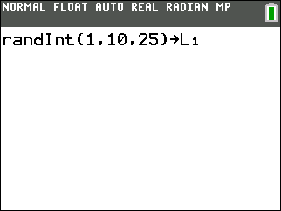
3. Explain in words what the function is calculating.

4. Look at the list in L1 (press S and select 1:Edit…) and write down your numbers.

5. Go back to the Home screen and sort your list in ascending order. Press ` ò ► 1 ` Ω ) e. To view the sorted list press S and select 1:Edit…. Write your ordered list here. | 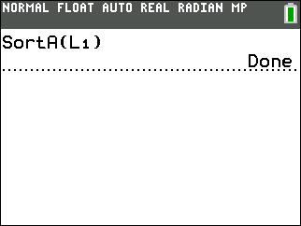
6. Since there is a 20% chance of randomly getting a 1 or a 2, let these represent someone not showing for the flight. In your list, how many people did not show up for the flight?

7. How many people in your class had a full flight?
8. Repeat the steps in Questions 2 and 5 four additional times (for 5 flights total). Were any of your flights full?
9. How many empty seats were on each flight? _____ ______ ______ ______ ______
10. How many seats do you think you might need to sell to ensure the flight is full each time? Explain.

Part 2 – Oversold Seats
Now, you will see how many tickets should be sold to help ensure a full flight.
11. Modify the function in Question 2 to generate 50 random numbers. Instead of sorting the list, this time count from the top of the list and see how many numbers you count before you have a “full” flight. Remember 1s and 2s indicate a person that did not show up.
How many tickets needed to be sold for the flight to be full?
12. Repeat four more times (for a total of 5 flights including Question 11). How many tickets were needed for each flight?
Flight 2? Flight 3?
Flight 4? Flight 5?
13. How do the numbers of tickets sold for your flights compare to others in the class?

14. If you ran the company, how many extra seats would you sell to ensure that the flight is full each time? Explain.

15. What if the no-show rate was 30%? How many seats would then need to be sold to ensure the flights are full each time?

