Introduction
Consider right triangle ABC with right angle ∠ABC and an altitude from the right angle to the hypotenuse. Therefore, m∠ADB = 90° and m∠CDB = 90°. Using our previous work with similar triangles, we could conclude that ABC is similar to ADB and is similar to BDC. When we create proportions from the two smaller triangles we get:  . Simplifying this we have BD² = AD  DC.  The line segment is called the Geometric Mean between and . | 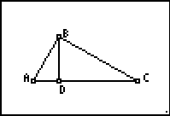
The Geometric Mean
Open the CabriTM Jr. application by pressing  and selecting CabriTM Jr. Open a new file by pressing □, selecting New.
Construct and a perpendicular to through B. Then, use the Point On feature to add a point C on the perpendicular line.

Hide the perpendicular line and construct line segments connecting A to C and B to C. Now construct altitude , such that point D lies on .  You should now have right triangle ABC, with altitude , similar to the triangle shown to the right. | 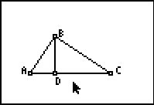
Construct line segments and . Measure the lengths of , , and .
Use the Calculate feature to find the product of the lengths of and .
Then, use the Calculate feature again to find the square of BD. To do this, click on the measure of , press  and click on the measure of again. The square of BD should be equal to the product of AD and DC.

To verify that the triangles are similar, measure the angles in the figure. All of the angles in this sketch have been measured. | 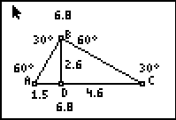
Drag point A and point C so that AD = 2 and DC = 6. It may be very difficult to get these values exactly due to the screen resolution. In this sketch, the accuracy of the lengths of and are shown to one decimal place. | 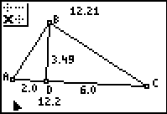
Press C and move your cursor over the measurements for and . Press  to increase the number of digits of accuracy. Now you can see that the lengths may or may not be exactly AD = 2 and DC = 6. Can you make the measurements more exact? If you can, then what you have accomplished is to construct a line segment, , that has length exactly .  (Note: Use the  key to decrease the number of digits of accuracy). | 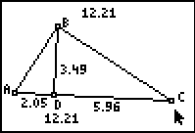
Manipulate your figure again so that AD = 1 and DC = 3. Note that the product of AD and DC, in the sketch at the right, indicates that the lengths aren’t exactly 1 and 3 units, respectively.  1. If the points had been moved so that AD was exactly 1 unit and DC was exactly 3 units, what exact length would have been found for the length of ? | 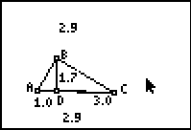
2. What would the lengths of and be in order for the length of segment to be exactly:
a.

b.

Exercises
Use the figure on the right to write a proportion using a geometric mean and solve each problem.  1. If AD = 3 inches, and DC = 27 inches, find the length of .  2. If AD = 4 inches, and BD = 8 inches, find the length of . | ∠ABC is a right angle and .  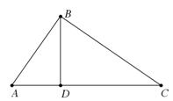
3. If AD = 6 inches, and DC = 9 inches, find the length of .

4. If AD = 5 cm and DC = 10 cm, find the lengths of , , and .

5. If BD = 2 cm and DC = 8 cm, find the lengths of , , and .

