Lesson Overview
Students engage in a dice game with the goal of finding the optimum strategy for winning, in this case, maximizing the possible number of points when tossing dice as long as no sixes show up in a toss. After experimenting with actual dice, students use technology to generate random integers representing the situation and explore how technology can facilitate their investigation. They investigate finding an efficient way to eliminate certain subsets of each set of random numbers (those with a six) and finding a way to accumulate the results of each simulation (typically with some guidance from their teacher). As they try different strategies, students should recognize the tradeoff between the potential for getting a large sum by tossing many dice and the increased risk of getting a six, which results in no points. | Learning Goals
Students will be able to:
- Recognize and capture the variability in tossing dice using simulated samples of the same size (i.e., repeated samples for the same number of dice in a toss)
- Identify possible approaches for maximizing outcomes of a chance game
- Recognize the value of simulation in developing understanding of a problem
- Identify and use conditionals and accumulation commands in creating a simulation
About the Lesson and Possible Course Connections:
The activity can be used whenever students have a background in finding measures of center and elementary probability, typically in upper middle school. The problem can also be done in an algebra two or year two high school mathematics course where students think about expected value and/or examine variability within and across samples in a probability and statistics unit.

CCSS Standards

Statistics and Probability Standards:
- 7.SP.A.1
- 7.SP.A.2
- 7.SP.C.6
- 7.SP.C.7B
- 7.SP.C.8C
- HSS.SP.MD.A.1 +
- HSS.SP.MD.A.2 +

Mathematical Practice Standards

SMP.4

Lesson Materials
- Compatible TI Technologies:
TI-Nspire CX Graphing Calculators, TI-Nspire Apps for iPad®, TI-Nspire Software
- The_Game_of_Hog_Student.doc
- The_Game_of_Hog_Student.pdf
- The_Game_of_Hog_Teacher Notes.doc
- The_Game_of_Hog_Teacher Notes.pdf
- MeanHog.tns

Background
Some games of chance involve dice. One such game is Hog. In this version of Hog, each player may toss any number of dice from one up to the total number of dice available. (In the example that follows, each player can choose from 1 to 7 dice). The number of dice a player chooses to toss can vary from turn to turn. The player's score for a turn is zero if at least one of the dice comes up with the value six. Otherwise, the player's score for the turn is the sum of the faces showing on the dice. (Tossing a six gets a zero just for that toss not for the total cumulative score for the player.) A cumulative running total of the scores is kept for each player.

If you can choose to toss anywhere from 1 to 7 dice, what number of dice should you choose to win the game?

Facilitating the Lesson
Give students sets of dice and have them spend five or ten minutes tossing different numbers of dice and reflecting on the number of points each toss would earn. The idea is not to develop a mathematical approach to solving the problem but rather do so experimentally, by actually simulating different strategies. Have students in random groups of three brainstorm about possible strategies for optimizing the chance of winning the game.

Students’ initial thinking is likely to be based on empirical evidence, actually tossing a given number of dice and finding the sum. Eventually they may want to replicate the situations in ways that are less time consuming by using random number generators and writing some simple steps to facilitate the process. Several examples are described below.

1) Open-Ended Approach:
The problem is not well defined- how many tosses, how long should the game run, etc. Some groups might decide to set a limit on the number of points, say whoever reaches 100 points first wins. Others might decide to limit the number of tosses, say to 25, where the winner is the person with the most points after 25 tosses. Others might decide to look for the mean number of points per toss for a given number of dice. Be sure students recognize that the number of points will vary per toss for a given number of dice, and they need to find some way to estimate what is likely to happen overall.

2) More-Structured Approach to Finding a Model:
If students need more guidance, structure the problem by prescribing the total number of points to win the game, e.g., the first to reach 100, or by defining the number of tosses, e.g., who is ahead after 25 tosses for each participant. Encourage the students to share the work, either with different students repeatedly tossing a different number of dice or by all tossing the same number of dice and pooling their results.

What to Expect: Example Student Approaches
No Technology:
One approach is to investigate what is likely for each number of tosses from 1 to 7. One student might toss one die 25 times, do this repeatedly, then find the mean of the sums for one die. Another might do the same for two dice and so on. Another approach is to have everyone in class toss one die and find the mean of the sums earned by the students in the class; repeat the process with everyone in class tossing two dice and so on. Some students might think alternating the number of dice would be a good strategy, particularly if they are behind and want to risk tossing a larger number of dice to potentially get a larger sum.
After students have tossed different numbers of dice by hand and recorded the results, they should realize they need to do many simulations to see any pattern. This is where technology comes in. Note however, that technology can easily become a black box, where inputting several numbers produces a result that might not be understood. Ensuring that students actually understand what the technology is doing often means taking small steps to lay the groundwork. Some students might be content with primarily using technology to generate the random numbers and working from there to eliminate sixes from the sums. Several possible pathways are described below.
Example 1 Best Score out of 25 tosses:  A spreadsheet can be used to simulate the number of points that would be earned if a player took 25 turns and tossed only one die each by defining column A as randint(1,6,25) (Figure 1). | 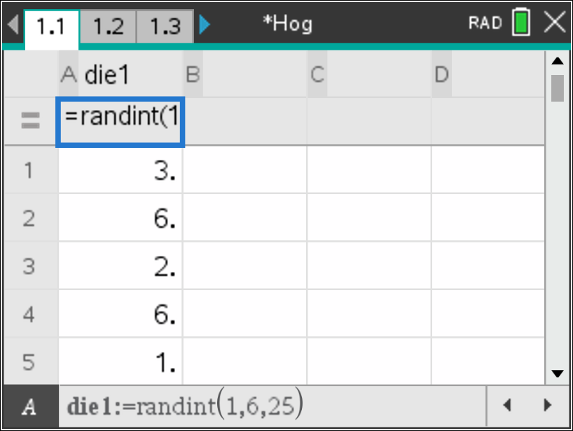  Figure 1: Simulate tossing one die 25 times
In an empty cell, enter total:=sum(die1) to sum the 25 numbers (Figure 2). Be aware though, that this sum includes all the sixes. | 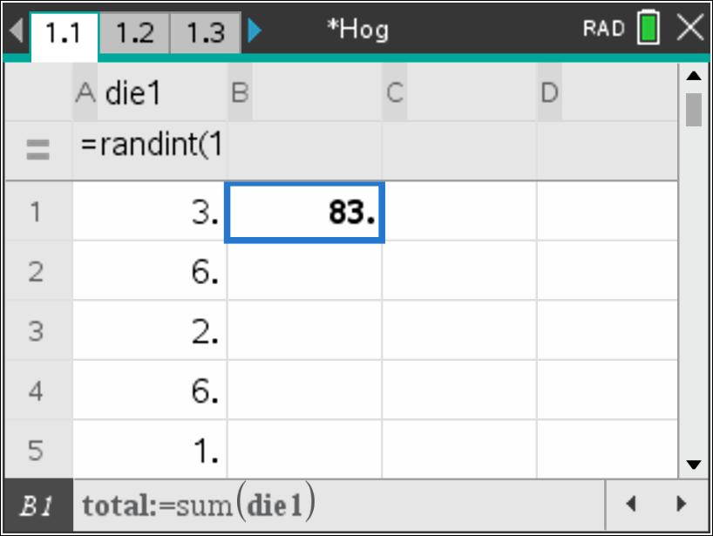  Figure 2: Sum the faces for the 25 tosses

Students will need to devise a method to eliminate any toss that was a six. For example, using the command sixes:=countif(die1,?=6) in another cell will show the number of times the toss resulted in a six (Cell B2 in Figure 3). Subtracting 6 times the number of sixes from the original sum gives the total score for the 25 tosses. In another cell students can define score:=total – 6*sixes. Entering control R in any empty cell will generate a new set of random numbers in column A and a new sum in column B. | 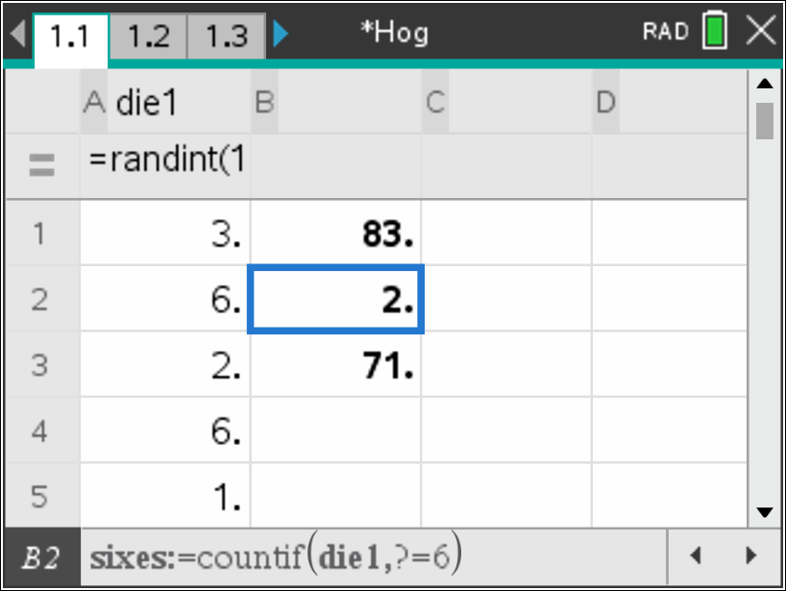  Figure 3: Subtract 6 x 2 = 12 from sum
Students can record the sums in another column manually or accumulate them as they are generated by using score1:=capture(score1,0) in the equation line of a new column (Figure 4). Each time a new "roll" is made, press ctrl and the period key to capture the data point. So the process for collecting data is / + R then / + ^ repeatedly. | 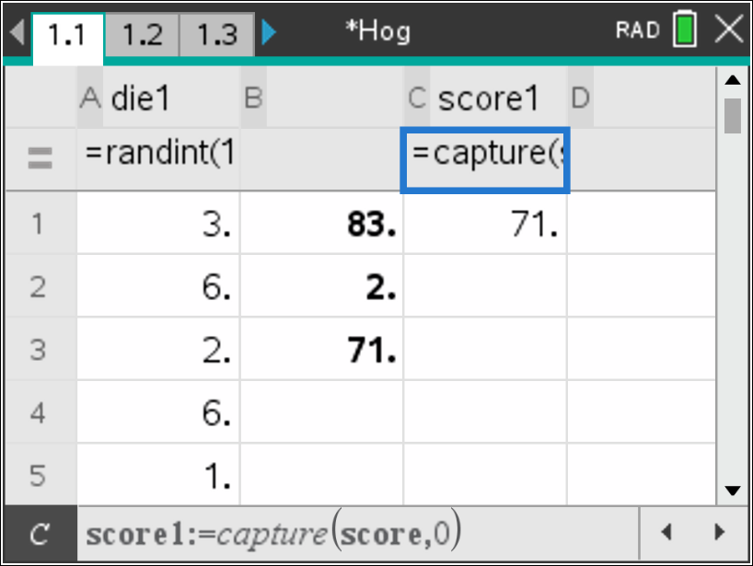  Figure 4: Capture the score in another column
Repeating the process will produce a distribution of sample sums similar to the one in Figure 5a. To find the mean sum for many repetitions of tossing a die 25 times, plot score1 in a Data & Statistics page and then select Menu, Analyze, Plot Value. Type in mean(score1) for the definition of v1 (Figure 5a).  Using a split screen displays the distribution as it is generated. To display split screen press doc and select page layout.(Figure 5b) | 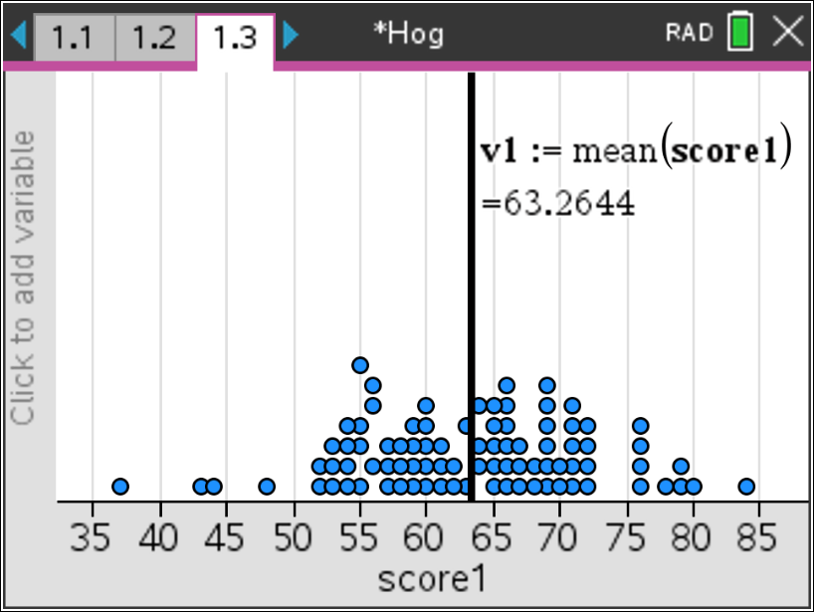  Figure 5a: Hog mean score tossing one die 25 times  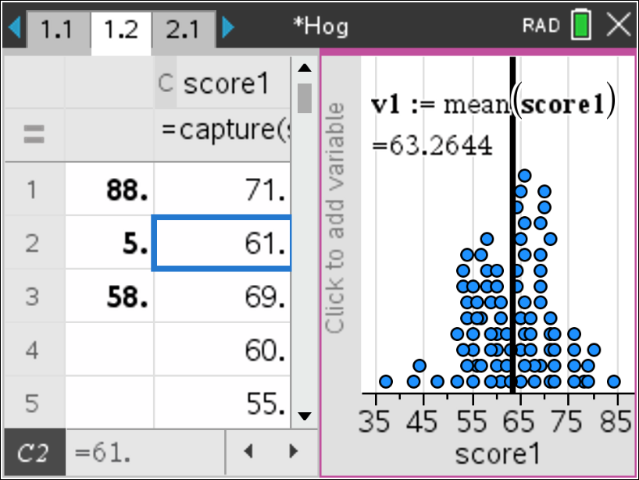  Figure 5b: Split screen to see accumulation

To estimate a score when tossing two dice, students might generate two columns of 25 random numbers as before. In column C and fill down 25 cells with the following statement =when(a1=6 or b1=6, 0, a1+b1). This means for each row, when either column a is a 6 or column b is a 6, column C will show a 0, otherwise it will show the sum of columns A and B for that row. Using fill down applies the logic to each row (Figure 6). To fill down, select cell c1, press menu, select data>fill, then arrow down to c25. Store the sums and capture them as before, using the capture command. Using / + R then / + ^ in any cell many times will give a simulated distribution of scores for tossing two dice 25 times (Figure 7). | 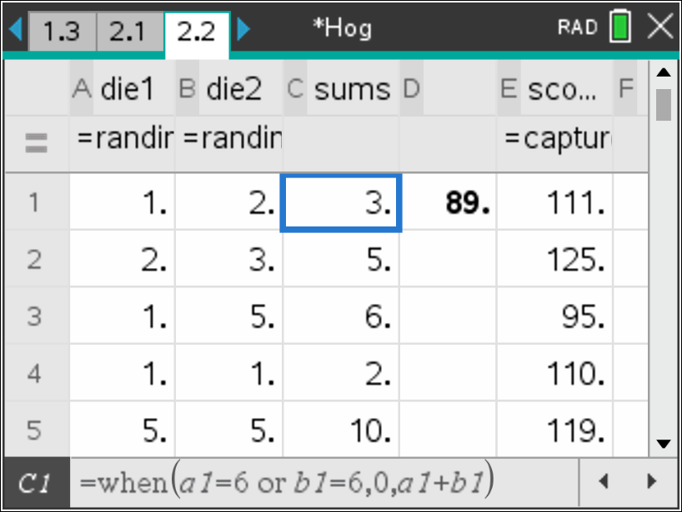  Figure 6: Fill down the “when” statement
The same procedure can be used to estimate the total scores in 25 tosses of three, four, five, six or seven dice. Note that students might find other ways to generate the outcomes. | 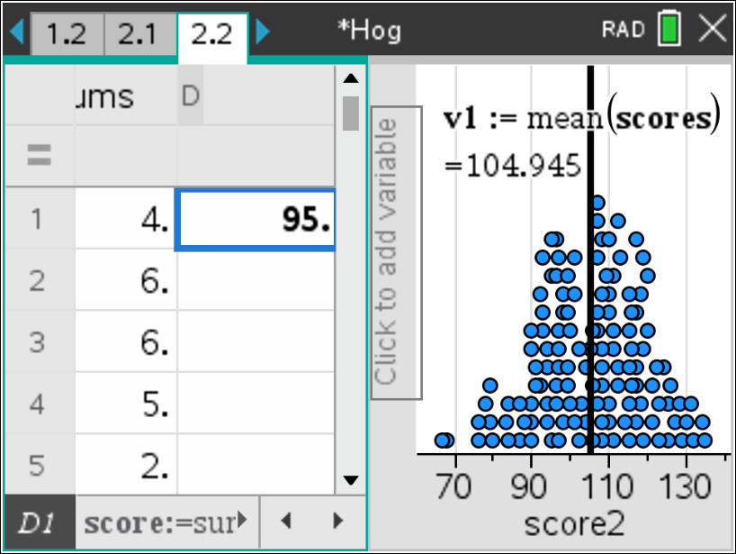  Figure 7: Distribution of Hog mean scores tossing two dice 25 times
Example #2: Finding the mean sum for tossing a given number of dice one time using a spreadsheet  Another approach is to consider what a typical score will be when tossing a specified number of dice, say three. This can be done on a spreadsheet by creating a set of three random numbers in column A. To find the score, check the maximum value using a “when” statement in column B; score:=when(max(set)= 6,0,sum(set)). The value in b1 will equal 0 if a six is present and the sum if a six is not (Figure 8). | 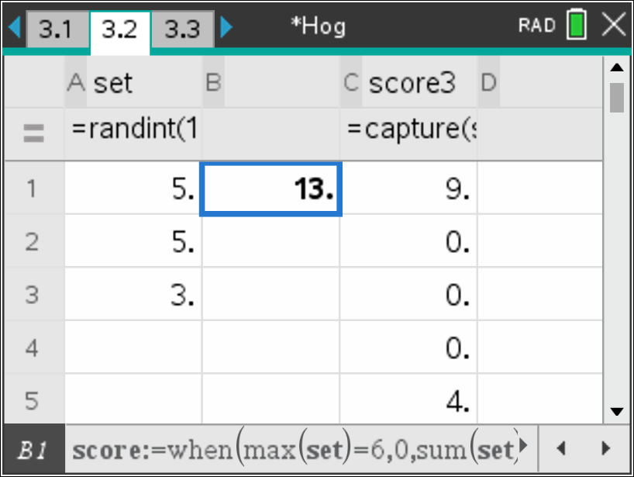  Figure 8: Spreadsheet and tossing three dice

Using capture(set,0) in column C then / + R then / + ^ repeatedly will generate new sets of random numbers and display the corresponding sums. Collecting the sums will give a sampling distribution of sums when tossing three dice. You can add the mean as shown in Example 1 (Figure 9). | 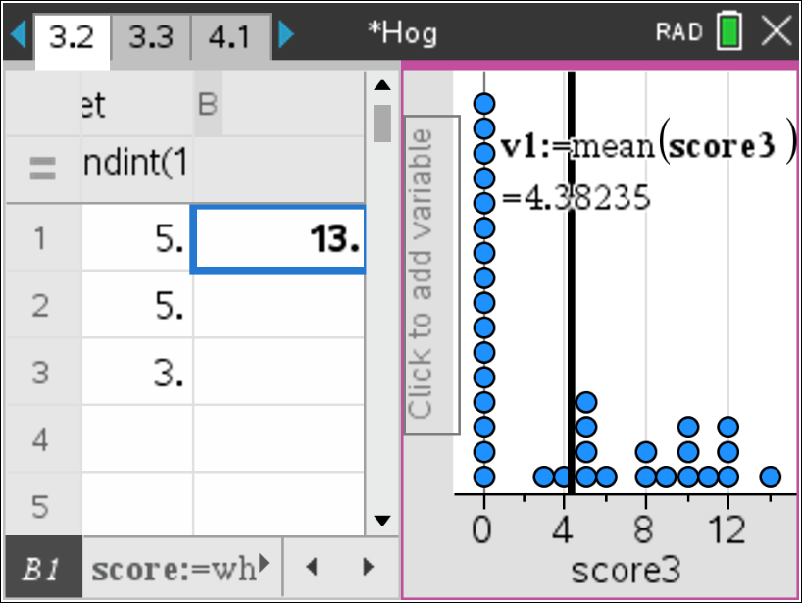  Figure 9: Simulated distribution of scores from tossing three dice
Example #3: Finding the mean sum for tossing four dice one time using a notes page  The simulation can also be done in a notes page using a math box (ctrl +m). (Figure 10). Define t with value 1 or 0. Define “set” to generate random numbers simulating tossing four dice. Define the “when” statement to calculate the sum using score(t) as in line three in Figure 10. | 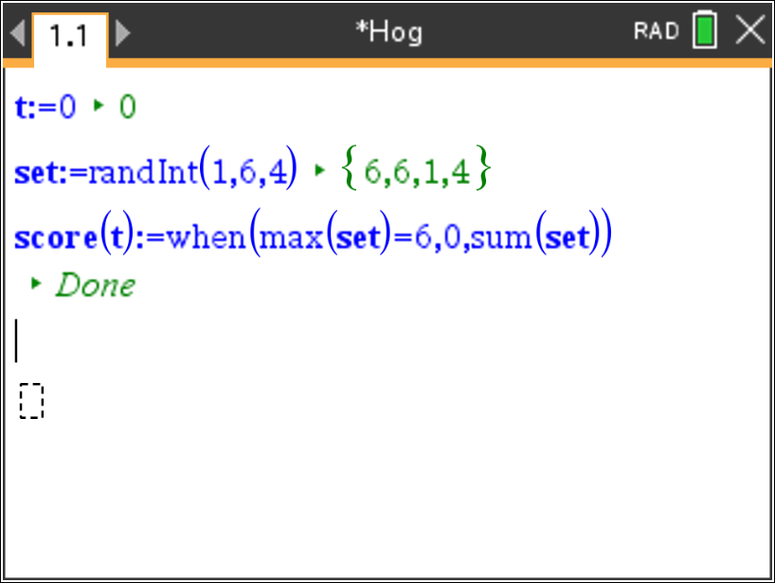  Figure 10: Math Box and tossing four dice
Define the list “sum4” as an empty list as shown in Figure 11 on line four. | 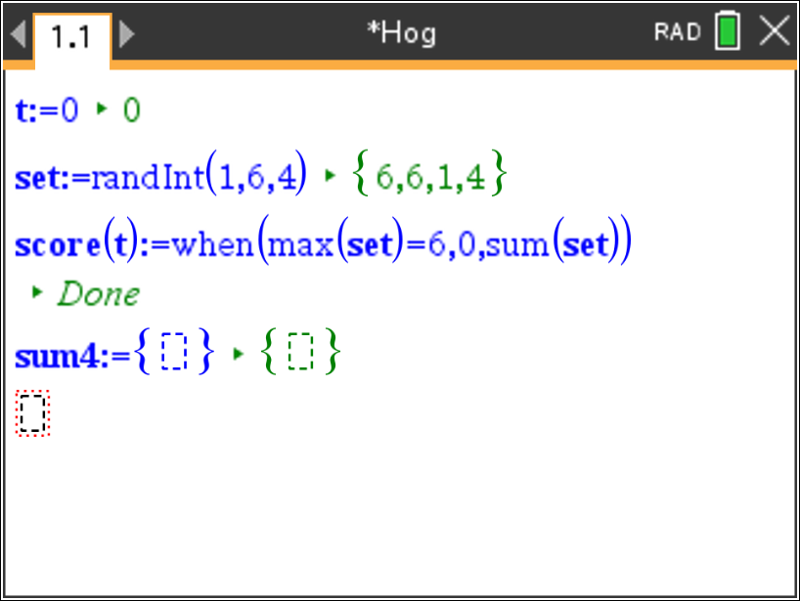  Figure 11: Defining list sum4
Redefine sum4 using the augment command as in line 4 in Figure 12. This will augment, or append the list, sum4, with the value score(t) each time enter is pressed in the definition of set. The “t” serves as a trigger for collecting the sums and does not have any impact on the value of those sums. | 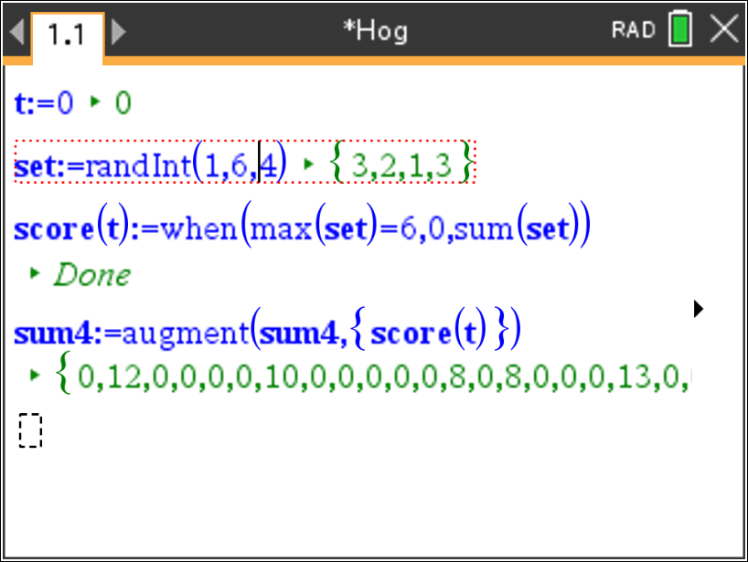  Figure 12: Augmenting sum4 with new sums

Figure 13 displays a simulated distribution of the mean sum for tossing four dice. | 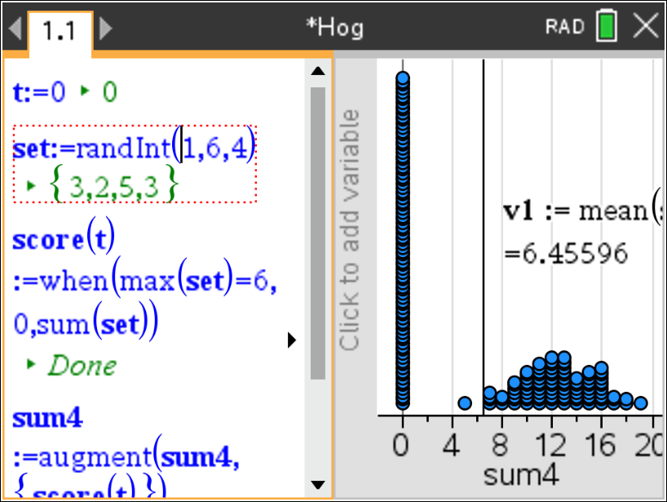  Figure 13: Hog mean sum tossing four dice
A slider can be used to make the entire process automatic by triggering the commands to generate random numbers, compute sums, accumulate the sums as they are generated and keep track of how many different sums have been calculated. Start by inserting a slider for variable n, as shown in Figure 14. Minimizing the clicker helps save screen space. | 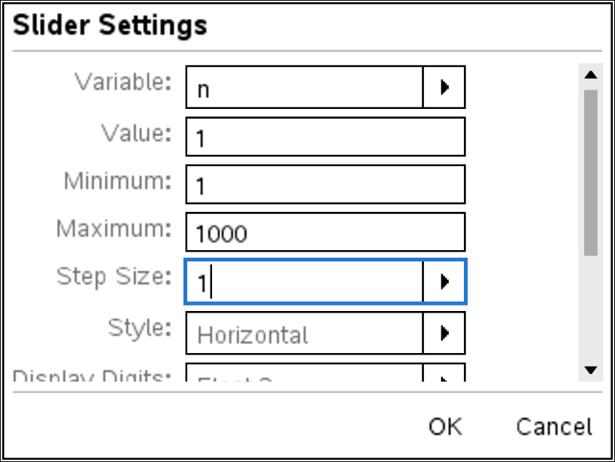  Figure 14: Setting up the slider
Next, define a function, set(n) to show the five random numbers. Then define a variable toss5 to store those numbers. Define score(n) as shown on line four in Figure 15, using a when statement to determine whether to sum the toss or record a zero. Then setup the list variable sum5 as an empty list. | 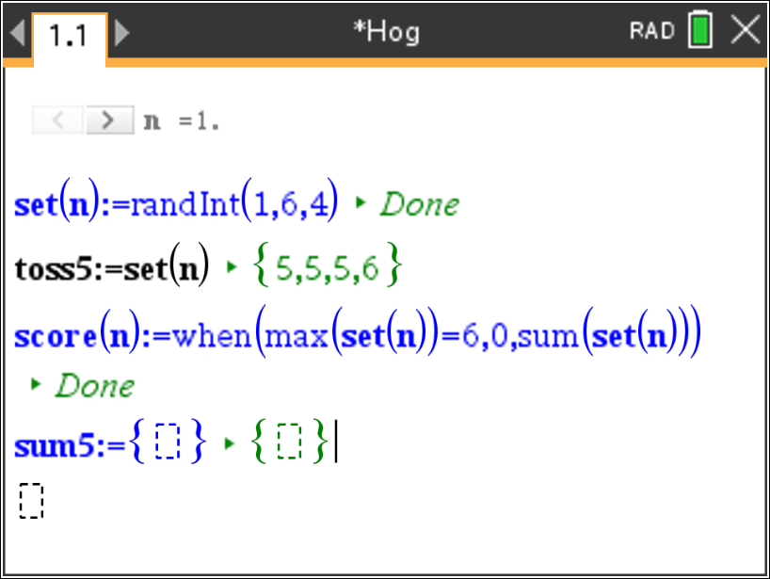  Figure 15: Setting up the simulation
Finally, redefine sum5 to augment or append the scores recorded in the score variable using the augment command as shown in line five in Figure 16. | 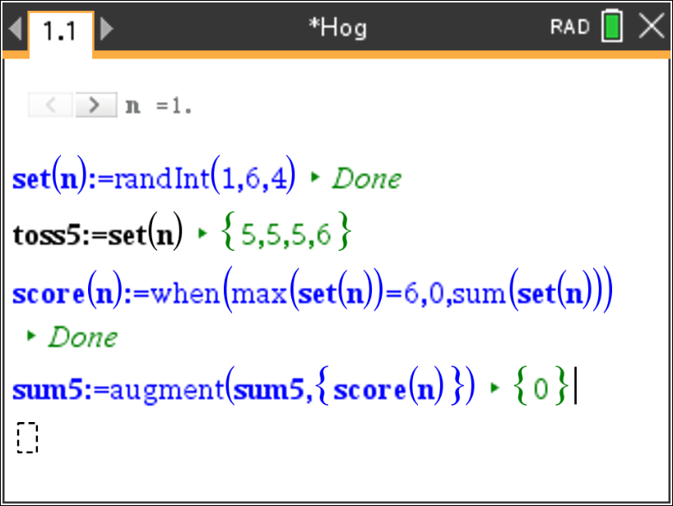  Figure 16: Augmenting the list to accumulate the sums

The distribution of the mean sum for 50 tosses of five dice is displayed in Figure 18. Estimated mean sums for tossing six and seven dice can be done in the same way, replacing the 5’s by the appropriate number. | 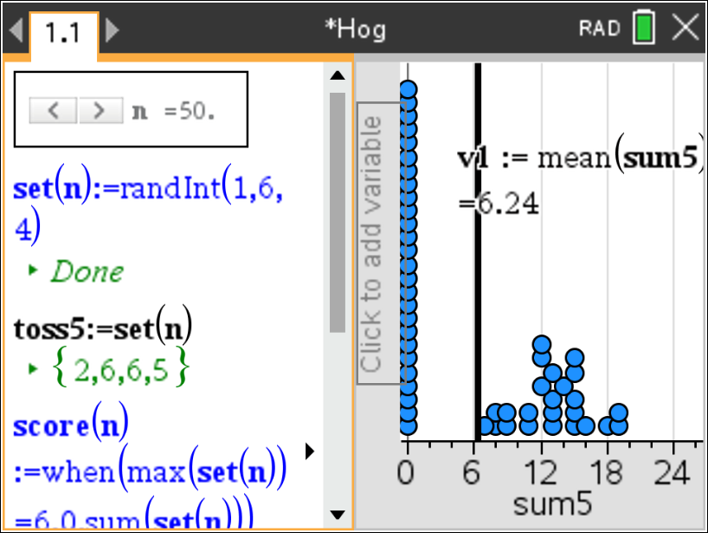  Figure 18: Hog mean sum of 50 tosses of five dice
Table 1 shows the results for simulating the mean sum when tossing 1 to 7 dice 50 times as well as the mean score in 25 tosses. | Table 1  Number of dice Estimated mean score per toss Estimated mean score for 25 tosses  1 2.52 63.26  2 4.20 104.95  3 4.38 131.46  4 6.46 161.5.  5 6.24 172.0  6 6.72 168.00  7 6.31 157.75

Validating the Models
Students should validate their models either by asking whether the models make sense in different scenarios related to the context or by finding other information to reflect against the model. The suggestions below might be useful in helping students think about whether their model was reasonable:
- Students should compare their results to those others found. Note that the values might vary as much as 3 points. If the results are quite different, they should reexamine what they did.

- If students have a background in thinking about probability, they might use expected value to compare the theoretical results to the experimental results. Expected value is the sum of the probability of each outcome times the value of that outcome. For example, the formula for the expected value for rolling one die would be:
$\frac{1}{6}\left(1\right)+ \frac{1}{6}\left(2\right)+ \frac{1}{6}\left(3\right)+ \frac{1}{6}\left(4\right)+ \frac{1}{6}\left(5\right)+ \frac{1}{6}\left(0\right)=\frac{15}{6}=2.5$

For two dice:
$\frac{1}{36}\left(2\right)+ \frac{1}{36}\left(3\right)\left(2\right)+ \frac{1}{36}\left(4\right)\left(3\right)+ \frac{1}{36}\left(5\right)\left(4\right)+ \frac{1}{36}\left(6\right)\left(5\right)+ \frac{1}{36}\left(7\right)\left(4\right)+\frac{1}{36}\left(8\right)\left(3\right)+ \frac{1}{36}\left(9\right)\left(2\right)+\frac{1}{36}\left(10\right)\left(1\right)+ \frac{1}{36}\left(11\right)\left(0\right)+ \frac{1}{36}\left(12\right)\left(0\right)=\frac{150}{36}=4.17$

And so on. (Note that as the number of dice increases, the complexity of counting the possible number of ways to obtain a sum also increases.)

*The tns file Meanhog can be used to find the actual expected values for different numbers of dice.

Extension

- Answer each of the following:
- How would your analysis change if the number of dice allowed was from 1 to 10?

- Is the probability of getting a sum of 25 tossing five dice greater than, less than or the same as the probability of getting a sum of 36 tossing six dice? Explain your reasoning.
- The tns file Meanhog can be used to create the expected value for tossing from 1 to 100 dice. Make a plot of (number of dice, expected value). Describe how the plot can be used to inform a strategy for winning in Hog.

  - Design a strategy for winning the games below.
    - A New Game: For each turn, a player repeatedly rolls a die until either a 6 is rolled or the player decides to "hold":
- If the player rolls a 6, the player scores nothing and it becomes the next player's turn.
- If the player rolls any other number, it is added to the player’s turn total and the player's turn continues.
- If a player chooses to "hold", the player’s turn total is added to the player’s score, and it becomes the next player's turn.
- The first player to score 100 or more points wins.

b) A variation: For each turn, a player repeatedly rolls one or two dice until a 6 is rolled or the player decides to hold.
- If neither face is a six, the sum of the faces is added to the player’s score and the player’s turn continues.
- If a player chooses to “hold”, the total the player has earned from the round is added to the player’s score and it becomes the next player’s turn.
- The first player to score 100 or more points wins.

4. A fair game is when every opponent has an equal chance to win the game. Is the following game fair?
- Player 1 rolls a die and records the number.
- Player 2 rolls two dice. If one of the numbers is the same as the number player 1 rolled, player 2 gets a point. If neither number is the same, player 1 gets a point
- The turn passes to player 1 again.
- First player to 11 points wins.

Resources
Resource: See http://jse.amstat.org/v11n2/feldman.html

