With a large number of observations, the overall pattern of the data may be so regular that is can be described by a smooth curve. A smooth curve describes an idealized situation and ignores irregularities as well as outliers.
A density curve is a special smooth curve which has two properties.
a. Always on or above the horizontal axis.
b. The area underneath it is 1.

1. Sketch a density curve that fit each of these histograms.
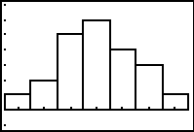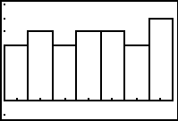

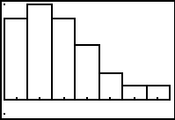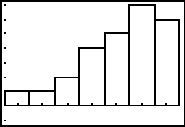

2. For each distribution above, put your pencil on the horizontal axis where you estimate the mean is. Draw and label a vertical line at this point.
3. For each distribution above, put your pencil on the horizontal axis where you estimate the median is. Draw and label a dotted vertical line at this point.
Press S e and then enter the data at the right into lists L1 – L5. | 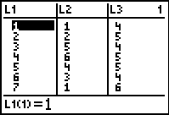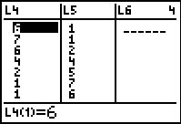
Adjust the window settings as shown below. Graph each of the four histograms by setting each Xlist as L1 and then Freq as L2 through L5, respectively.
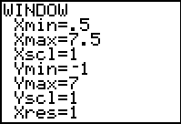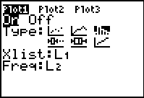
For each histogram, find and plot the mean and median using these commands:
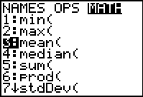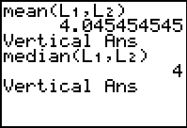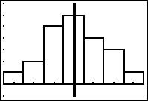
Press ` p, and select ClrDraw after finding the mean and median for a distribution.

4. Compare the mean and the median in the distributions. Write a sentence describing where these values lie for each type of distribution.

Symmetric:

Skewed right:

Skewed left:

