Problem 1 – Constant Integrand
Suppose you have the function y = 1.5 as seen at the right. How will the area under the curve change as we go from 0 to x? Find the area under the curve by evaluating the definite integral. |  | 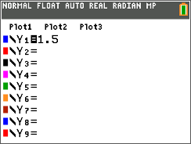
For each value of x, you are looking at a rectangle with x for the length and 1.5 for the height. Graph Y1(X)=1.5 using X[–1, 6] and Y[–3, 5] for the window. While on the graph screen, press y r (Calc), and press ¬ for the command .  The lower limit is 0 and the upper limit is the current value for x, starting with 1. |  | 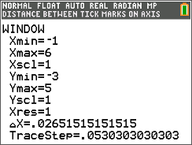
1. Use the Integrate command illustrated above to complete the table. |  | 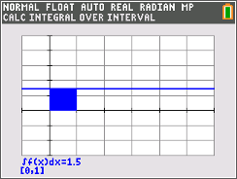
  x
  1
  2
  3
  4
  5
2. If x = 0, what is ? Why?

3. For every 1 unit that x changes, how much does change?

4. If you were to graph the ordered pairs , what would the graph look like?

Using the data in Question 1, enter the data into L1 and L2. Then plot the data.
5. What does your graph look like? Was this graph what you predicted in Question 4?

6. If you changed the integrand from 1.5 to 0.5, what would the graph of look like?
Problem 2 – Non-Constant Integrand
Suppose you have the function as seen below. How will the area under the curve change as you go from 0 to x? Find the area of the triangle by hand or by evaluating the definite integral, as shown in Problem 1.
7. Complete the table.
 | 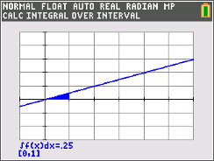
  x
  1
  2
  3
  4
  5
8. If x = 0, what is? Why?

9. Explain why, when x increases by 1, the value of does not increase by the same amount every time?

10. a. Is the graph of linear? Explain.
b. Using the values in the table in Question 7, enter the data into lists L1 and L2. Then plot the data.

c. Describe the shape of the graph.

d. By using guess ‘n check, try to find the equation that models this data and graph it.
Problem 3 – An Integrand that Changes Sign
In the previous exercises, the function was positive over the interval. This time you are going to examine a function which changes sign, . How will the area bounded by the curve and the x-axis change as we go from 0 to x? Find the area bounded by the x-axis and the curve by evaluating the definite integral. Complete the table and round answers to the nearest hundredth.
Graph Y1(X)= using X[–2, 15] and Y[–3, 8] for the window. While on the graph screen, press y r (calc), and press ¬ for the command . The lower limit is 0 and the upper limit is the current value for x, starting with 1.
11. Complete the table.
 |  | 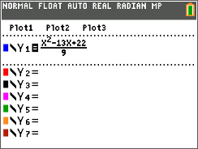  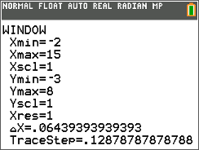  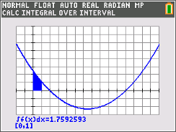
  x
  1
  2
  3
  4
  5
  6
  7
  8
  9
  10
  11
  12
  13
  14
12. At what value of x does the integral’s value begin to decrease?

13. a. What are all the values of x for which the definite integral’s value is decreasing?

b. What is true at these values of x?

14. a. What are all the values of x for which the integral’s value is increasing?

b. What is true of the integrand at these values of x?

15. a. What is the smallest value of the integral, and at what value of x is this reached?

b. What happens with the integrand at this value of x?

16. Is the connection between the location of the minimum value of and the sign change of the integrand from negative to positive one you that you have seen before? If so, in what context?

