June collected the distances she drove each weekend for 30 weekends. The distances, stored in the list WKND, are listed below.
31, 8, 93, 69, 75, 2, 33, 194, 83, 17, 2, 207, 99, 32, 8,
2, 75, 126, 30, 9, 211, 93, 8, 75, 198, 25, 32, 71, 9, 98
Part 1 – Create a Box Plot
Create a box plot of the distances.  Press ` å and select Plot1. Press e to turn the plot on. Select the box plot icon. Arrow down to Xlist.  To select WKND as the Xlist, press ` ò, arrow down WKND, and press e. | 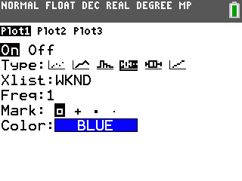
Press @. An appropriate window would include x-values that range from 0 to 220. The box plot is not affected by the y settings because it is not paired with a second set of numbers.  Press %.  Press $ to view the values of each section of the plot. | 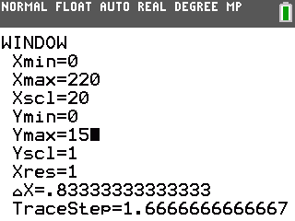
1. Minimum: ____ Q1: ____ Median: ____ Q3: ____ Maximum: ____
2. Why is the first whisker so short? What does it mean for the other whisker to be so long?

3. What does the median value say about the distances traveled? Since this point is the “middle” point in the data, why is the box plot not balanced at this point?

4. Plot the mean of the distances by entering the command shown at the right. Press ` õ to access the Vertical command and press ` ò and arrow to the MATH menu for the mean command.  Where is the mean located on this plot? | 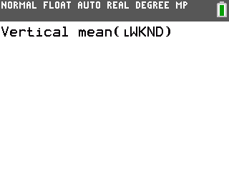
Part 2 – Create a Histogram
Create a histogram of the distances.  Press ` å and select Plot1. Press e to turn the plot off.  Press ` å and select Plot2. Press e to turn the plot on. Select the histogram icon. Arrow down to Xlist and select WKND. | 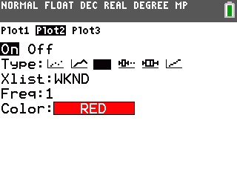
Press %. Press $ and use the arrow keys to view the number of entries per bar.
5. How many weekends did June drive between 20 and 40 miles? ____
6. How many weekends did June drive less than 60 miles? ____
7. How many weekends did June drive more than 120 miles? ____
Plot the mean and median of the distances. Press ` ò and arrow to the MATH menu for the median command.
8. Where are the median and mean on this plot?

9. The interval from 40 to 60 should contain the median of 51, but it shows zero entries. How is that possible?

Part 3 – Compare a Box Plot and a Histogram
To better understand the shape of the box plot, compare it to the histogram. Press ` å and select Plot1. Press e to turn the plot on.
10. How does the shape of the histogram compare to the shape of the box plot?

11. How does the tallness of the first bar relate to the shortness of the first whisker?

12. What do you see now about why the other whisker is so long?

