Start the Cabri Jr. application and open the file EXTINT. Triangle DEF is shown with its interior angle measures.  - Create using the Line tool.  - Place point G on the outside of point E using the Point On tool.  - Use the Angle tool to find the measure of ∠GEF. | 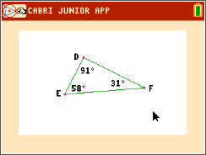
1. Move point E to four different positions and record the data in the table.
Position | m∠GEF | m∠EDF | m∠DFE
1
2
3
4
How is the measure of ∠GEF related to the measures of ∠EDF and ∠DFE?

- Use the Alph-Num tool to place EDF + DFE on the screen.
- Find the value of the expression using the Calculate tool. Select the first angle measure, select the operation, and select the other angle measure.
2. Move point E to four different positions and record the data in the table.
Position | m∠GEF | m∠EDF + m∠DFE
1
2
3
4
How is the measure of ∠GEF related to the sum of the measures of ∠EDF and ∠DFE?

3. Angle GEF is an exterior angle. Angles EDF and DFE are its remote interior angles. What conjectures can you make about an exterior angle and its remote interior angles?

