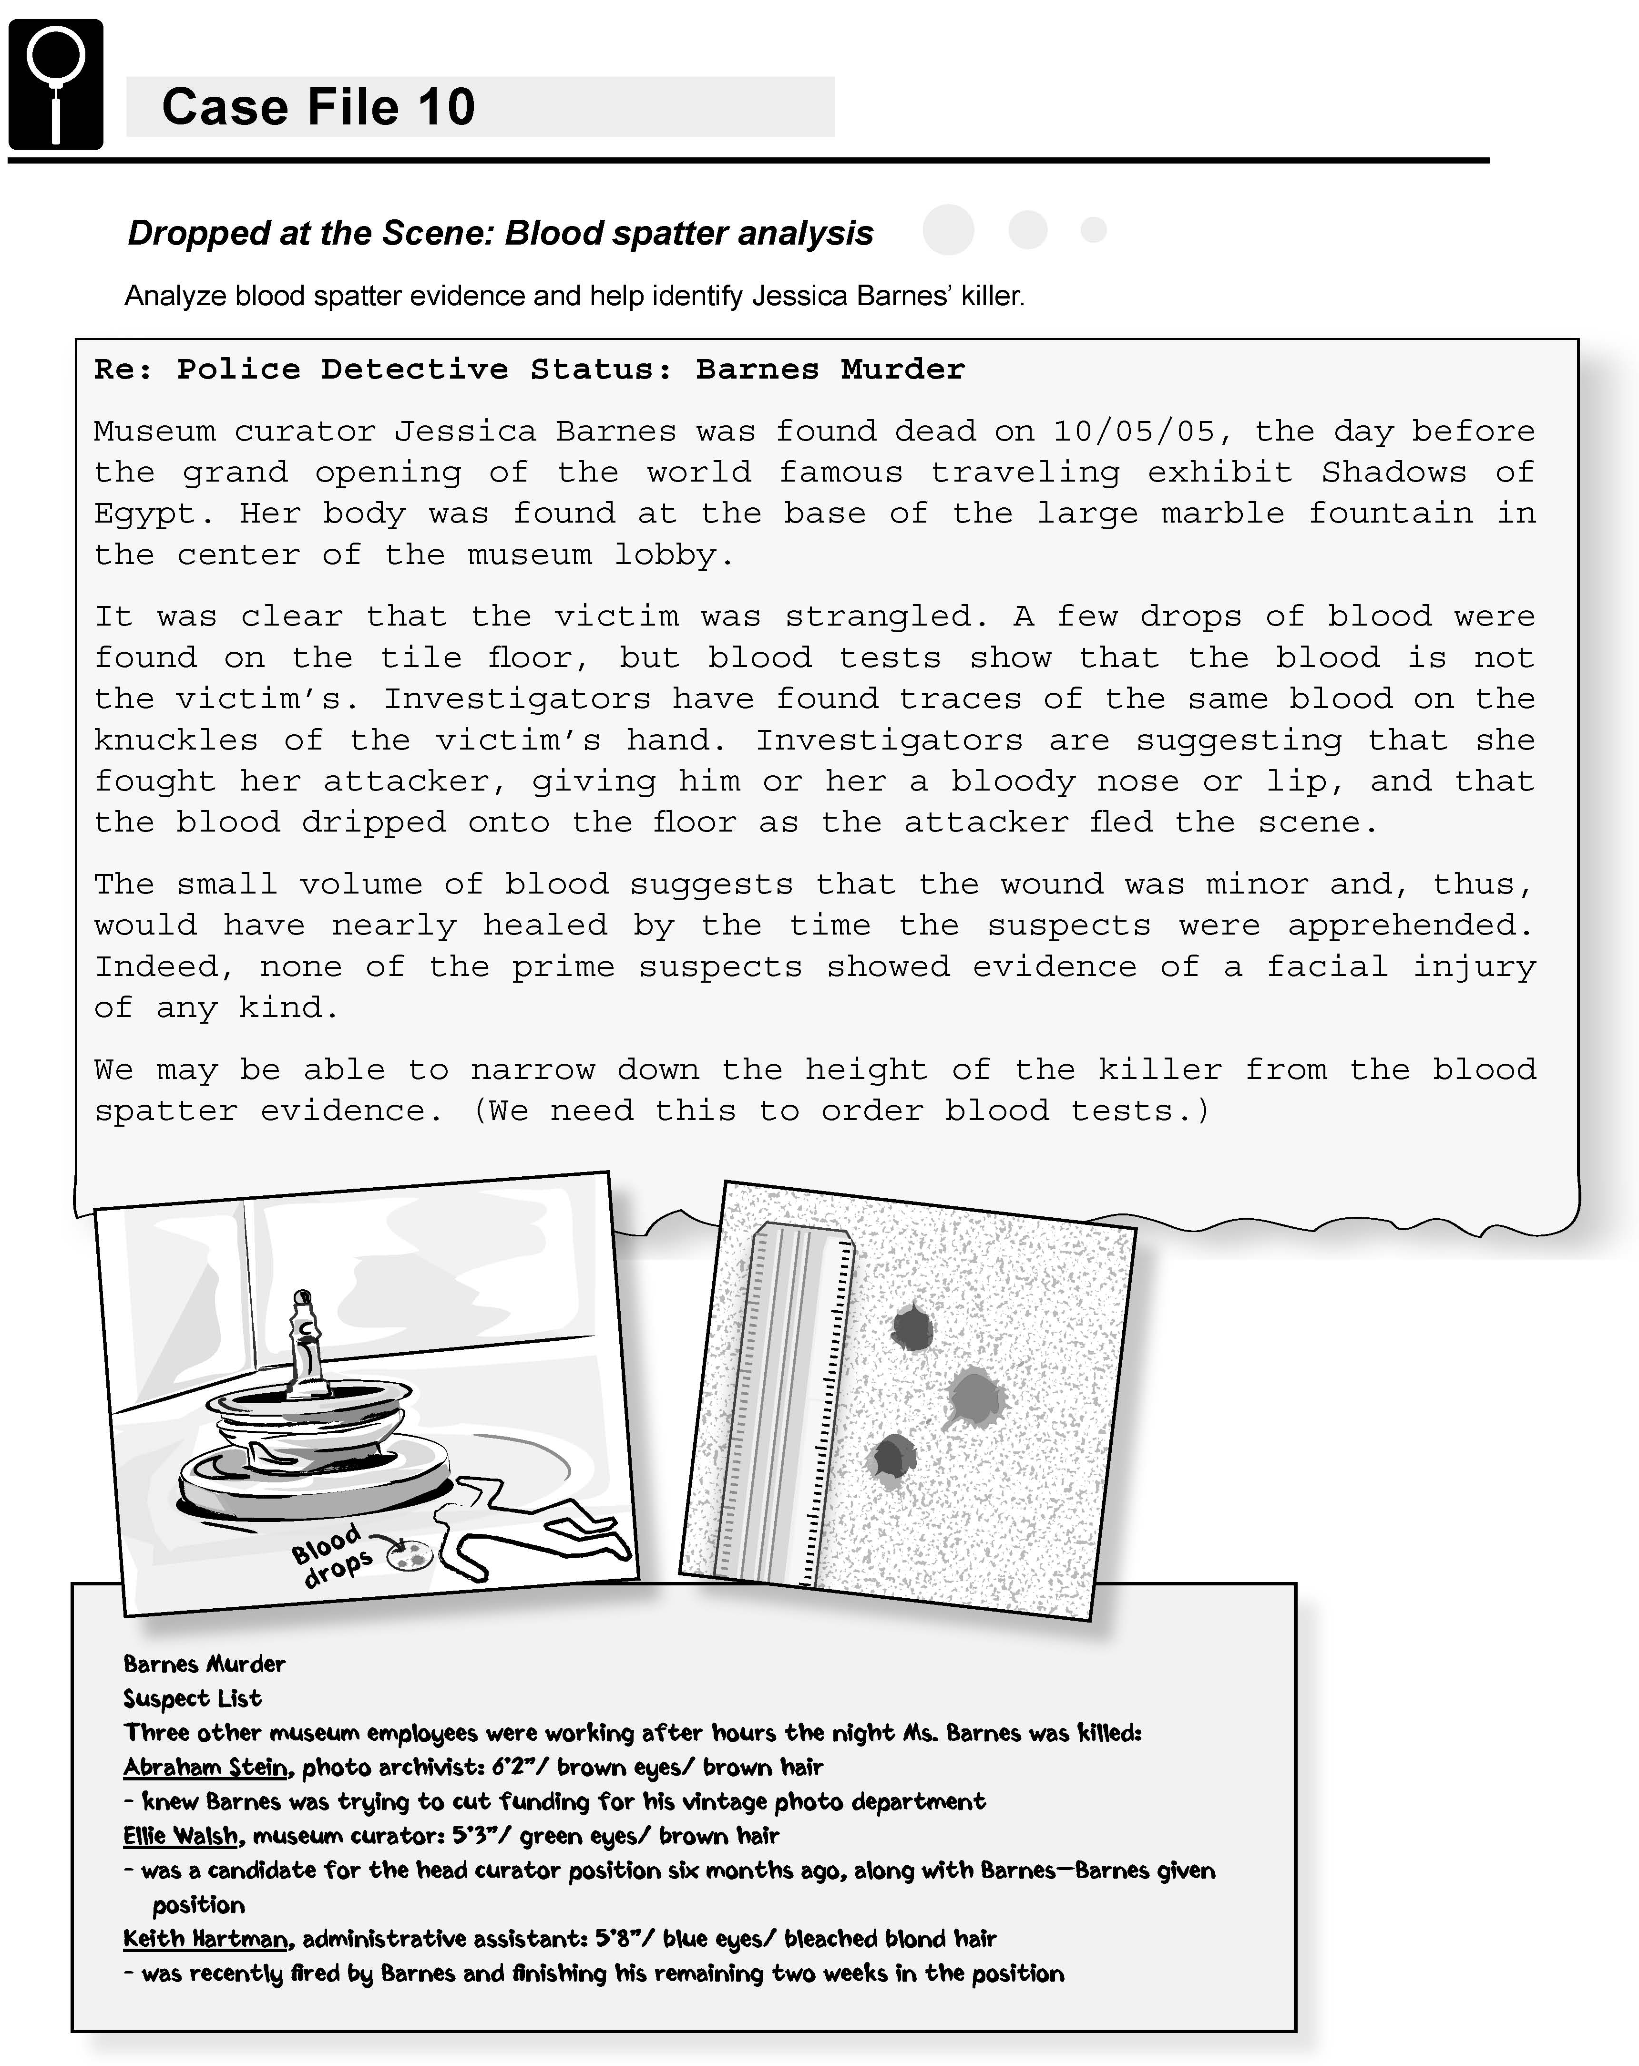
Science Objectives
- Determine the height of a source of blood spatters or drops
- Graph data to find quantitative relationships
- Create a standard reference curve for comparison with unknown data

Activity Materials
- TI-Nspire™ technology  - Case 10 Dropped At The Scene.tns file  - metric tape measure or meter stick  - newspaper | - 13 pieces of white paper  - disposable pipettes or droppers  - simulated blood  - calipers, or compass and metric ruler
Procedure
Open the TI-Nspire document Case 10 Dropped At The Scene.tns.  CAUTION: Obtain and wear goggles during this experiment. Tell your teacher right away if any spills or accidents occur. |  | 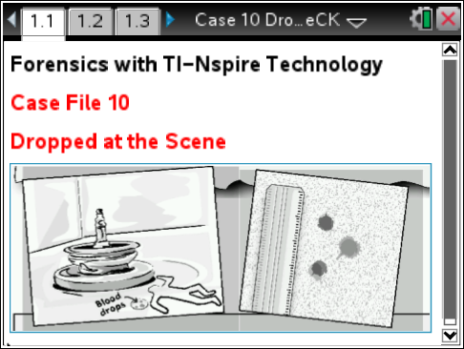
Part 1 – Collecting Data
Move to pages 1.2–1.3.
1. Create blood spatters from known heights and compare them with unknown samples.
a. Spread newspaper on the floor. Place a piece of white paper on the newspaper.
b. Fill a pipette with simulated blood. Drop a single drop onto the white paper from a height of 10 cm.
c. Measure the diameter of the spatter in millimeters, using calipers or a compass. Record the diameter in the Evidence Record, along with any observations you can make about the shape of the spatter. Note: If the spatter has a ragged edge, measure only the diameter of the main blood drop; do not include any ragged edges in your measurement.
d. Repeat Steps 1b and 1c twice more, moving the pipette to slightly different locations but maintaining a height of 10 cm.
2. Calculate the average diameter of the spatters that fell from 10 cm, and record it in the Evidence Record below.
3. Replace the white paper with a clean sheet.
4. Repeat Steps 1–3 for each remaining height in the Evidence Record below.
Part 2 – Analyzing the Data
Move to pages 2.1–2.3.  5. Transfer the data from your Evidence Record to page 2.1 in order to create a graph of the average spatter diameter vs. drop height.  a. In the first cell in the height column in the table, enter the height of the first blood spatter recorded in the Evidence Record.  b. Move to the first cell in the diameter1 column. Enter the diameter of the first blood spatter next to the corresponding height.  c. Continue in this manner to enter data for all the remaining heights recorded in the Evidence Record.  d. Next, select the “graph view” tab to examine the graph of your data points to see if they fall along a straight line or a curve. |  |  | 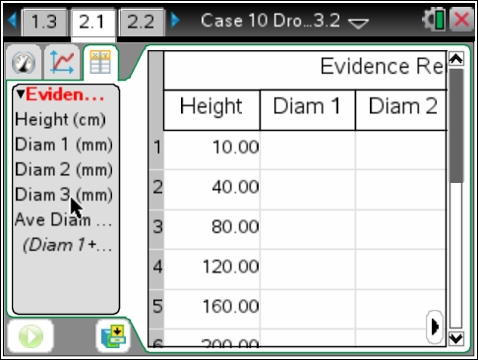
6. In order to determine the kind of relationship between height and blood spatter diameter, you will test several different types of curves to see which gives the best fit to your data. The first curve you will attempt to fit to your data will be a Linear curve (a straight line). On the “graph view” tab:
a. Press the menu key; then select Analyze > Curve Fit.
b. Select Linear as the Fit Equation.
c. The fit parameters for the equation are displayed. Record the equation. Include a simple sketch of this graph on your evidence record, as you will be doing several other types of curves and will need to decide which best fits your data.
7. Change the Fit Equation to Logarithmic, record the equation, and make a simple sketch of this graph on your evidence record. You will want to first remove the previous fit equation that is graphed. Analyze > Remove >
8. Repeat Step 6/7using a Quadratic fit.
9. Repeat Step 6/7 using a Power fit.
10. Once you have completed each of the above, choose the equation that appears to be the “best fit” for your data.
11. Change the Fit Equation (curve fit) to the equation with the best fit based on your comparison of the sketches. Select OK.
Move to pages 2.3–2.5.
12. Estimate the height from which the blood at the crime scene fell by comparing it to your known data.
a. With the curve fit still displayed on your graph, choose Interpolate from the Analyze menu.
b. Move along the curve-fit line until the average spatter diameter value is approximately the same as the average diameter of the blood spatters from the crime scene. The corresponding height value is the estimated height, in centimeters, from which the blood at the crime scene fell. Record this value in your Evidence Record and on page 2.5.

Evidence Record
Height (cm) | Diameter of Drop 1 (mm) | Diameter of Drop 2 (mm) | Diameter of Drop 3 (mm) | Average Diameter of Drops  (mm) | Shape and General Observations of Blood Spatters
10
40
80
120
160
200
Crime Scene

Equation for linear fit:
Equation for logarithmic fit:
Equation for quadratic fit:
Equation for power fit:
Type of curve that gives best fit to data:
Equation for best fit: y =
Height of spatters from crime scene:

Sketches:
Linear | Logarithmic | Quadratic | Power

Case Analysis
Answer the following questions here, in the .tns file, or both.
1. Which type of curve gave the best fit to your data?

2. Did the shape of the blood spatters change as the height increased? Explain.

3. Which of the three suspects could have created the blood spatters at the scene? Explain.

4. How accurate do you think your height estimate is? What factors can contribute to inaccuracy in your estimate? How can you reduce the errors from these factors?

5. Forensic scientists often do tests to determine the relationship between height and spatter diameter for the different cases they are involved in. What factors can cause the relationship between height and spatter diameter to differ from crime scene to crime scene?

