Investigating Special Triangles  ID: 7896 | Time required  45 minutes

Activity Overview
In this activity, students will investigate the properties of an isosceles triangle. Then students will construct a 30°-60°-90° triangle and a 45°-45°-90° triangle to explore the ratios of the lengths of the sides.

Topic: Right Triangles & Trigonometric Ratios
- Calculate the trigonometric ratios for 45°-45°-90°, 60°-60°-60° and 30°-60°-90° triangles.

Teacher Preparation and Notes
This activity is designed to be used in a high school or middle school geometry classroom.
- If needed, review or introduce the term median of a triangle. Any median of an equilateral triangle is also an altitude, angle bisector, and perpendicular bisector.
- This activity is designed to be student-centered with the teacher acting as a facilitator while students work cooperatively.
- The worksheet guides students through the main ideas of the activity and provides a place for students to record their work. You may wish to have the class record their answers on separate sheets of paper, or just use the questions posed to engage a class discussion.
- To download the Cabri Jr. files ISOSC and EQUIL go to education.ti.com/exchange and enter “7896” in the quick search box.

Associated Materials
- GeoWeek08_Special Triangles_worksheet_TI84.doc
- EQUIL.8xv (Cabri Jr. file)
- ISOSC.8xv (Cabri Jr. file)

Suggested Related Activities
To download any activity listed, go to education.ti.com/exchange and enter the number in the quick search box.
- Interior & Exterior Angles of a Triangle (TI-84 Plus family) — 8775
- Triangle Inequalities (TI-84 Plus family) — 11757
- Exterior & Remote Interior Angles (TI-84 Plus family) — 7777
Problem 1 – Investigation of Triangles
First, turn on your TI-84 and press . Arrow down until you see Cabri Jr and press . Open the file ISOSC. This file has a triangle with an isosceles triangle with AB = AC. | 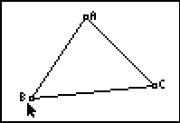
Using the Perpendicular tool ( > Perp.), construct a perpendicular from point A to side BC. Label the point of intersection of this line with BC as D. To name the point, they need to select the Alph-Num tool ( > Alph-Num), select the point, and press   for the letter D. | 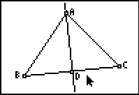
Construct line segments BD and CD ( > Segment) and then measure the segments ( > Measure > D. & Length).  Would you have expected these segments to be equal in length? | 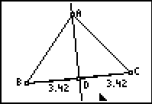
Drag point C to see the effect on the lengths of the line segments. It appears that the perpendicular from the vertex always bisects the opposite side. Measure the angles BAD and CAD.  Will they always be equal? | 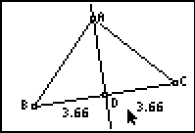

Problem 2 – Investigation of 30°-60°-90° Triangles
Open the file EQUIL. Note that all three angles are 60° angles.  Construct the perpendicular from A to side BC. Label the point of intersection as D.  From the construction above, we know that D bisects BC and that m∠BAD = 30°. | 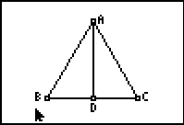
Construct segment BD. We now have triangle BAD where m∠D = 90°, m∠B = 60° and m∠A = 30°. We also have triangle ACD where m∠A = 30°, m∠C = 60° and m∠D = 90°.  This completes the construction of two 30°-60°-90° triangles. We will work only with the triangle BAD.  You may choose to have the students hide the segments AC and CD. To do this, construct segments BD and AB on top of the larger triangle. Then hide the original triangle. Keep the point C. We will need that point later to resize the triangle. | 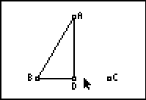
Measure the three sides of the triangle. | 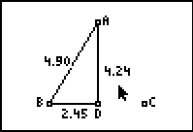
Press   and select the Calculate tool. Click on the length of BD, then on the length of AB. Press the  key. Students will see the result 0.5. Move it to the upper corner. Repeat this step to find the ratio of AD:AB and AD:BD. These ratios will become important when you start working with trigonometry. | 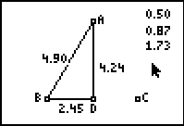
Drag point C to another location.  What do you notice about the three ratios?  The three ratios remain constant. | 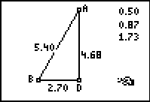
Problem 3 – Investigation of 45°-45°-90° Triangles
Press the □ button and select New to open a new document.  To begin the construction of the 45°-45°-90° triangle, construct line segment AB and a perpendicular to AB at A. | 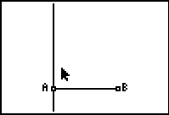
Use the compass tool with center A and radius AB. The circle will intersect the perpendicular line at C. | 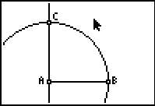
Hide the circle and construct segments AC and BC.  Can you explain why AB = AC and why angle ACB = angle ABC?  Why are these two angles 45° each?  Students should notice that the two angles must be equal, and angle A is 90°. Therefore, because the sum of the angles in a triangle is 180°, the two angles must be 45° each. | 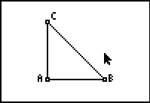
Measure the sides of the triangle.  This verifies that AB = AC. | 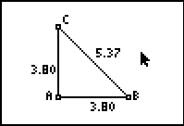
Use the CALCULATE tool to find the ratio of AC:BC and AC:AB. Once again, these ratios will be important when you study trigonometry. | 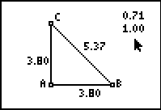
Drag point B and observe what happens to the sides and ratios.  Why do the ratios remain constant while the sides change?  Students should notice that AC and AB are equal, so the ratios will always remain the same. | 