Create a scatter plot
The table on the right shows the life expectancies from 1900 to 2004 for men, women, and people (men and women combined). Investigate the relationship between the year and the life expectancy for a person living during that year by creating a scatter plot.
Step 1: Press  . Enter the data for Year in list L1 and the data for Person in list L2. |  | 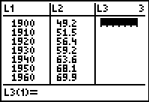
Step 2: Create the scatter plot by pressing   and set up Plot1 as shown on the right.  Press  and select ZoomStat to adjust the window settings appropriately. |  | 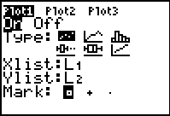
- Describe the relationship between the two variables.

Draw a line that fits the data
Step 3: Draw a line that fits the data as well as possible. Press   to access the CALC menu and then choose Manual-Fit. |  | 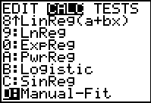
Step 4: Move the cursor to one side of the scatter plot and anchor the point by pressing . |  | 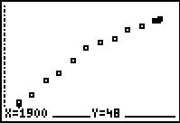
Step 5: Move the cursor to the other side of the scatter plot and press  to anchor the right endpoint. The equation of your line will appear in the top left corner.  Step 6: Modify the graph until you have a line that fits the data better than the line shown to the right. This line will be your line of “better fit.” |  | 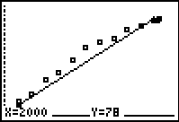
Step 7: Press   to finish the Manual Fit function. The equation of your line is saved in Y1.  - What is the equation of your line? |  | 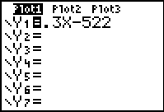
Compute the sum of the squares of the residuals
Step 8: Compare the coordinates of the points on your line with those of the original data by entering Y1(L1) in the top of list L3. Press . |  | 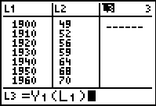
Residuals are the differences between the actual y-values of the data set and the corresponding y-values predicted by your line of “better fit.”
Residual = Actual value – Predicted value
- If a data point is above the line, is the value of the residual positive or negative?

- If a data point is below the line, is the value of the residual positive or negative?

Step 9: Find the square of these residuals. Move to the top of list L4 and enter (L2 – L3)². Press .  Step 10: Return to the Home screen. Find the sum of the squares of the residuals. Press   and under the MATH menu select sum(. Then enter L4). Press .  - What is your sum?  Did you get a value lower than the one shown? If so, then you found a line of “better fit.” |  | 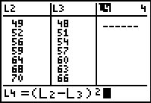  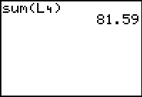
- Compare the sum of the squares of your residuals with those of your classmates. What was the lowest sum?

- How many points are above their line? Below their line?

- Which data points do you think increase the sum of the squares the most?

- How do the values in list L4 for these data points compare to the others?

- Where are these points located in relation to the line?

- What do you notice about the distribution of the data points around the line (i.e., above vs. below the line, or equal spacing vs. clusters)

- To have the smallest sum, how do the points need to be distributed?

Find the line of best fit
Step 11: There is a line of best fit. That line is called the Least Squares Regression Line, often written as LSRL.  Press   and select LinReg(ax+b) from the CALC menu. Then enter L1, L2, Y2. Press .  This command computes the equation of the Least Squares Regression Line and stores it in Y2. Graph this line, along with your line of “better fit,” and the scatter plot. |  |  | 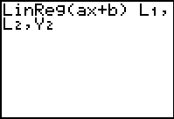
If using MathPrint™ OS:  Choose LinReg(ax+b) from the CALC menu. A screen similar to that shown at the right will be displayed. Enter the Xlist, Ylist, a location (Y2) to store the regression equation, and then select Calculate. |  |  | 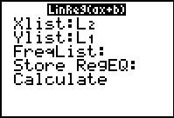
- How does the graph of the LSRL compare with the graph of your line of “better fit?”

Step 12: Repeat Steps 8–10 to find the sum of the squares of the residuals for the LSRL which is stored in Y2.
- What is the value of the sum of squares?

- How well did you do? Does your sum of squares compare favorably to the sum of squares for the calculator-generated LSRL equation?

Homework
Analyze the two additional sets of data in the spreadsheet by using Manual-Fit to draw a line that fits the data. Compute the sum of the squares for your equation. Compare your answers each time to the Least Squares Regression Model and the sum of the squares for the regression equation.
 | Women | Men
Your equation
Sum of squares
Calculator equation
Sum of squares

