Part 1 – Exploring Multiples
Use the following diagram in Exercises 1–6.

Multiples of 6
Multiples of 3
Multiples of 5

1. Place the following numbers in the correct location in the Venn diagram above.
12 15 21 41 30 6 5 45 31 24
2. Which numbers share the circles for 3 and 6?

3. What is similar about these numbers?

4. Where will you place the Least Common Multiple (LCM) of 5 and 6? What is this number?

3 and 6? 3 and 5?
5. Did any numbers fall outside the circles? ____ If yes, what do the numbers have in common?

6. Can you find a number that falls in the “Multiples of 6” and not in the overlap area for “Multiples of 3”? Why or why not?

Part 2 – Greatest Common Divisor  The greatest common divisor (or greatest common factor) is the greatest number that you can divide into two numbers. For example, the greatest common divisor for 27 and 63 is 9.  To use the gcd( feature of the TI-84, follow these steps. Press m ► 9 2 7 , 6 3 ) e. | 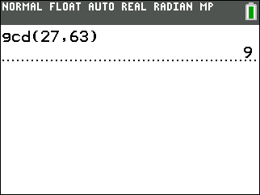
7. Find the greatest common divisor of 24 and 54. Write the answer.
8. Find the GCD of 18 and 90. Write the answer.
9. In the following Venn diagram, place all factors of each number in the correct location.
88
102
48
10. What must a number have in common with all three numbers to be placed in the overlap of all three circles?

11. What is the greatest common divisor of 88 and 48? Where is it located in the diagram?

What is the greatest common divisor of 88 and 102? Where is it located?

12. When will a greatest common divisor not exist between two numbers?

